

**Education Resources**

**RUTHERGLEN HIGH SCHOOL**

SCHOOL HANDBOOK

2024

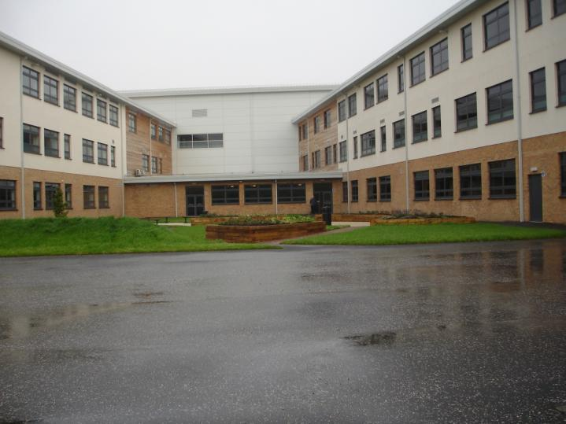



**CONTENTS**

**SECTION 1 Introduction**

**SECTION 2 About our School**

**SECTION 3 Parental Involvement**

**SECTION 4 School Ethos**

**SECTION 5 Attendance**

**SECTION 6 The Curriculum**

**SECTION 7 Assessment and tracking progress**

**SECTION 8 Reporting**

**SECTION 9 Transitions**

**SECTION 10 Support for Pupils (Additional Support Needs)**

* **Getting it Right for every child**
* **Enquire**
* **Attachment Strategy**

**SECTION 11 School Improvement**

* **Pupil Equity Funding**

**SECTION 12 School Policies and Practical Information**

* **Free meals**
* **Uniform/dress code**
* **Clothing Grant**
* **Transport**

If you need this information in another language or format, please contact us to discuss how we can best meet your needs.

Phone: 0303 123 1023 Email: [education@southlanarkshire.gov.uk](mailto:education@southlanarkshire.gov.uk).



**SECTION 1**

**Introduction**

|  |  |
| --- | --- |
|  | **Introduction** |

Dear Parent/Carer

I am delighted to welcome you to Rutherglen High School. This handbook provides you with key information in relation to all aspects of the school including school procedures and personnel. I hope it also gives you a flavour of our culture and ethos.

We aim to provide a range of learning experiences, which meet the needs of all our learners. Working together in partnership: school staff, parents, and our partner agencies can help us achieve this goal.

Communication is essential and we would welcome you to contact Rutherglen High with regards to any aspect of your son/daughter’s education.

I look forward to working with you over the coming years to ensure that you and your son/daughter enjoy a happy and successful time at Rutherglen High School

Jan Allan

**Head Teacher**

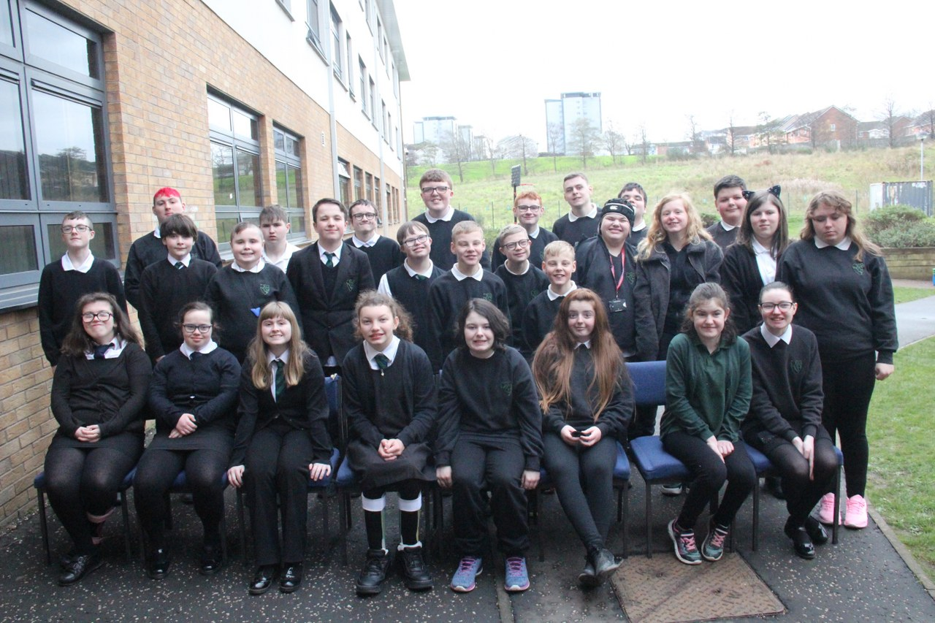

**Vision, Values and Aims**



**Healthy**

**Respected**

**Safe**

**Our Vision**

In Rutherglen High our vision is to provide an inclusive, safe, nurturing environment which allows our pupils to achieve their full potential and to find their rightful place in their community

**Our Values**

In Rutherglen High our values are:

* mutual respect and understanding
* kindness and trust
* empathy and tolerance
* inclusion and cooperation
* encouragement, support and valuing everyone

**Our Aims**

In Rutherglen High we aim to:

* provide a safe and nurturing environment
* provide a positive, inclusive and holistic educational experience
* encourage pupils to achieve their full potential
* work in partnership with the wider community to ensure support and access for all pupils

South Lanarkshire Council is the fifth largest authority in Scotland. It covers the following main areas; Clydesdale in the south which features extensive rural areas, Cambuslang, Rutherglen, Blantyre and Uddingston to the north as well as the towns of East Kilbride and Hamilton**.**

The Council’s Plan Connect sets out the Council’s vision which is, “to improve the quality of life for all within South Lanarkshire”.

For Education Resources this means delivering services of the highest quality as well as striving to narrow the gap. It is about continually improving the services for everyone at the same time as giving priority to children, young people, families and communities in most need. The priorities for schools and services are set out in the Education Resources Plan which confirms the commitment to provide better learning opportunities and outcomes for children and young people.



**SECTION 2**

**About Our School**

|  |  |
| --- | --- |
|  |  |

|  |  |  |
| --- | --- | --- |
| Rutherglen High School opened in August 1999 and is a non-denominational and co-educational school. The school is part of the Cathkin Learning Community and has formed strong links within the local community.  The school provides education for over 115 pupils and is currently located in Langlea Road in Cambuslang. All pupils attending Rutherglen High School have a range of Additional Support Needs and have an Additional Support Plan or Co-ordinated Support Plan to assist the school in planning a curriculum which supports pupils in achieving their potential. Support for pupils is provided in the form of smaller class sizes (maximum 10) with allocated support staff to provide continuity and security.  Pupils are supervised at morning interval and lunchtime and are provided with assistance with personal care and eating and drinking if required.    Rutherglen High has strong links with Glasgow Clyde College (Langside and Cardonald Campus), New College Lanarkshire (Motherwell Campus) and Glasgow Kelvin College (Easterhouse and Haghill Campus). Through our Work Experience programme good partnerships have been established with local employers.  Rutherglen High is a Rights Respecting School, a Health Promoting School and an Eco School. Fund raising for charity and the promotion of Fairtrade are an integral part of the school ethos. |  |  |
|  |  |  |

**Official Address**

Rutherglen High School

Langlea Road

Cambuslan

G72 8ES

Telephone: 0141 643 3480

Email : **office@rutherglen.s-lanark.sch.uk**

Website : [www.rutherglen.s-lanark.sch.uk/](http://www.rutherglen.s-lanark.sch.uk/)

**Current Roll at March 2024: 120 pupils**

S1 22 S2 21

S3 20 S4 20

S5 18 S6 19

**The Staff of Rutherglen High School**

**Head Teacher**

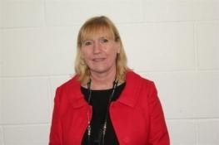Mrs Jan Allan Responsible to the Executive Director of Education Resources for the overall management of school, timetable, curriculum, child protection,

Look After and Accommodated Children,

Pastoral care.

Curricular areas – Art, Music and Drama

gw14rutherglenht@glow.sch.uk

**Depute Head Teacher**

Mrs Geraldine Johnston

Curriculum Remit Pastoral Care

Curricular areas – Maths, English

ICT, RME, Technical

SQA Coordinator

CPD Coordinator

gw07[johnstongeraldin@glow.sch.uk](mailto:johnstongeraldin@glow.sch.uk)

**Depute Head Teacher**

Mrs Lorna Jenson Inclusion

Learning Support

[gw07jensenlorna@glow.sch.uk](mailto:gw07jensenlorna@glow.sch.uk)

**Principal Teachers**

**Heather Haggarty Rebecca McFarlane Caroline Perston Guto Williams**

***

**Heather Haggarty** Pastoral care

Curricular remit Spanish, French & Social Subjects

Assemblies

Buddy Programme

RERC, CARITAS Award

Pupil Voice

S3 Profile

gw

**Rebecca McFarlane** Pastoral care for

Curricular Remit Health &Wellbeing, PE, IDL and PSE

S1 Induction

**Caroline Perston**

**Guto Williams** Pastoral care S5&S6

Curricular remit Science, Outdoor Learning, John Muir Award

DYW, Duke of Edinburgh Award, College S4-S6, Work

Experience S4 – S6, Post School Transition Planning

**Home School Link**

Home/School Support for Parents.

**Veronica McBride**

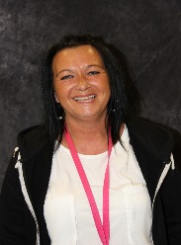

[gw12mcbrideveronica@glow.sch.uk](mailto:gw12mcbrideveronica@glow.sch.uk)

Pupil Attendance

Support for Parents

Parent Support Group

**Teaching Staff (in Subject Department)**

**Art & Design** Mrs C Perston (Acting Principal Teacher)

Ms L Robertson

**Supported Classes** Ms S Cumming

Ms L Cuthbertson (Acting Principal Teacher)

Ms O Guild (Acting Principal Teacher)

Mrs H Haggarty (Principal Teacher)

Mrs R McFarlane (Principal Teacher)

Mr Ms AM Hastie

Mrs C Perston (Acting Principal Teacher)

Mrs C Young

Teacher 1

Teacher 2

**Drama**  Mr B Reavey

**English** Ms L Coyle (Literacy Co-ordinator)

Ms S McCormack

Mr W McEvoy

**French**  Mr W McEvoy

**Home Economics** Mrs S McGowan

**I.C.T.** Mr M Dornan (ICT Co-ordinator)

**Mathematics**  Mrs Y Nandi

Mrs A Paul

Miss L Cuthbertson (Numeracy Coordinator)

**Music** Mrs B Steel (DYW Coordinator)

**P.E**. Mrs M Cresswell (DYW Coordinator)

Mrs E Devlin

Mrs K Sclater

**Health & Well Being** Mrs H Haggarty

Mrs R McFarlane

Mr G Williams

**R.M.E.** Miss S Cumming

Mrs G Rosenberg

**Science** Ms L Gaughan

**Social Subjects** Mr A MacDonald

Mrs G Rosenberg

**Spanish** Ms AM Hastie

Mr W McEvoy

**Technical Education** Mr A Campbell

**Developing Young**  Mrs M Cresswell (DYW Coordinator)

**Workforce (DYW)** Mrs S McGowan

Mrs B Steel (DYW Coordinator)

Mr G Smith

**Outdoor Learning /** Mr Williams (Principal Teacher)

**Wider Achievement**

**Cluster Support Services Co-ordinator** Mrs L Seenan

**Team Leaders** Mr P Eunson

Mrs V McBride

Mrs M Muir

Mrs M Naismith

**Office Staff** Ms A Cassells

Ms J Greenhorn

Mrs A Thorpe

**Support Staff**

Mrs E Ahern Ms C Esler Ms H Matheson

Mrs L Balfour Mrs H Gemmell Ms J Mitchell

Ms S Bell Mrs J Griffin Mr J Paterson

Mrs A Bennie Mrs M Kalsi Gray Mrs F Pert

Mrs M Brown Mrs A Kirkland Mrs M Scott

Mrs L Buchanan Mrs E Larkins Mr J Templeton

Mrs L Carroll Mrs A McGowan Ms H Tsiolis

Ms E J Currie Mrs A Mc McLaughlin Mrs L Watson

Ms M Doran Mrs A McNulty Mrs K Whyte

Mr C Mckenna Ms L McNeish

**Instrumental Instructors** MrE Murray (Woodwind)

Mrs A McKirdy (Voice)

Mr B Payne (Percussion)

**Janitor**  Mr M Everet

**Catering Staff** Mrs D Thomson

**Cleaning Supervisor** Mrs A Johnston

**Concerns and Complaints**

There are occasions when parents and pupils have a concern about an aspect of the service that we provide. In the first instance parents and pupils should contact the appropriate Pastoral Teacher Link to raise their concern either by telephone/writing or email.

In most cases, the Pastoral Teacher Link will be able to investigate and respond within a few days and the majority of issues are resolved in this way. For more complex or serious matters, complaints should be made in writing, again to the Pastoral Teacher Link. They will acknowledge receipt and pass it on to Depute Head/Head Teacher. Complaints will be investigated and a written response provided within 20 days, in line with South Lanarkshire Council’s, ‘Have Your Say’ policy. We would normally maintain contact within that period to provide, or to seek, further information.

In exceptional circumstances, where this timescale cannot be met, we would maintain contact and explain why. If we cannot resolve the complaint at school level, complaints can be escalated to the Quality Improvement Officer within the Education Resources team at South Lanarkshire Council.

**Working with Parents Team**

**Area of Responsibility of Team Contact Number**

Bullying and related issues, [parents@southlanarkshire.gov.uk](mailto:parents@southlanarkshire.gov.uk)

Care and Welfare Issues,

Class organisation and complaints.

**Richard Young 01698 454495**

Parent Council (procedural and [theparentcoucil@glow.sch,uk](mailto:theparentcoucil@glow.sch,uk)

Administrative issues only),

Parental Involvement.

Parental enquiries and concerns relating to school transport, placing requests, property, Inclusive Education and Early Years should be directed to the appropriate service Manager:

**Aisling Boyle** Inclusive Education Manager 01698454455

aisling.boyle@southlanarkshire.gov.uk

**Eleanor Brady** Inclusion Advisor (ASN Transport) 01698 455094

**Alex McLeod** Quality Improvement officer 01698 454467

alex.mcleod@southlanarkshire.gov.uk

**SECTION 3**

**Parental Involvement**

**Parental involvement/Parent Councils**

South Lanarkshire Council recognises the importance of parents as partners in the education of their child and has published a strategy entitled, ‘Making a difference – working together to support children’s learning’. This is available from the Council’s website: [www.southlanarkshire.gov.uk/downloads/file/13457/parents_as_partners_-_strategy_2019](http://www.southlanarkshire.gov.uk/downloads/file/13457/parents_as_partners_-_strategy_2019)

Parents, carers, and family members are by far the most important influences on children’s lives. Children between the ages of 5 and 16 children spend only 15% of their time in school! Research shows that when parents are involved in their child’s learning, children do better at school and throughout life. Parental involvement can take different forms, but we hope you share the same aims and agree that by working together we can be partners in supporting children’s learning.

As a parents/carers we want you to be:

* Welcomed and given an opportunity to be involved in the life of the school.
* Fully informed about your child’s learning.
* Encouraged to make an active contribution to your child’s learning.
* Able to support learning at home.
* Encouraged to express your views and involved in forums and discussions on education related issues.

Every parent with a child at school is automatically a member of our parent forum. The Parent Council is a formal group, with a constitution, and acts as the Parent Voice of the school.

To find out more on how to be a parent helper, or a member of the Parent Council and/or the Parent Teacher Association contact the school or visit our website. We have also produced a guide on the role of a Parent Council which was produced by parents for parents.

**Parent Council**

**Office Bearers**

Chairperson R Young

Vice Chairperson Vacancy

Treasurer L Penny

Secretary K Whyte

**Parent Members**

L Collins

C A Young

**Associated Member**

J Sanderson School Chaplain

**Councillors**

R Brown

**Staff Members**

J Allan

H Haggarty

[Parentzone Scotland](https://education.gov.scot/parentzone) is a unique website for parents and carers in Scotland, from early years to beyond school.  The website provides up-to-date information about learning in Scotland, and practical advice and ideas to support children’s learning at home in literacy, numeracy, health and wellbeing and science. Information is also available on Parentzone Scotland regarding additional support needs, how parents can get involved in their child’s school and education.

Parentzone Scotland also has details about schools, including performance data for school leavers from S4-S6 and links to the national, local authority and school level data on the achievement of Curriculum for Excellence levels.

**HOME AND SCHOOL LINKS**

Rutherglen High School places a great value on the links which have been established between the school and parents.

Formal consultation evenings are held twice a year, (November and May).

In addition to this all pupils will have a yearly review meeting.

S1 October/June S3 February

S2 April/May S4 March

S5/6 November/December

At all other times, parents who wish to consult a member of staff should arrange an appointment through the school office (0141 643 3480). If the interview is concerned with a child’s general progress or welfare, a meeting with the appropriate Pastoral Care Link will be arranged. On other matters, school administrative personnel will direct parents to the most appropriate member of staff.

Parents who call at the school without an appointment may not be able to see the teacher best qualified to deal with the enquiry because of teaching commitments, but we always do our best to arrange an interview with an appropriate member of staff.

Informal school events such as School Café, Christmas Coffee Morning, Spring Coffee morning, Summer Barbeque and MacMillan Coffee Morning provide an invaluable opportunity for developing links between staff and parents. It is hoped that parents will give these events their full support.



**SECTION 4**

**School Ethos**

**School Ethos**

Pastoral Care is a whole school responsibility and all staff, teaching and non-teaching have an important role to play.

A House system is in operation. There are three Houses: Jedburgh, Kelso and Selkirk and all staff and pupils belong to one of the Houses.

We are concerned with each pupil’s personal, social and vocational welfare and are able to offer support and guidance throughout their school career. We also have close links with outside agencies: Social Work Department, Psychological Services, Allied Health Professionals and Skills Development Scotland. We are also keen to encourage close contacts between home and school and to involve parents in all aspects of their son / daughter school career.

**Initial Contact**

S1 and S2 Mrs R McFarlane Principal Teacher

S3 and S4 Mrs H Haggarty Principal Teacher

S5 and S6 Mr G Williams Principal Teacher

**Extended Support Team**

**Educational Psychologist**

The link Educational Psychologist: Mr Craig Thomson

**Physiotherapist**

The physiotherapist:Mrs Julie O’Donoghue

**Speech and Language Therapist**

The speech and language therapist: Mrs Phillippa Watters

**Additional Needs School Nursing Team**

The additional needs school nursing team:

Marie Watts

Morag Alexander

Jacqueline Johnstone

Allison Young ( link nurse)

**Social Worker**

Link worker: Mr Michael Murry

**Skills Development Scotland**

Link worker: Mrs Jennifer Latimer

**Rights Respecting Schools**

Rutherglen High School pupils are encouraged to reflect on how their behaviour and actions affect those around them, which allows us to build and maintain a positive and safe learning environment for all, both in the classroom and around the school site. In the preparation for the RRSA, and in consultation with pupils and staff at all levels, our school rules and expectations were re-written to form charters, which outline expectations in the classroom. These are displayed throughout the school.

**Eco Schools**

As part of the Eco Schools Programme, pupils in Rutherglen High take part in a wide range of environmental projects and have been successful in gaining our fourth Eco flag. A wide range of topics are covered such as Waste Management, schools grounds and biodiversity.

As a school, we have made links with outside agencies that have provided invaluable support to us.

In addition, we are grateful to parents and friends who have assisted at our Eco Days.

**Spiritual, Social, Moral & Cultural Values**

It is the policy of the school to provide in the curriculum a compulsory element of Religious and Moral Education. This is based on the policy on religious education and religious observance (1993). Although the study of Christianity is a main component of the Religious and Moral Education syllabus, it does also involve the study of beliefs and customs of a number of world religions.

We value the links with our school chaplaincy team who contribute to both the formal and informal life of the school. He roll of the chaplains is divers and includes:

* Assisting the school to provide young people with opportunities for reflection, both individual and collective.
* Providing pastoral care and support for staff, pupils and their families, where appropriate.
* Having a key role during times of extreme difficulty or crisis.
* Supporting school community events.
* Visiting classes to complement the curriculum.
* Leading or helping pupil groups with a particular religious, moral or citizenship interest.
* Providing a link between the school and local community.
* Addressing the school community at end of term services.

The school chaplaincy links:

Rev John Sanderson United Reformed Church

Alison Kennedy Outreach Trust

Ross Murray Outreach Trust

**Rights of Parents/Carers**

Scottish Government Ministers consider that religious observance complements religious education and is an important contribution to pupils’ development. It should also have a role in promoting the ethos of a school by bringing pupils together and creating a sense of community.

Parents have a statutory right to withdraw children from participation in religious and moral education. However, national guidance also indicates that without this aspect of their education, learners will not enjoy the full benefits of Curriculum for Excellence since this area of their education contributes to pupils thinking for themselves and making their own decisions about what they believe to be true and about human living.

This right of parents’ wishes will be respected. Where a child is withdrawn from religious observance, we will make suitable arrangements for the child to participate in a worthwhile alternative activity.

Parents may request that their children be permitted to be absent in order to celebrate recognised religious events. Advance notice should be provided to the school when children will be absent. Appropriate requests will be granted and the pupil noted as an authorised absentee in the register.

**School / Community Links**

We aim to extend the learning experiences ofour pupils beyond the confines of the classroom by means of various educational visits and excursions not only within the local area but also further afield.

The school is very conscious of its role in the wider community, and every effort is made to foster links.

The school has close links with several of the local churches, representatives from St Columbkilles and the United Reformed Church participate in the school’s Chaplaincy group. Students from the school work with these churches and churches within their own community as part of the Caritas programme.

Students from the school also volunteer in Cathkin Community Nursery. The Nursery is a popular choice for participants volunteering for the Duke of Edinburgh’s Award scheme.

Groups from Rutherglen High regularly take part in projects at Camglen Radio, Lifestyles Sports Centre, Universal Connections and Holmhills Wood Community Park.

The school has good links with many local employers – most senior pupils have a work experience placement at a variety of local businesses.



**SECTION 5**

**Attendance**

Every effort should be made to ensure that your child attends school during term time. Please contact the school as soon as possible if your child is unable to attend school. It is important for the school to work with parents/carers in encouraging children to attend school. All absences are required by law to be recorded. Absences will normally fall under two categories – authorised or unauthorised absence. In cases where your child is unable to attend school parents are asked to:

*Enter absence reporting procedure here for your school.*

*Example – If your child is unable to attend school you are asked to let us know by xx on the first day of absence.*

*If you know they have a hospital/dental appointment, please let us know in advance.*

Requests for your child to be absent from school to make an extended visit to relatives either in the UK or overseas must be made in writing to the head teacher, detailing the reason, destination and duration of absence and arrangements for their continuing education. On these occasions the pupil will be marked as an unauthorised absence.

Parents may request that their children be permitted to be absent in order to celebrate recognised religious events. Advance notice should be provided to the school when children will be absent. Appropriate requests will be granted, and the pupil noted as an authorised absentee in the register. (See section 7).

**Information on emergencies**

We make every effort to ensure the school remains open during term-time for pupils. However, on occasions circumstances may arise which can affect the school. Schools may be affected by, for example, severe weather, power failures or through any other circumstances that may impact on the school day. In such cases we shall do all we can to let you know as soon as possible. We shall keep in touch by the most appropriate method at the time normally through text message, and via our social media channels.

In cases of severe weather in the morning such as snow and a heavy frost and if there is a reason the school cannot open in the morning at the normal time, we will adopt the protocol for a delayed start until 10am.

If this is the case a message via social media and on the council’s website will be posted.

The Council’s website [www.southlanarkshire.gov.uk](http://www.southlanarkshire.gov.uk) will be used to let you know if the school is closed or has a delayed start. Further information will be provided later in the day as to whether the school will be open as normal the next day.

**Things we need you to do:**

* It is important for parents/carers to let the school know of any change to your mobile/home telephone number and change of address.
* If for any reason, you are unsure if the school is open visit the website [www.southlanarkshire.gov.uk](http://www.southlanarkshire.gov.uk) or email [education@southlanarkshire.gov.uk](mailto:education@southlanarkshire.gov.uk)
  1. **Your commitments**

We ask that you:

* support and encourage your child’s learning – ask them what they have been doing.
* respect and adhere to the school’s policies and guidance.
* accept your responsibility to respect staff who work in the school and for the school to be proactive in taking forward its commitment to care for and educate your child.

**Family holidays during term time**

Every effort should be made to ensure that your child attends school during term time. Please contact the school as soon as possible if your child is unable to attend school.

Family holidays should be avoided during term time as this both disrupts the child’s education and reduces learning time. If holidays are taken during times when the school is open parents should inform the school in advance by letter.

If your child is taken on a family holiday during term time, then in line with Scottish Government advice this will be classified as an unauthorised absence. However, in exceptional circumstances schools may register a family holiday during term time as an authorised absence when for example, parents are able to demonstrate they have been unable to obtain leave during the school holiday period.

Clearly, absence with no explanation from parents will mean that the absence will be recorded as unauthorised.

In our approach to raising attainment and achievement it is recognised that attendance at school is something that should be continuously encouraged. Parents/carers, children and the school all have a part to play in encouraging and stressing the importance of attendance at school.

The school holiday dates, and in-service dates are available from the website [www.southlanarkshire.gov.uk](http://www.southlanarkshire.gov.uk)



**SECTION 6**

**The Curriculum**

**The Curriculum**

Curriculum for Excellence is the name given to the curriculum in Scotland for all children and young people aged 3-18. It is a forward looking, coherent, more flexible and enriched curriculum that provides young people with opportunities to engage with the knowledge, skills and attributes they will need to flourish in life, learning and work, now and in the future.

The curriculum includes all of the experiences that are planned for children and young people to support the development of their skills, wherever they are being educated, for example in the family and community, pre-school centre, nursery and school. In a secondary school setting the broad general education (BGE) will provide them with opportunities to become successful learners, confident individuals, responsible citizens and effective contributors to life in the 21st century. The Senior Phase that follows on from the BGE will provide learners with the opportunity to achieve a wide range of qualifications to recognise their learning.

In taking this forward our school will work closely with South Lanarkshire Education Resources and other services to enrich the curriculum, to provide the best possible education for all children and young people. We wish you to feel confident that your child is encouraged and supported to develop their literacy, numeracy and other skills whilst they attend our school. The curricular areas for the Broad General Education are as follows:

* Expressive arts
* Languages and literacy
* Health and wellbeing
* Mathematics and numeracy
* Religious and moral education
* Science
* Social studies
* Technologies

If you want to know more about Curriculum for Excellence, please visit website [**www.curriculumforexcellence.gov.uk**](http://www.curriculumforexcellence.gov.uk) **or** [**www.parentzonescotland.gsi.gov.uk**](http://www.parentzonescotland.gsi.gov.uk)

Our learning and teaching activities are based on the outcomes and experiences in the guidelines that all schools have for Curriculum for Excellence.

|  |  |
| --- | --- |
| **Level** | **Stage** |
| **Early** | **The pre-school years and Primary 1 or later for some.** |
| **First** | **To the end of Primary 4, but earlier or later for some.** |
| **Second** | **To the end of Primary 7, but earlier or later for some.** |
| **Third and Fourth** | **Secondary 1 to Secondary 3, but earlier or later for some. The Fourth Level broadly equates to Scottish Credit and Qualification Framework level 4. The Fourth Level experiences and outcomes are intended to provide possibilities for choice and young people’s choices will not include all of the Fourth Level outcomes.** |
| **Senior Phase** | **Secondary 4-6 and college or other means of study.** |

**Aims**

Curriculum for Excellence aims to:

Focus on classroom practice upon the child and around the four capacities of education:

* Successful learners
* Confident individuals
* Responsible citizens
* Effective contributors
* Simplify and prioritise the curriculum
* Encourage learning through experiences
* Create a single framework for the curriculum and assessment 3-18

**Purpose of the Curriculum 3-18**

The curriculum provides the structure and support in learning which will develop the four capacities listed above.

Our approach has been to alter the balance between a process that is heavily dependent on content, providing learning and teaching approaches that improve the pupils’ understanding of what is being taught. This is not a one-off change but the start of a continuous process of review to ensure that the curriculum remains up to date.

**Principles for Curriculum Design**

* Challenge and enjoyment
* Breadth
* Progression
* Depth
* Personalisation and choice
* Coherence
* Relevance

**Organisation and Curriculum: Courses in S1-S3**

In S1- S3, pupils are generally in mixed ability teaching groups which provide an equal opportunity for all pupils to follow a Common Course in line with Curriculum for Excellence. In English and Maths there may be some broad band setting according to ability.

The Curriculum is tailored made to meet individual needs. Most pupils are working at Early or First level.

**All pupils in S1 – S3 currently:**

**Subject Periods per Week**

**S1 S2 S3**

English 4 5 4

Maths 5 4 4

French 1 1 1

Spanish 1 1 1

Social Subjects 2 2 2

Home Economics 2 2 2

Information Technology 1 1 1

Technical Education 2 2 2

Science 2 2 2

Art 1 1 2

Music 1 1 1

Drama 1 1 1

Physical Education 2 2 2

Religious and Moral Education 1 1 1

Personal and Social Education 2 1 1

Developing Young Workforce 1 1 1

Interdisciplinary Learning 1 1 1

Skills for learning Life & Work N/A 1 1

Literacy 1 1 1

Numeracy 1 1 1

**Organisation and Curriculum: Courses in S4/S5/S6**

Pupils continue with a range of core subjects and where appropriate National Qualifications (NQ) are taken.

**Core Curriculum Periods per Week**

**S4 S5 & S6**

English 4 4

Maths 4 4

Physical Education 2 2

Home Economics 2 2*

Developing Young Workforce 3 2

Religious and Moral Education 1 1

Personal and Social Education 1 1

Option 1 2 2

Option 2 2 2

Option 3 2 2

Option 4 2 varies

College 4* varies

Literacy 1 1

Numeracy 1 1

John Muir Award 2* 2*

Citizenship 2* 2*

Personal Achievement Award 2* 2*

Skills for Education, Life & Work N/A 2*

* Dependent on individual pupil

**Options**

Options are an integral aspect of curricular provision for all students from S4 onwards. Options allow pupils to pursue courses in which they have a personal aptitude / interest.

Prior to choosing options, pupils will have the opportunity to take part in an Induction programme. This will involve input from subject specialists, Skills Development Scotland and Colleges. As part of this process an option information booklet will be issued to all pupils / parents.

Options are chosen at the end of S3 and pupils follow their chosen courses for two years**.**

**Options:** Art

Music

Drama

ICT

Technical

Science

Social Subjects

Duke of Edinburgh Award

French

Spanish

DIY

Horticulture

Health & Wellbeing

Home Economics (S6)

In S4, pupils choose 4 subjects from the above list and in S5 & S6 this reduces to 3 subjects. Pupils study the subject for 2 periods a week.

For more information regarding the S4/5 /S6 curriculum please see the S4/S5/S6 Curriculum Handbook.

**Severe and Profound Needs**

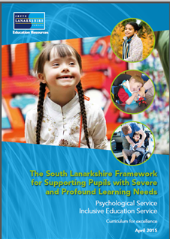Rutherglen High School’s provision for learners with Severe and Profound Needs follows the guidelines as set out in the South Lanarkshire document “Framework for Supporting Pupils with Severe and Profound Learning Needs”

Young people who would benefit from a highly support learning environment are identified at transition through consultation with Primary Headteachers, Educational Psychologists and parents. Pupils in supported classes benefit from an adapted secondary school curriculum with emphasis on supporting communication, and promoting daily living skills. Provision is also made to incorporate the daily exercise programmes in response to physical and sensory needs of the individual pupils, under the direction of physiotherapists and occupational therapists, where appropriate.

While the core subjects (English, Maths, Health & Wellbeing and Independent Living Skills) are delivered in the same classroom, pupils also access a secondary school timetable in various practical classrooms around the school. Opportunity is also given in many areas of school life for all pupils to socialise and work together.

**Developing the Young Workforce**

* Work Experience is an important part of the S4-S6 curriculum. In S4, some pupils will have the opportunity of a work experience placement.
* In S5 & S6 some pupils will have the opportunity to further work experience placements.
* Rutherglen High has a full Developing Young Workforce (DYW) Programme which allows for individual progression at each stage for every pupil. Rutherglen high has built up excellent links with many businesses. We believe that DYW has a very important role to play in preparing pupils for post-school life.

DYW is a core subject from S1-S6. It begins in S1 when pupils visit a place of business / college to learn more about the working environment. They also learn about the jobs that people in the school do and the types of skills and qualifications required to do these jobs. In S2, pupils visit more places of work and explore their own interests, In S3, pupils have more opportunities to visit places of work. The preparation for these visits takes place in World of Work. These visits help pupils to prepare for work experience, giving them important information about what they can expect in a workplace

**Work Experience**

Some pupils from S4-S6 have the opportunity to participate in a work experience placement. All placements are agreed upon after discussion with pupils, parents and staff and are dependent on individual pupil’s needs, abilities and interests. College placements and possible career choices are also taken into consideration when choices are being made about work experience placements.

The Work Experience programme is overseen by the Principal Teacher (S5 and S6). This involves making new links with businesses and maintaining links with existing participating businesses, keeping pupils and parents informed of opportunities for placements, talking to pupils about career choices, arranging any Health & Safety checks wherever necessary and arranging the necessary paperwork. Preparation for work experience (Health & safety, dress code, career choices, etc.) takes place at allocated times throughout the year with the school’s World of Work teacher during DYW class. During their work experience pupils keep a record of their activities through a Work Experience Diary. This provides useful feedback to school and parents about the placement and also serves as a valuable source of self-evaluation for each pupil to reflect upon both during their placement and on their return to school.

**College**

Rutherglen High has a full college programme which begins in S1 and continues through to S6. The school has strong links with a range of colleges: New College Lanarkshire (Motherwell Campus), South Lanarkshire College, Glasgow Kelvin College (Easterhouse and Haghill) and Glasgow Clyde College (Langside and Cardonald). Rutherglen High believes that college is an integral part of a student’s whole education. College provides students with important skills and qualifications that will help them in post-school life. College is also a very successful destination for many of our students when they leave Rutherglen High.

As soon as pupils begin Rutherglen High they have the opportunity to experience a flavour of college with visits to some of the colleges we work with. This allows pupils to become familiar with college life and all it has to offer from a very early stage. This continues into S2 where pupils plan their journey to college and carry out research into each college and what it has to offer. In S3 our college programme continues to progress and pupils have the opportunity to engage in some lessons at college with college staff. By the time pupils begin their schools-link programme at college in S4 they know a great deal about college and are happy and relaxed to attend.

Most pupils from S4 – S6 have the opportunity to attend one of the college campuses mentioned above. Programmes are dependent on individual needs, aspirations and abilities and decisions are made after discussion with pupils, parents and staff. There is careful consideration given to progression of skills and certification prior to allocation of placements. Possible future post school placements are also given consideration when advising pupils on college choices.

Management of college provision is the responsibility of the Principal Teacher (S5 and S6). Parents are contacted to update on concerns or issues which arise throughout the year. The Principal Teacher is available to discuss reports and options at Parents evenings throughout the year.

Currently we have pupils who attend Motherwell Campus, Langside Campus, Cardonald Campus, Easterhouse Campus and Haghill Campus.

Independent travel is encouraged but is not a pre-requisite of college placement and lunch is either purchased in the college canteen or packed lunch is provided by the school.

Pupils in S5/6 who have demonstrated a responsible and mature attitude are allowed to leave Langside Campus at lunchtime – after parental permission has been given and after an initial settling in period.

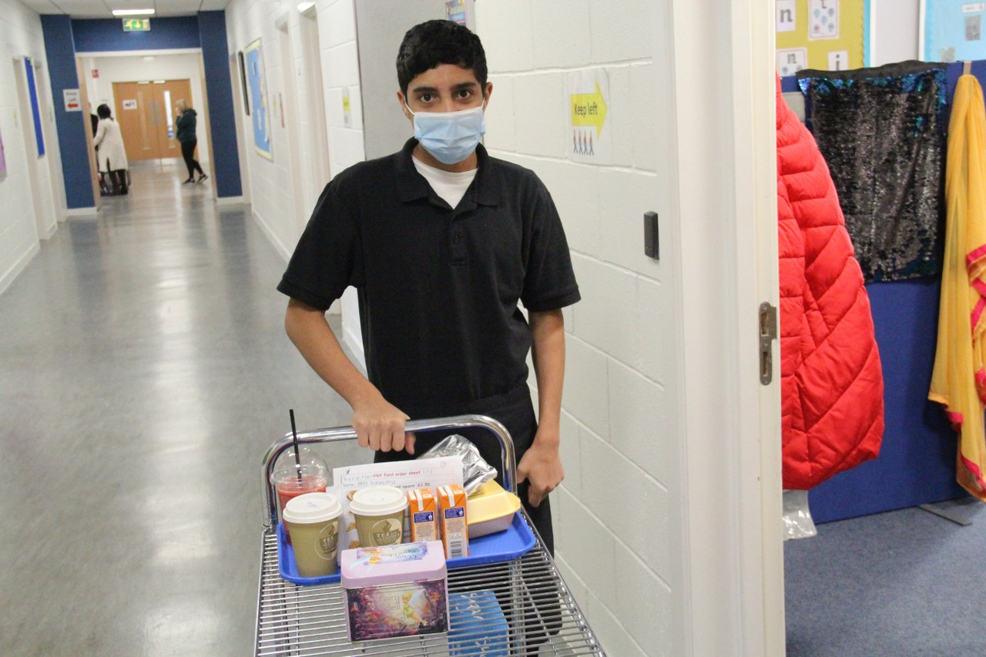



**SECTION 7**

**Assessment**

**Assessment**

Assessment is a key feature in planning for pupils.

Continuous assessment is used in First, Second and Third year. Formative assessment is used extensively. This assessment employs a range of techniques including peer observation, sharing criteria and self-evaluation. Through this teachers and pupils are able to confirm strengths and identify next steps.

In S4 – S6 assessment continues as above however for young people undertaking New National Qualifications a National Assessment forms part of the assessment criteria. These are internal assessments which are set in school and moderated within the school.

For Moderation, we have links with Cathkin High & Sanderson High to moderate pupils work. We have a successful SQA external verification every year. There is planned moderation throughout the year

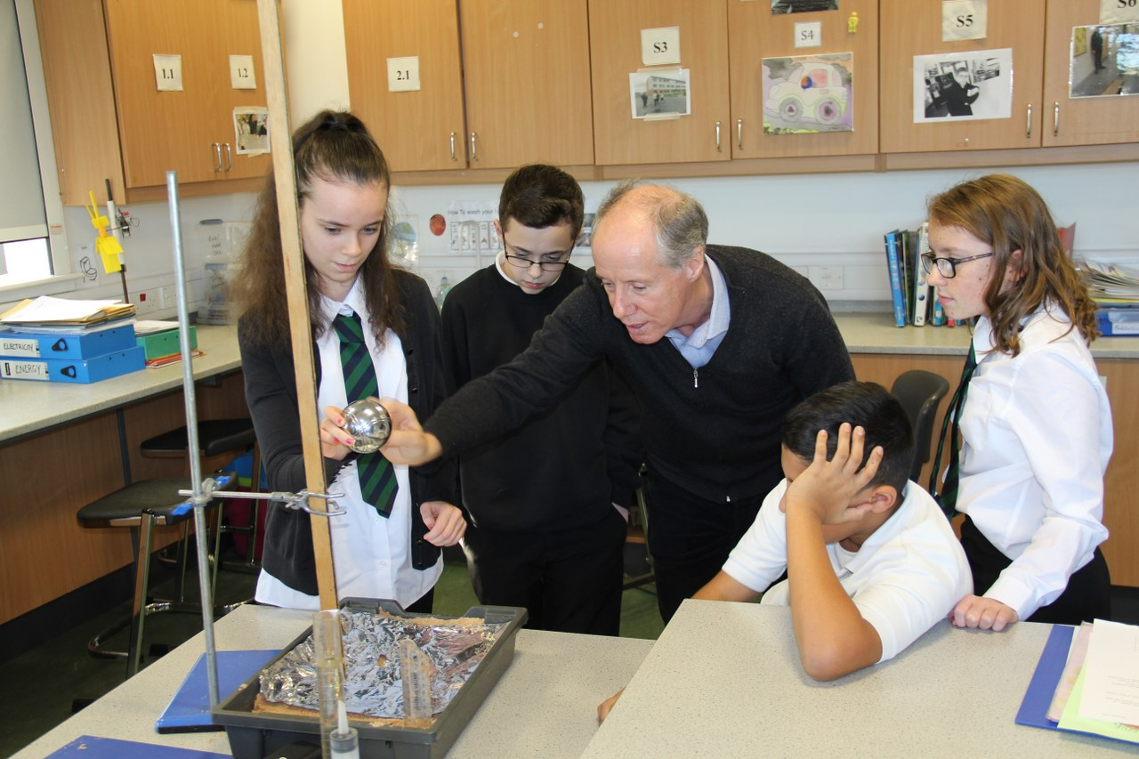Most S3 pupils are assessed in Numeracy, Reading, Writing and Talking and Listening using Standardised Assessments.



**SECTION 8**

**Reporting**

**Reporting**

Reporting will be ongoing and comprise of a range of activities which can include children presenting their learning, newsletters, and ongoing oral discussions.

We will provide parents with reports so that you can see what your child is doing and how they are progressing. In addition, there will be parents’ meetings which offer you the opportunity to discuss how your child’s progressing and how you can contact the school if you wish further information. The school will offer you an appointment time so that you can have a discussion about your child’s education.

Our ‘pupil reports’ will help you to get to know more about the curriculum which each child follows and will describe their strengths, achievements and areas for development so you know what encouragement and support you can give.

**S1-S6 Interim Reports November**

**S1-S6 Final Reports May**

We welcome any comments or additional information from parents to help us provide the best possible education for your child.

In addition, all pupils will have an annual review to update their Additional Support Plan / Coordinated Support Plan.

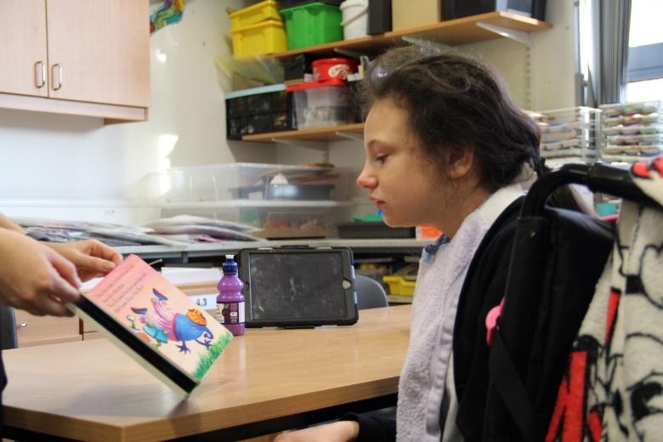



**SECTION 9**

**Transitions**

**Transitions**

We endeavour to ensure a smooth transition for pupils.

All pupils who attend Rutherglen High are involved in a comprehensive induction programme where regular liaison takes place with the sending primary school and units. The Principal Teacher with responsibility for S1, works closely with the sending schools.

Throughout the school year, subject teachers visit schools to get to know the pupils.

In addition to the Induction programme, P7 pupils are encouraged to visit the school café, which provides them with the opportunity to become familiar with their new surroundings and to meet staff and pupils.

An information session is held for new S1 parents in January.

School staff visit all associated schools to talk and get to know the pupils prior to transfer to Rutherglen High.

Our S4 & S5 pupils receive “buddying” training. On arrival at Rutherglen High, each new first year is teamed with senior pupils who will support the pupil in transition.

All Primary 7 pupils attend a two-day induction in June. An extended transition programme also takes place from March through to June with parents and teachers.

Throughout the year pupils are invited to various events held within Rutherglen High:

February / March Café Visits

March Health & Wellbeing

April Literacy & Expressive Arts

May Numeracy & Technologies

June Two day Induction

Pupils normally transfer from primary to secondary school between the ages of 11½ and 12½, so that they will have the opportunity to complete at least 4 years of secondary education. Arrangements are made by the school to transfer children to the associated secondary school as determined by their home address. Parents of P7 children will be informed of the transfer arrangements made for their child to attend secondary school.

We will also provide you with information at this time and on events designed to support P7 children before they move onto secondary school.

Normally children attend the school in their catchment area. However, there are times when parents may wish their children to go to other schools. If you wish your child to go to another school then you may make what is known as a ‘placing request’. If you live in South Lanarkshire and decide to submit a ‘placing request’, we are unable to reserve a place in your local school until the Council have made a decision on the ‘placing request’. Please note if your ‘placing request’ application is unsuccessful and all places at your catchment school are filled you will be offered a place at the next nearest appropriate South Lanarkshire School.

Please note that if an application for a ‘placing request’ is successful then school transport is not provided.

If you move out with your catchment primary school a ‘request to remain form’ must be completed. If you move out with your catchment primary, this may affect your right to transfer to the associated Secondary School. Please note the secondary school is determined by the pupil’s permanent home address and chosen denomination. If you require further information, please contact Education Support Services on [edauppserv.helpline@southlanarkshire.gov.uk](mailto:edauppserv.helpline@southlanarkshire.gov.uk) or 0303 123 1023.

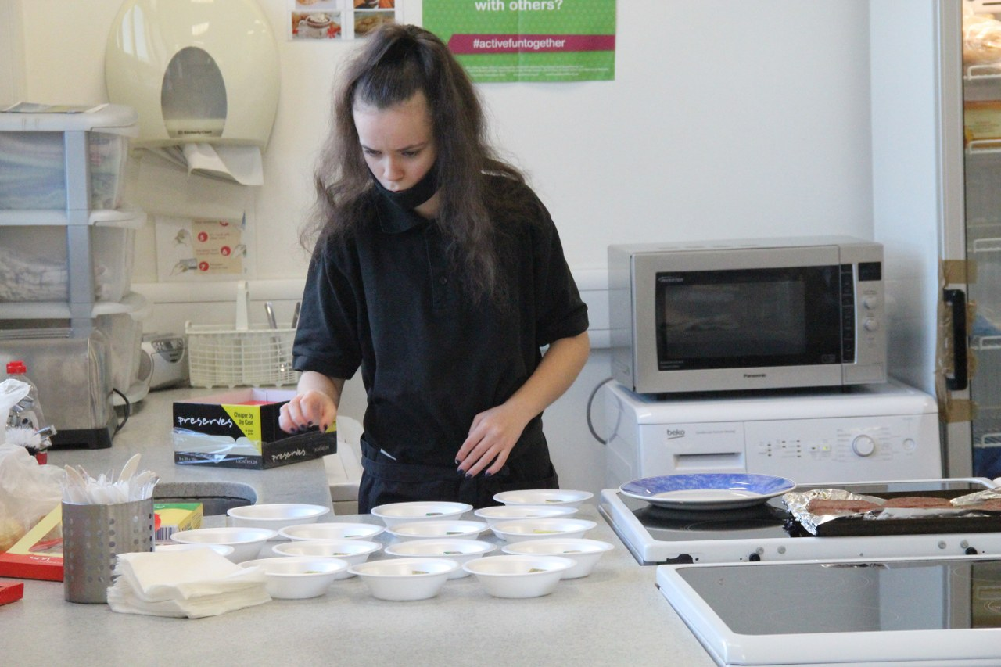

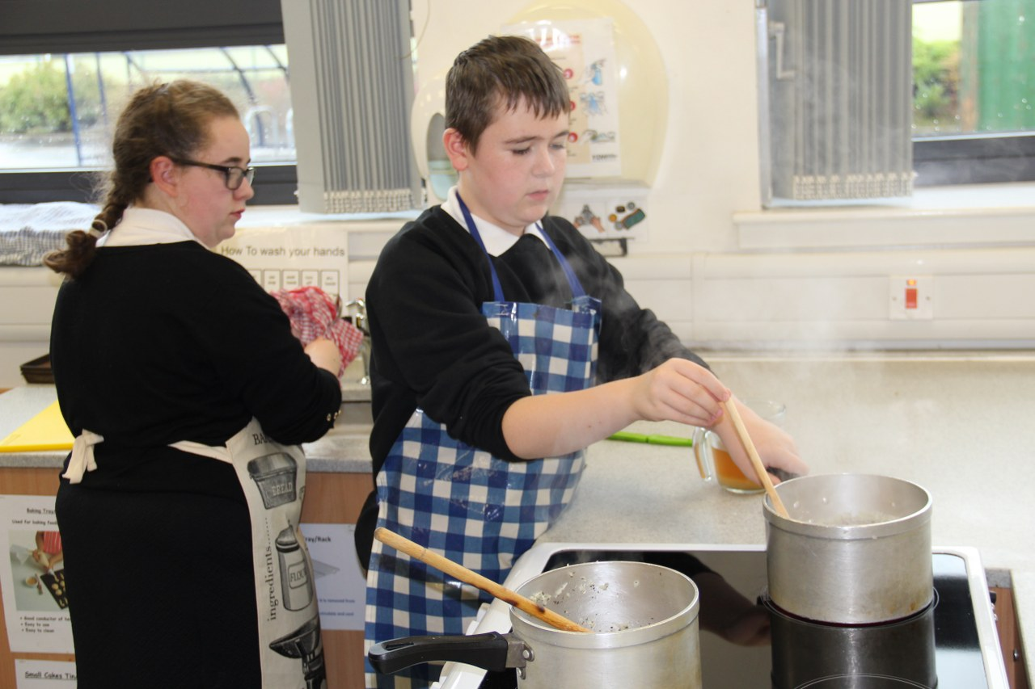



**SECTION 10**

**Support for Pupils**

**Support for pupils**

**Getting it right for every child**

Getting it right for every child (GIRFEC) supports families by making sure children and young people can receive the right help, at the right time, from the right people. The aim is to help them to grow up feeling loved, safe and respected so that they can realise their full potential.

Most children and young people get all the help and support they need from their parent(s), wider family and community but sometimes, perhaps unexpectedly, they may need a bit of extra help. GIRFEC is a way for families to work in partnership with people who can support them, such as teachers.

If you have any concerns about your child’s wellbeing you can speak to the named person who will work with you to provide support and decide how to move forward.

In Rutherglen High School the named people are:

S1 & S2 Mrs R McFarlane (Principal Teacher)

S3 & S4 Mrs H Haggarty (Principal Teacher)

S5 & S6 Mr G Williams (Principal Teacher)

**More information can be found on:** [**www.scotland.gov.uk/gettingitright**](http://www.scotland.gov.uk/gettingitright)

**Reach Forward**

The Reach Forward groups are an initiative within Rutherglen High School which provides a nurturing and supportive environment where our pupils can thrive. The Reach Forward groups support a significant number of our young people who have had early adverse experiences, specifically trauma. These young people can show signs of secondary traumatic stress and insecure attachment patterns have led to a difficulty regulating emotion and therefore struggle to manage traditional classroom settings successfully.

At the core of the Reach Forward programme is the health and wellbeing of the pupils through a varied and structured programme, through which we believe that their physical and mental health can be enriched. The programme is based on the evidence now widely accepted, of Bruce Perry and the development of the brain and its optimal functioning. Bruce Perry’s particular focus in his research is children and young people who have experienced trauma and neglect.

**The specific outline of the programme is:**

4 week blocks in which we have:-

* Circle time – a chance for the young people to discuss particular issues that they wish to raise or a topic is picked for them to discuss.
* A craft orientated task is undertaken - we have found that the craft materials not only allow the young people to relax, but the physical action of painting, constructing a model, making sculptures, etc. allow the young people to focus and articulate their experiences.
* A paperwork exercise – the pupils undertake a solution focused approach where they are asked a question or given a scenario where they rate their answer on a scale of 1 to 10.
* An outing – the young people are taken to a local Country Park, for instance, where they are able to go for a walk, play at the play park and socialise in the café.

We work very closely with Universal Connections in delivering this programme.

We also have participated in residential visits to the Arran Outdoor Centre, which provides a very structured and safe environment for our pupils. The Centre staff are extremely understanding of our pupils needs and tailor their programme to accommodate these. The pupils stay in a 4 bedroom dorm and are responsible for keeping the room tidy and it is inspected every morning. They have to preselect their breakfast and dinner choices, plus are responsible for making their own healthy packed lunch. Both breakfast and dinner are served in the dinner hall where the pupils sit with the adults and have an opportunity to discuss the day’s events in a natural and supportive environment.

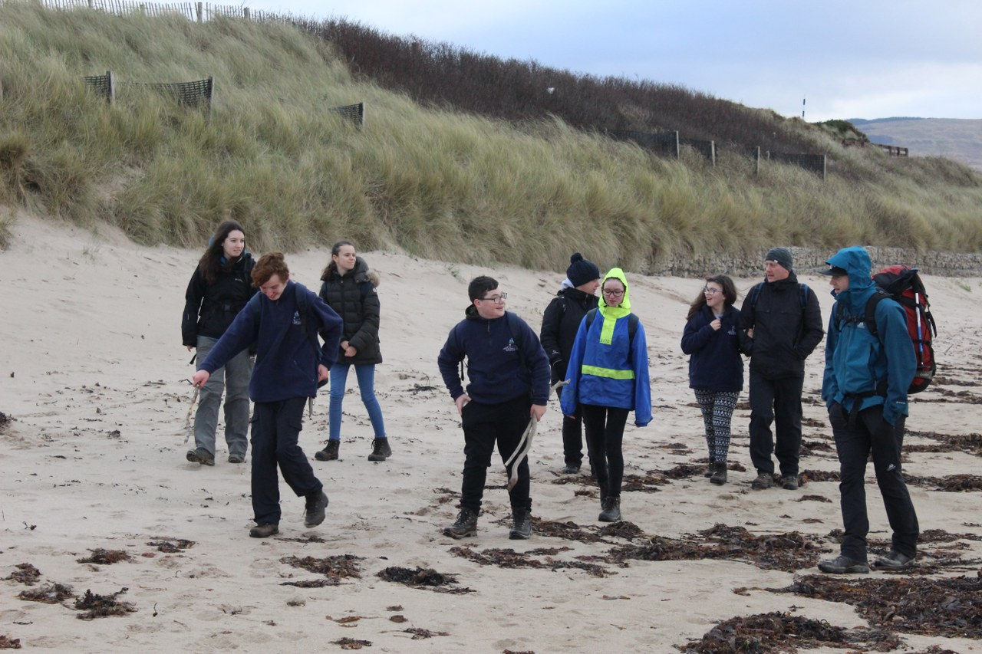

**Extra - Curricular Activities**

As a school, we strongly believe in the importance of extra-curricular activities and we offer a range of activities out with normal classroom work which help to widen the experience of all pupils. Extra - curricular activities can relieve some of the pressures of academic work and assist pupils to develop their talents and use leisure time effectively.

These activities may occur at lunchtime.

Activities which have recently been available to pupils include:

Reading Football

Hama Beads Craft

Karaoke Sports

Good News School Band

There is also a well-developed house system which encourages healthy competition between the houses, and which helps to foster good relationships between pupils and staff.

Many pupils participate in the Duke of Edinburgh Award Scheme, John Muir Award, Caritas and Youth Achievement Awards,

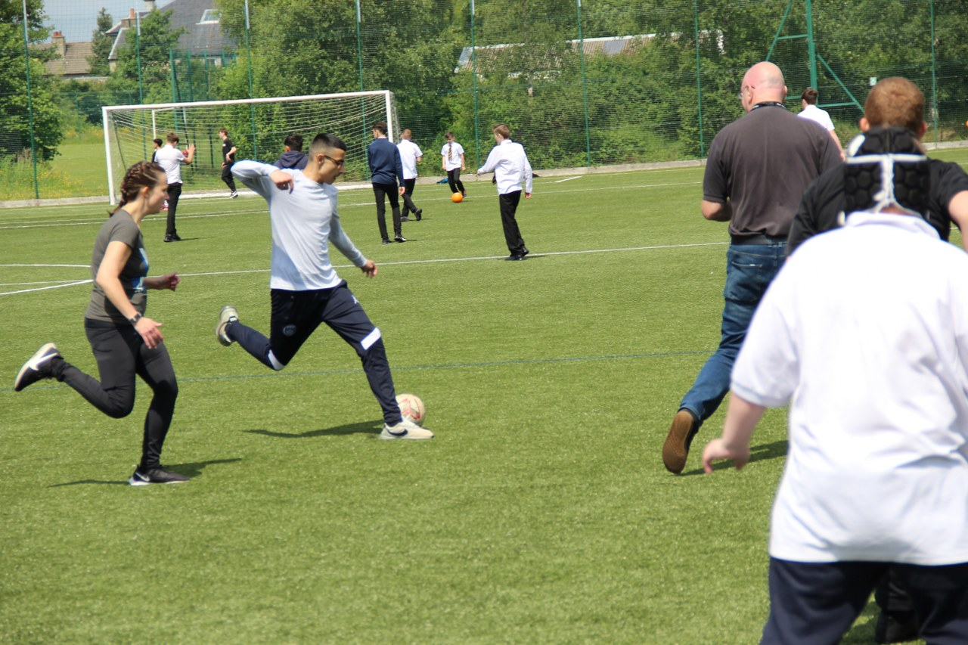

**FAIR Programme**

There is now a growing recognition of individual differences in children’s responses to stress and adversity, and emerging research findings have had the effect of shifting the emphasis toward studying of children's coping strategies and identifying protective factors both within the child and in the interplay between the child and the environment. Resilience can be defined as normal development in spite of serious adversity.

The FAIR seeks to incorporate this emphasis through aiding the process of identifying and fostering resilience in vulnerable children and young people, particularly those who are looked after and accommodated. The FAIR will enable parents, carers, and social and education staff to identify protective factors available to the young person and to plan how best these can be mobilised in the interest of the child’s development

**GUAB**

***Give us a break!*** Is an 8-week group work programme for 10-14 year olds which was developed by South Lanarkshire Council Psychological Services in collaboration with Macmillan Cancer Support and NHS Lanarkshire. We had wonderful advice throughout the development of the programme from teachers, young people, parents and carers and those who work to support young people through the challenging times of bereavement and loss. We are indebted to a wide range of colleagues.

The programme gives young people a chance to make sense of these experiences in a supportive environment with others who have gone through similar changes and also helps to build a deeper understanding in adults about just what young people go through following on from bereavement and loss.

**Support for All (Additional Support Needs)**

South Lanarkshire Education Resources have published a series of leaflets which cover information for parents and carers about Additional Support for Learning Acts.

In keeping with duties set out in the Education (Additional Support for Learning) (Scotland) Act 2004 (as amended) the guidance states that hand books should specifically mention Enquire, the Scottish advice for additional support for learning.

Enquire is funded by the Scottish Government to provide information on the framework for supporting children who require additional support for learning and to encourage positive partnerships between families, schools and local authorities to ensure children get the right support.

Enquire – the Scottish advice service for additional support for learning

Enquire offers independent, confidential advice and information on additional support for learning through **Telephone Helpline: 0845 123 2303**

**Address: Enquire**

**Children in Scotland**

**Rosebery House**

**9 Haymarket Terrace**

**Edinburgh**

**EH12 5EZ**

**Email Enquiry service:** [**info@enquire.org.uk**](mailto:info@enquire.org.uk) **Advice and information is also available at** [**www.enquire.org.uk**](http://www.enquire.org.uk)Enquire provides a range of clear and easy-to-read guides and fact sheets including The parents’ guide to additional support for learning.  
**If you would like to order our leaflets, postcards or guides to share with parents and carers of pupils in your school, please contact us on** [**info@enquire.org.uk**](mailto:info@enquire.org.uk)

**Attachment Strategy for Education Resources**

**Attachment – what we do to support children and young people**

South Lanarkshire Council Education Resources is committed to improving outcomes for children and young people by creating emotionally supportive learning experiences in our nurseries and schools.

The Education Resources Attachment Strategy supports the action in the ‘Getting it Right for Every Child in South Lanarkshire’s Children Services Plan 2021-23’, following the launch of the Attachment Strategy in 2020, to provide staff training in Attachment and Trauma based practice.

***What does it set out to do?***

The aim of the strategy is to promote better experiences of attachment for South Lanarkshire’s children and young people and to ensure that all education practitioners understand the importance of attachment theory and its application and how positive relationships can make a difference to outcomes.

***How can I find out more?***

South Lanarkshire Council Education Resources have published a series of leaflets and posters for establishments which aim to share information on attachment theory and on how this can inform the ways in which we support children and young people.

These are available from schools and SLC Staff Learning Centre Sway accessible by teachers and staff.



**SECTION 11**

**School Improvement**

|  |
| --- |
| **Key Successes/Challenges and Achievements Session 2020/21**  **Key Successes / Achievements**   * Setting up a digital platform in a short timeframe that could be accessed and used by staff and pupils to ensure quality of learning and teaching took place during the period of remote learning * Settling in new S1 pupils who had a very limited transition and identifying and planning positive post school destinations for leavers * Senior pupils achieving SQA units and courses at Nat1-Nat 5 * Keeping staff and pupils safe in school during pandemic   **Key Challenges**   * Engaging some learners with home learning and delivering home learning for practical classes * Restriction of activities / experiences for pupils (college, residential, educational visits, PE outside, Drama, Music) * Managing staff and pupil health and wellbeing during pandemic |
| **Remote Learning Jan-March 2021**  Google classrooms was set up for remote learning and all staff posted learning activities on a daily basis for their classes. Most pupils were able to engage in google classroom. Chrome books were provided for some pupils. All staff were supported with google classroom by a variety of CLPL activities including sharing of good practice sessions. Parents were supported through remote learning policy and helpline. Levels of pupil engagement were monitored weekly. Pupils were able to access a variety of Google classroom documents, slideshows, videos (both commercial and pre-recorded by staff) and live sessions. Parents were contacted if pupils were not engaging in home learning packs were provided for those pupils. Pupil progress was tracked termly through tracking and monitoring system. Weekly welfare calls were made to parents of vulnerable pupils. Staff and JAT meetings took place through Microsoft teams and pupil review meetings including post school transition meetings took place via google meets.  Some pupils attended school during this period. Challenges included keeping pupils safe, teaching mixed groups with learners accessing different lessons. Opportunities included getting to know pupils in smaller groups and working with different pupils with a greater emphasis on Health and Well-being. Staff reported a greater confidence in using ICT in classroom.  Next steps are to extend the use of google classroom and to make more use of on-line learning in school and for homework. Health and wellbeing of staff and pupils is also a priority.  **The Standards and Quality Report is available on the school website.** |
|  |

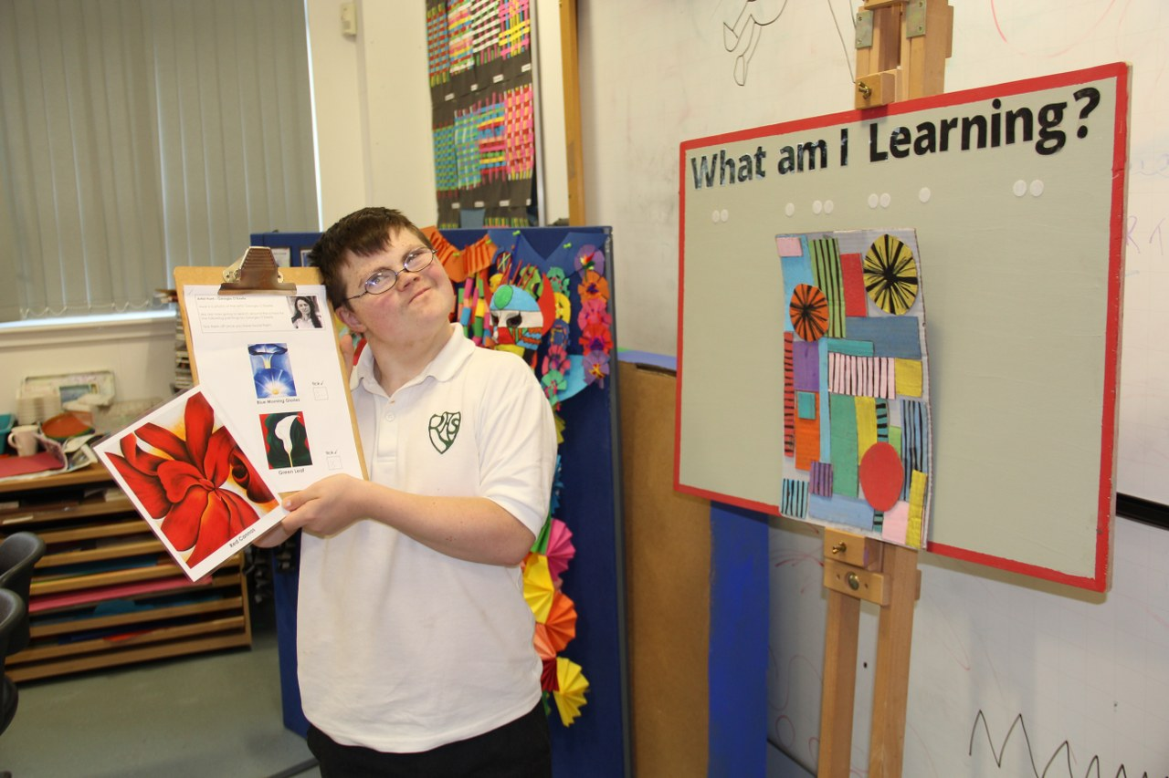



**SECTION 12**

**School Policies and Practical Information**

**School Policies and Practical Information**

**School Meals**

Healthy eating is something that the school supports and a range of meals are available at lunchtime that meet the Nutritional Requirements for Food and Drink in Schools (Scotland) Regulations 2020.

The secondary school menu includes a range of options available from breakfast, mid-morning and lunchtime.

* A meal deal for £1.95 consisting of a choice of main meal served with two portions of vegetables/salad and seasonal fresh fruit selection
* A selection of Grab ‘n’ Go snacks that are individually priced including panini, pizzini and freshly prepared baguettes and sandwiches with selection of fillings
* “Beat the Queue” use our new Pre-order Fusion Mobile App where mid-morning snacks and lunches can be ordered via mobile phone and pick it up during mid-morning and lunch break avoiding the queues

Fresh drinking water is also available with all meals

**Special diets**

If your child within Nursery, Primary or Secondary requires a special diet for medical reasons please speak to the school/nursery office who will provide the request form for you to complete

**Free School Meals**

Children of parents who receive the following benefits are entitled to a free lunchtime meal for their child

* Income Support, Universal Credit (where your take home pay is less than £610 per month), Job Seeker’s Allowance (income based), Employment and Support Allowance (income related), Working Tax Credit and Child Tax Credit (where your gross annual income does not exceed £7,330 as assessed by the HM Revenues and Customs), Child Tax Credit Only (where your gross annual income does not exceed £16,105 as assessed by the HM Revenues and Customs) or receive support under Part VI of the Immigration and Asylum Act 1999. ( Please check current criteria with SLC website – there is auto enrolment)

**If you are in receipt of Housing Benefit and/or Council Tax Reduction from us there is no need for you to apply online, we will use the information we hold to automatically award free school meals (P4 to S6) and/or school clothing grants (P1 to S6) to eligible families.**

We would encourage parents of pupils who are in receipt of any of the above benefits to take up the opportunity of having a meal provided for their child when they are at school. All secondary schools operate a cashless school meals system which protects the anonymity of pupils entitled to a free school meal.

We also encourage all pupils to remain in school at lunch times.

**Currently all pupils at Rutherglen High School receive a free school meal irrespective of income.**

**Education Maintenance Allowance**

EMA is available to young people between 16 and 19 years of age and is awarded depending on your household’s gross taxable income and the number of other dependent children living with you.

The online application form and information is available from South Lanarkshire Council website [www.southlanarkshire.gov.uk](http://www.southlanarkshire.gov.uk/)

If the online form is not an option, please contact your school office for assistance.

**School uniform**

We ask all parents/carers to support the school by encouraging your child (ren) to adhere to the agreed dress code and the wearing of our school uniform. The wearing of a school uniform helps promote the identity of the school in the local community and helps create an ethos of sharing and pride in the school.

In addition, the wearing of a uniform helps towards increasing the protection of all pupils. The wearing of a uniform helps staff and the pupils to distinguish between who belongs to the school and those who may be visitors. This enables staff to approach and identify visitors more readily and helps in trying to offer a safer environment for pupils and teachers alike.

Equality of opportunity is an important aspect of the life of the school. Any proposals on the dress code and on what constitutes the school uniform will be the subject of discussion with the Parent Council and where appropriate consultation with parents, pupils and staff.

There are forms of dress which are unacceptable in all schools such as:

* the wearing of football colours
* clothing with slogans that may cause offence (anti-religious, symbolism or political slogans)

1. clothing which advertises alcohol, tobacco or drugs
2. clothing which can be deemed unsuitable in terms of health and safety grounds such as shell suits, combat style clothing, dangling earrings, loose fitting clothes particularly in practical classes
3. articles of clothing that could be deemed to inflict damage on other pupils or be used by others to do so
4. footwear that may be deemed to damage flooring.

**The uniform for all Rutherglen High pupils is:**

* White shirt with school tie
* White school polo shirt
* School sweatshirt
* Black jumper / cardigan
* Black trousers / skirt

**Order forms are available from the school office.**

**Allergies**

A significant number of children and young people in our schools will have allergies and it is important that parents keep the school fully informed on these matters.

Allergies can present in a variety of ways and can occur at any point in a person’s life. Symptoms range from mild to severe. Children and young people known to have an allergy with moderate to severe symptoms will likely have a Health Care Plan drawn up by the NHS. This will detail symptoms and appropriate interventions.

It is vital that parents share this information with the school and continue to provide any updated information.

Where symptoms are mild and a Health Care Plan is not in place, parents should still continue to liaise regularly with the school on any new triggers, medications and actions required.

In all cases, our employees need to know your child’s symptoms, treatments and any actions required to help prevent exposure to the allergen and minimise the risk of allergic reactions.

Employees in schools will receive training on allergies and will liaise with parents and NHS on any additional specialist training required.

In supporting children and young people with allergies, school employees will operate in accordance with South Lanarkshire Council’s Safe Systems of Work / risk assessment and national guidance on the administration of medicines.

**Support for parent/carers**

**Clothing Grants**

In certain circumstances the Council provides support to parents/carers for the purchase of school wear.

Applications can be made online at [www.southlanarkshire.gov.uk](http://www.southlanarkshire.gov.uk). If you are required to submit evidence of your Tax Credit income it is important that a copy of this evidence is attached to your online application. Should you require further information or you are unable to submit an application online then please contact the helpline number **0303 123 1011** (option 5).

**Mobile Phone Policy**

We are committed to providing a caring, friendly and safe environment for all our students and believe that modern technology in the form of mobile phones, when used appropriately offers young people /carer’s peace of mind, particularly when travelling to and from school. We are also clear that when phones are used inappropriately, they distract from our core business of learning, and at the worst can be used as a tool for bullying.

* Pupils are allowed to bring mobile phones into school.
* If mobile phones are brought to school it is entirely at the owner’s risk. The school accepts no responsibility for replacing lost, stolen or damaged mobile phones / electronic devices.
* Parents are advised that in cases of emergency the school office is the point of contact to ensure that information is communicated quickly and in an appropriate way.

**School Hours**

|  |  |  |  |  |  |  |  |  |  |  |
| --- | --- | --- | --- | --- | --- | --- | --- | --- | --- | --- |
| Day/  Time | 8.50-  9.00 | 9.00-9.50 | 9.00 – 10.40 | 10.40-10.55 | 10.55-  11.45 | 11.45-  12.35 | 12.35-  1.15 | 1.15-  2.05 | 2.05-  2.55 | 2.55-  3.45 |
| Monday | Reg | Period 1 | Period 2 | Interval | Period 3 | Period 4 | Lunch | Period 5 | Period 6 | Period 7 |
| Tuesday | Reg | Period 1 | Period 2 | Interval | Period 3 | Period 4 | Lunch | Period 5 | Period 6 | Period 7 |
| Wednesday | Reg | Period 1 | Period2 | Interval | Period 3 | Period 4 | Lunch | Period 5 | Period 6 |  |
| Thursday | Reg | Period 1 | Period 2 | Interval | Period 3 | Period 4 | Lunch | Period 5 | Period 6 |  |
| Friday | Reg | Period 1 | Period 2 | Interval | Period 3 | Period 4 | Lunch | Period 5 | Period 6 |  |

**School Holidays**

**School holiday Dates Session 2023/24**

| **Types of holiday listed by month** | **Holiday dates** |
| --- | --- |
| In-service days - all schools | Monday 14 and Tuesday 15 August 2023 |
| Teachers return on Monday 14 August 2023 | All pupils return on Monday 16 August 2023 |
| September weekend | Friday 22 and Monday 25 September 2023 |
| October break | Monday 16 to Friday 20 October 2023  Pupils return on Monday 23 October 2023 |
| In-service day - all schools | Monday 13 November 2023 |
| Christmas/New Year | Schools close at 2.30pm on Friday 22 December 2023  Schools re-open on Monday 8 January 2024 |
| February break | Monday 12 and Tuesday 13 February 2024 |
| In-service day - all schools | Wednesday 14 February 2024 |
| Spring break/Easter | Schools close at 2.30pm on Thursday 28 March 2024 Schools re-open on Monday 15 April 2024 |
| In-service day - all schools | Thursday 2 May 2024 |
| May Day | Monday 6 May 2024 |
| Local holiday | Friday 24 and Monday 27 May 2024 |
| Summer break | Schools close at 1pm on Wednesday 26 June 2024 |

**School holiday Dates Session 2024/25**

| **Types of holiday listed by month** | **Holiday dates** |
| --- | --- |
| In-service days - all schools | Monday 12 and Tuesday 13 August 2024 |
| Teachers return on Monday 14 August 2023 | All pupils return on Wednesday 14 August 2024 |
| September weekend | Friday 27 and Monday 30 September 2024 |
| October break | Monday 14 to Friday 18 October 2024  Pupils return on Monday 21 October 2024 |
| In-service day - all schools | Monday 11 November 2024 |
| Christmas/New Year | Schools close at 2.30pm on Friday 20 December 2024  Schools re-open on Monday 6 January 2025 |
| February break | Monday 17 and Tuesday 18 February 2025 |
| In-service day - all schools | Wednesday 19 February 2025 |
| Spring break/Easter | Schools close at 2.30pm on Friday 4 April 2025*  Schools re-open on Tuesday 22 April 2025 |
| In-service day - all schools | Thursday 1 May 2025 |
| May Day | Monday 5 May 2025 |
| Local holiday | Friday 23 and Monday 26 May 2025 |
| Summer break | Schools close at 1pm on Wednesday 25 June 2025 |

**Transport**

**School transport**

South Lanarkshire Council has a policy of providing school transport to Secondary pupils who live more than **one** mile by **the** recognised shortest safest walking route from their catchment school. This policy is more generous than the law requires. This means that the provision of transport could be reviewed at any time. Parents who consider they are eligible should complete a form online [www.southlanarkshire.gov.uk](http://www.southlanarkshire.gov.uk/) or contact 0303 123 1023. These forms should be completed before the end of March for those pupils starting the school in August to enable the appropriate arrangements to be made. Applications may be submitted at any time throughout the year and will be considered by Education Resources.

A paid privilege transport scheme is operated for mainstream school contracts where a pupil is not entitled to free school transport. Privilege transport will only be granted providing there is spare capacity on an existing school contract and will be from and to designated pick up and drop off points. Privilege transport will not be provided where a service bus is used on the school run. Any spare capacity will be allocated using agreed priorities. More information on school transport is available on phone **0303 123 1023** or

[www.southlanarkshire.gov.uk/info/200188/secondary_school_information/545/school_transport](http://www.southlanarkshire.gov.uk/info/200188/secondary_school_information/545/school_transport)

**Pick-up points**

Where school transport is provided it may be necessary for pupils to walk a certain distance to the vehicle pick-up point. Walking distance in total, including the distance from home to the pick-up point and from the drop-off point to the school in any one direction, will not exceed the authority’s distance limit for school transport.

It should be noted that it is the parent’s responsibility to ensure their child behaves in a safe and acceptable manner while travelling in and alighting from the vehicle. Misbehaviour can result in your child losing the right to school transport.

Parents are asked to note that South Lanarkshire Council does not provide transport for those pupils who attend school via a placing request.

**Insurance for schools – pupils’ personal effects**

South Lanarkshire Council is concerned at the level of claims being received for loss or damage to pupils’ clothing or personal effects. Parents are asked to note the Council’s position in terms of insurance for pupils’ personal effects:

**(i) Theft/loss of personal effects**

The Council is not liable for the loss or theft of pupils’ clothing or personal effects for example mobile phones, tablets etc. and any items are therefore brought into the school at the pupil/parents’ own risk.

Parents can assist by ensuring that valuable items and unnecessarily expensive items of clothing are not brought to school.

Teachers and other staff have been advised not to accept custody of any such items.

The same principle applies to musical instruments and other equipment used for activities within the school, which belong to the pupil, but are brought into the school. Parents should be aware that if such equipment is left in school, it is done at the pupil/parents’ own risk.

In the case of valuable items such as musical instruments, parents should ensure that these items are covered by their own household insurance.

**(ii) Damage to clothing**

The Council is only liable for damage caused to pupils’ clothing where the damage has resulted from the negligence of the Council or one of its employees. Claims arising otherwise will not be accepted by the Council’s insurers.

**Promoting positive behaviour**

It is the responsibility of staff within the school to ensure that parent council members, parents and pupils are involved in the creation of a positive school ethos that encourages good behaviour. Equally, the school whilst trying to promote positive behaviour must support young people should incidents or bullying occur. Parents have a significant role to play in working with the school so that teachers, parents and pupils know what is expected of them in trying to change the behaviour and attitudes that contribute to bullying behaviour.

Our approach is to create an environment where better behaviour will encourage better learning. The school, along with the support of parents, can work together to create a learning environment which young people can enjoy and feel safe.

Incidents of bullying should be reported to the school immediately so that each alleged incident can be looked at. Together we can work towards creating a safer school for children and staff.

In addition, a guideline (Promoting Positive Relationships and Behaviour) has been produced to support all teaching and support staff and inform them of their roles and responsibilities in respect of dealing with the small number of children and young people who display challenging behaviour. Early identification is crucial so that intervention can be provided to support children and young people to help them address their issues and concerns. Staff training is provided to help develop the skills needed to respond to and manage challenging behaviour. A wide range of appropriate staff development opportunities has been developed for this purpose.

**Child Protection**

All staff in educational establishments in South Lanarkshire Council receive an annual Child Protection update and are required to follow the advice and guidance contained within relevant Education Operating Procedures. They must also complete a mandatory Learn on Line Course “Child Protection in Education”.

South Lanarkshire’s children’s services partnership works together to support children, young people and their families so that children grow up in communities where they are safe, healthy, active, achieving, respected, responsible and included, and have the opportunity to achieve their full potential. They are committed to continuously improve our services to ensure children, young people and their families get the right support at the right time.

Sometimes children and young people need additional help to make sure that they are *“cared for and protected from abuse and harm in a safe environment in which their rights are respected” (*CPC South Lanarkshire Child Protection shared vision). The Child Protection Committee has the overarching responsibility to ensure that agencies individually and collectively work to protect children and young people as effectively as possible.

All staff have a responsibility to report any suspicions that a child has been abused or is at risk of harm, abuse, or neglect. Robust procedures and guidance are in place to support education staff to: -

* be alert to signs that a child may be experiencing risks to their wellbeing,
* report concerns to the head of establishment or the child protection coordinator without delay.
* be actively engaged in support and protection and development of wellbeing.

If you would like more information, or if you have a concern of a child protection nature, please contact the head of the educational establishment which your child attends.

The Child Protection Committee’s website has a range of useful information for parents/carers on how to help them keep their children safe. [www.childprotectionsouthlanarkshire.org.uk](http://www.childprotectionsouthlanarkshire.org.uk)

**Information on emergencies**

We make every effort to ensure the school remains open during term-time for pupils. However, on occasions circumstances may arise which can affect the school. Schools may be affected by, for example, severe weather, power failures or through any other circumstances that may impact on the school day. In such cases we shall do all we can to let you know if this happens. We shall keep you in touch by telephone, text, where appropriate, letters, web news and through local radio stations particularly if there are prolonged periods of severe weather. The Council’s website [www.southlanarkshire.gov.uk](http://www.southlanarkshire.gov.uk/) will be used to let you know if the school is closed and when it will re-open.

It is important for parents/carers to let the school know of any change to your mobile/home telephone number and change of address.

If for any reason, you are unsure if the school is open visit the website [www.southlanarkshire.gov.uk](http://www.southlanarkshire.gov.uk/) or email us at: [education@southlanarkshire.gov.uk](mailto:education@southlanarkshire.gov.uk)

**Your commitments**

We ask that you:

* support and encourage your child’s learning
* respect and adhere to the schools policies and guidance
* let the school know if you change your mobile/telephone number and/or address
* enjoy and take part in school activities
* accept your responsibility to respect staff who work in the school and for the school to be proactive in taking forward its commitment to care for and educate your child.

**General Data Protection Regulation (GDPR)**

General Data Protection Regulation as supplemented by the Data Protection Act 2018 (GDPR)

Information on pupils, parents and guardians is held by the school to enable the teaching, registration and assessment of pupils as well as associated administrative duties. The information is stored and used as per the requirements of the GDPR, with South Lanarkshire Council defined as the data controller. The Council have established a data protection policy that applies to all of its school.

Education Resources has also prepared a privacy notice (below) which sets out how we will deal with personal information as part of our statutory function as an education authority. For more information please contact the school.

Privacy Notice

Introduction

In line with the General Data Protection Regulation (GDPR) we have produced this privacy notice to inform you how we deal with personal information as part of our statutory function as an education authority.

The Council has a legal obligation to deliver effective education services to children, young people and adult learners in South Lanarkshire. In order to do this we need to collect personal information about children, young people and their families so that we can help them to learn and keep them safe.

Using your personal information

The Council is a “controller” of the personal information you provide when enrolling for a nursery or school, applying for an education service or participating in groups or activities provided by Education Resources.

Information we collect from you about you and your child at enrolment

When you enrol for a nursery or school, we ask for the following information:

• parent/carer contact details (name, address, phone, email);

• the child’s name, date of birth, gender and address;

• information about medical conditions, additional support needs, religion and ethnicity;

• any information you may wish to provide about family circumstances.

Information we collect at other times

We will also collect information at other times such as when you apply for a benefit, request a services or other support. We will provide an additional privacy notice at these times.

• If you apply for an education service or benefit, such as school transport, free school meals, clothing grant, placing request or EMA, we will also ask for personal information as set out above. We will also ask for information about your income for education benefits applications.

• If you make a request for additional support such as an educational psychologist or other support for learning we will ask for more detailed information to allow us to provide the most appropriate support for your family. This may include information about family circumstances or medical conditions.

• If there are concerns about your child’s wellbeing and/or your child has needs that may require additional support, we will wish to work with you to collect and consider information to enable us to help you get the right support at the right time in line with the Getting it right for every child approach.

We require this information to ensure that children and young people are educated appropriately, supported, and that we take account of their health and wellbeing. We will also ask you to update this information annually and to tell us when there are changes to your details.

Information that we collect from other sources

As an education authority and as part of our statutory function in accordance with our legal obligations, we receive information from other sources such as the SQA, the NHS or Social Work about you or your child, this includes:

• exam results and assessment information;

• information about health, wellbeing or child protection.

Why do we need this information?

We need this information so the Council can ensure it is delivering education services appropriately to all learners:

• for the education of children, young people and adult learners;

• for teaching, enrolment and assessment purposes and to monitor the educational progress of children, young people and adult learners ;

• to keep children and young people safe and provide guidance services in school;

• to identify where additional support is needed to help children, young people and adult learners with their learning;

• to maintain records of attendance, absence and behaviour of children and young people (including exclusions);

• to support children and young people moving on each year from nursery to primary, primary to secondary and when they move or leave school;

• to help us develop and improve education services provided for young people, adult learners or families

• In accordance with our legitimate interests as an education authority we will also use your information to create statistical reports.

We will share your information with:

As an education authority and as part of our statutory function in accordance with our legal obligations we will share information with other bodies or parts of the Council, including:

• The Scottish Government and bodies such as Education Scotland, Scottish Qualifications Authority, Skills Development Scotland and other organisations that support children and young people’s learning;

• Other parts of the Council when required for services such as school meals, school transport, education benefits and with Social work in connection with any child protection concerns we become aware of;

• The NHS, to support health initiatives in accordance with the legal obligation on the Council in terms of section 39(3) of the National Health Service (Scotland Act 1978;

• South Lanarkshire Leisure and Culture Limited, where children and young people are participating in sports and leisure activities;

• Other schools/local authorities – if a child moves or transfers to another school the Council has an obligation to pass on information with regards to pupil records to the new school/local authority.

You have the right to access your personal information as well as the rights of rectification, erasure, restriction and the right to object. For information on these rights and how to exercise them or for information about how we manage your personal information, you can get a copy of our full privacy notice from our website: (https://www.southlanarkshire.gov.uk/info/200235/meta/1730/general_privacy).

Our full privacy notice will also provide information on how to make a complaint or to request a paper copy of the privacy notice from the Data Protection Officer.

**Appendix A**

**Contact Details**

Education Scotland’s Communication Toolkit for engaging with parents

The Scottish Government guide Principles of Inclusive Communications provides information on communications and a self-assessment tool for public authorities

Choosing a School: A Guide for Parents - information on choosing a school and the placing request system

A guide for parents about school attendance explains parental responsibilities with regard to children’s attendance at school

**Parental Involvement**

Guidance on the Scottish Schools (Parental Involvement) Act 2006 provides guidance on the act for education authorities, Parent Councils and others

Parentzone provide information and resource for parents and Parent Councils

National Parent Forum for Scotland; [www.npfs.org.uk](http://www.npfs.org.uk)

**School Ethos**

Supporting Learners - guidance on the identification, planning and provision of support

Journey to Excellence - provides guidance and advice about culture and ethos

Health and wellbeing guidance on healthy living for local authorities and schools

Building Curriculum for Excellence Through Positive Behaviour and Relationships outlines the Scottish Government’s priority actions around positive behaviour in schools and is also a source of support

Scottish Catholic Education Service’s resource ‘This is Our Faith’ which supports the teaching and learning of Catholic religious education

**Curriculum**

Information about how the curriculum is structured and curriculum planning

Information about the outcomes a learner can expect to experience and achieve across literacy, numeracy and health and wellbeing, as well as the 8 curricular areas

Advice, practice and resources to support the experiences and outcomes on literary, numeracy and health and wellbeing

Broad General Education in the Secondary School – A Guide for Parents and Carers

Information on the Senior Phase

Information on Skills for learning, life and work

Information around the Scottish Government’s ‘Opportunities for All’ programme

Information for organisations responsible for the planning, management and delivery of career information, advice and guidance services

The Skills Development Scotland website ‘My World of Work’ offers a number of tools to support career planning

**Assessment and Reporting**

Building the Curriculum 5: a framework for assessment provides guidance around the assessment framework

Information about Curriculum for Excellence levels and how progress is assessed

Curriculum for Excellence factfile - Assessment and qualifications

Information on recognising achievement, reporting and profiling

The Scottish National Standardised Assessment- in Scotland, pupils in P1, P4, P7 and S3 complete online standardised assessments in literacy and numeracy as part of their everyday learning and teaching.

**Transitions**

Curriculum for Excellence factfile - 3-18 Transitions - provides information on the transitions children and young people will face throughout their education and beyond

Career Information, Advice and Guidance in Scotland - A Framework for Service Redesign and Improvement provides guidance on career information, advice and guidance strategy

Choices and changes provides information about choices made at various stages of learning

The Additional support for learning page provides links to relevant legislation and guidance, including the arrangements that should be in place to support pupils with additional support needs

Supporting Children's Learning Code of Practice includes specific requirements on education authorities and others under the new legislation in relation to transition

Enquire is the Scottish advice service for additional support for learning

Parenting Across Scotland offers support to children and families in Scotland

**Support for Pupils**

The Additional support for learning page provides links to relevant legislation and guidance, including the arrangements that should be in place to support pupils with additional support needs

Information about the universal entitlement to support that underpins Curriculum for Excellence

Supporting Children's Learning Code of Practice (Revised edition) - provides Statutory guidance relating to the Education (Additional Support for Learning) (Scotland) Act 2004 as amended

Getting It Right For Every Child and Young Person, is essential reading for anyone involved or working with children and young people, including practitioners working in adult services with parents and carers

**School Improvement**

Scottish Schools Online - provides a range of school information, including contact details, school roll, facilities, website, inspection reports

Education Scotland’s Inspection and review page provides information on the inspection process

Scottish Credit and Qualifications Framework (SCQF)

Scottish Qualifications Authority provides information for teachers, parents, employers and young people on qualifications

Amazing Things - information about youth awards in Scotland

Information on how to access statistics relating to School Education

**School Policies and Practical Information**

**Schools and local authorities should consider the most relevant school, local and national policies and include details or links for parents to sources of further information.**

National policies, information and guidance can be accessed from the Scottish Government website on [www.gov.scot](http://www.gov.scot)