Rutherglen High School – Litter and Waste 2023-2024
At Rutherglen High School we foster a clean and safe environment which we believe is crucial for the well-being and development of our pupils. Pupils are encouraged to get involved with litter picking activities to instil a sense of responsibility and environmental consciousness. In doing so, pupils find they each have a role to play in maintaining cleanliness and taking care of their surroundings. By understanding the consequences of littering, pupils develop empathy towards the environment and the impact it has on others.

The litter picking analysis from August-December 23 can be found below. It can clearly be seen that all categories reduced over time.

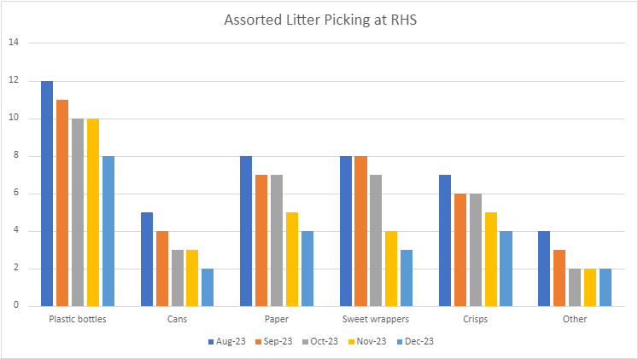
Feedback from pupils was that by actively participating in litter picking they developed a sense of pride in their accomplishments. They enjoyed seeing the positive impact of their efforts, such as a cleaner and tidier
environment, boosts their self-esteem and confidence. This sense of pride motivated them to continue engaging in responsible behaviours and taking care of their school environment.

Photographs of pupils participating in litter picking activities can be found below.
