
Education Resources

RUTHERGLEN HIGH SCHOOL

SCHOOL HANDBOOK
2024/25



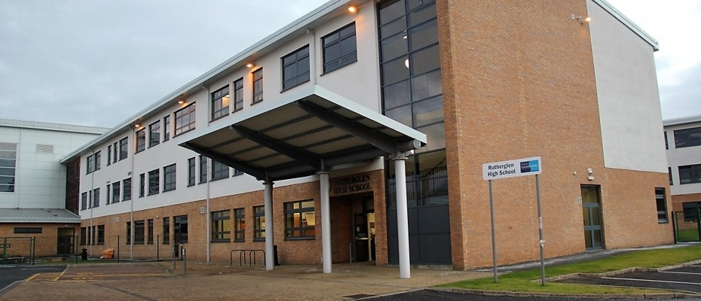
If you need the School Handbook in another language or format, please contact the School to discuss how we can best meet your needs.

Telephone 0303 123 1023
Email education@southlanarkshire.gov.uk
Section 1 – Introduction 2
Vision, Values and Aims 3
National Priorities - Key priorities of the National Improvement Framework 4
Section 2 - About Our School 4
School Admission Arrangements 6
Transitions into School 6
The Staff of Rutherglen High School 7
Concerns and Complaints 12
Extended Support Team 13
Section 3 - Parental involvement 13
Parent Council 14
Parent Zone Scotland 16
Home School Link 16
Section 4 – School Ethos 17
Rights Respecting Schools 18
Promoting Positive Behaviour 18
Equal Opportunities and Social Justice 19
Recognising Achievement 20
Eco Schools 21
Spiritual, Social, Moral & Cultural Values 22
Makaton 24
Rights of Parents/Carers 25
School/Community Links 26
Section 5 – Attendance 27
Emergency Information 28
Severe Weather Protocol 28
Communication 28
Parental Responsibilities 29
Family Holidays During Term Time 29
Encouraging School Attendance 29
Section 6 - The Curriculum 29
Aims 31
Purpose of the Curriculum 3-18 31
Principles for Curriculum Design 32
Curriculum Strategy – Base Classes 33
Milestones For Complex Learners 34
Senior Phase - National Qualifications 35
Options 36
Severe and Profound Needs 37
Developing the Young Workforce 38
Work Experience 40
College 42
Glasgow the Caring City – Skills Barn 43
Experiential Play 44
Edible Curriculum 48
Animal Assisted Therapy – Gus 50
Section 7 - Assessment 52
Section 8 – Reporting 54
Section 9 - Transitions 56
Section 10 - Support for Pupils 56
Getting it Right for Every Child 56
Nurture 57
Lunchtime Activities 57
Support for All (Additional Support Needs) 58
Additional Support for Learning and Additional Support Needs 58
Attachment – what we do to support children and young people 59
Section 11 - School Improvement 60
The School 61
Pupil Equity Fund (PEF) 64
Section 12 - School Policies and Practical Information 65
School Meals 66
Special diets 66
Free School Meals 66
Education Maintenance Allowance 66
Clothing grant 67
School Uniform 67
Allergies 68
Mobile Phone Policy 68
School Hours 68
School holiday Dates Session 2024/25 69
Transport 70
Pick-up points 71
Insurance for Pupils’ Personal Effects 71
Child Protection 72
Information on Emergencies 73
General Data Protection Regulation as supplemented by the Data Protection Act 2018 (GDPR) 73
Privacy Notice 74
The Freedom of Information (Scotland) Act 2002 75
Appendix A 76

Section 1 – Introduction
Dear Stakeholders,

I am delighted to welcome you to Rutherglen High School. This handbook provides you with key information in relation to all aspects of the School including School procedures and personnel. I hope it also gives you a flavour of our culture and ethos.

We aim to provide a range of learning experiences, which meet the needs of all our learners. Working together in partnership: school staff, parents and our partner agencies can help us achieve this goal. As a School, we value your involvement, support and partnership with us in providing your young person with the highest level of education/support.

Communication is essential and we would welcome you to contact Rutherglen High School with regards to any aspect of our learner’s education.

I look forward to working with you over the coming years to ensure that all our learners enjoy a happy and successful time at Rutherglen High School.

Richard Millar
Head Teacher

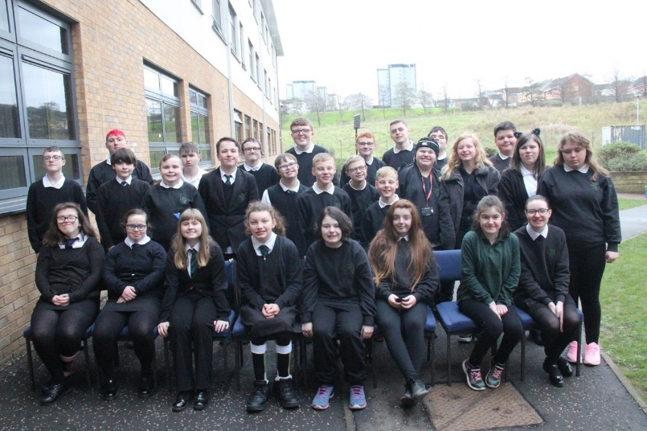

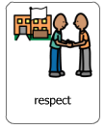

Vision, Values and Aims


Respected
Happy

Safe

Our Vision
In Rutherglen High School our vision is to provide an inclusive, safe, nurturing environment which allows our pupils to achieve their full potential and to find their rightful place in their community

Our Values
In Rutherglen High School our values are:-
- mutual respect and understanding
- kindness and trust
- empathy and tolerance
- inclusion and cooperation
- encouragement, support and valuing everyone

Our Aims
In Rutherglen High School we aim to:-
- provide a safe and nurturing environment
- provide a positive, inclusive and holistic educational experience
- encourage pupils to achieve their full potential
- work in partnership with the wider community to ensure support and access for all pupils

South Lanarkshire Council is the fifth largest authority in Scotland. It covers the following main areas; Clydesdale in the south which features extensive rural areas, Cambuslang, Rutherglen, Blantyre and Uddingston to the north as well as the towns of East Kilbride and Hamilton.

The Council’s Plan Connect sets out the Council’s vision which is, “to improve the quality of life for all within South Lanarkshire”.

For Education Resources this means delivering services of the highest quality as well as striving to narrow the gap. It is about continually improving the services for everyone at the same time as giving priority to children, young people, families and communities in most need. The priorities for Schools and services are set out in the Education Resources Plan which confirms the commitment to provide better learning opportunities and outcomes for children and young people.

National Priorities - Key priorities of the National Improvement Framework
Placing the human rights and needs of every child and young person at the centre of education. Improvement in children and young people's health and wellbeing. Closing the attainment gap between the most and least disadvantaged children and young people. Improvement in skills and sustained, positive school-leaver destinations for all young people. Improvement in attainment, particularly in literacy and numeracy.

Section 2 - About Our School
Rutherglen High School opened in August 1999 and is a non-denominational and co-educational school. The School is part of the Cathkin Learning Community and has formed strong links within the local community.

The School provides education for over 113 pupils and is currently located in Langlea Road in Cambuslang. All pupils attending Rutherglen High School have a range of Additional Support Needs and have an Additional Support Plan or Co-ordinated Support Plan to assist the School in planning a curriculum which supports pupils in achieving their potential. Support for pupils is provided in the form of smaller class sizes (maximum 10) with allocated support staff to provide continuity and security.

Pupils are supervised at morning interval and lunch time and are provided with assistance with personal care, eating and drinking if required.

Rutherglen High School has strong links with Glasgow Clyde College (Langside and Cardonald Campus), New College Lanarkshire (Motherwell Campus) and Glasgow Kelvin College (Easterhouse and Haghill Campus). Through our Work Experience programme strong partnerships have been established with local employers.

Rutherglen High School is a Rights Respecting School, a Health Promoting School and an Eco School. Fund raising for charity and the promotion of Fairtrade are an integral part of the School ethos.

Official Address
Rutherglen High School
Langlea Road
Cambuslang
G72 8ES

Telephone 0141 643 3480
Email office@rutherglen.s-lanark.sch.uk
Website www.rutherglenhighschool.co.uk/
X (previously Twitter) https://mobile.twitter.com/RutherglenHigh

Current Roll August 2024/25 – 113 pupils
S1 – 16 pupils
S2 – 21 pupils
S3 – 20 pupils
S4 – 19 pupils
S5 – 21 pupils
S6 – 16 pupils

School Admission Arrangements
Before a young person enrols in Rutherglen High School, the Education Department will seek documentary evidence to validate their entitlement to a catchment place. If appropriate evidence is not submitted, the Education Department will withdraw the offer of a place. Documentary evidence can be submitted to the Education Department via the School office.
Further detail on required documentary evidence and change of circumstances is available in the Education Department’s school admission policy which is accessible on the Council’s website via the web address below:
https://www.southlanarkshire.gov.uk/info/200187/additional_support_needs_schools_information/248/additional_support_needs_schools_and_basesdepartments
A child’s parents(s)/carer(s) is/are responsible for providing the Education Department with full and correct information about their child(ren) and any changes to that information which may affect their status as a catchment child. If parent(s)/carer(s) fail to do this, the Education Department will view this as a refusal to comply with the rules and regulations of the school; this lack of cooperation will result in the Council seeking to exclude the child(ren) from Rutherglen High School.
If information that is submitted is found to be fraudulent, the Council may pass the matter to the Procurator Fiscal’s Office. The Council will use all means available in order to investigate suspicions or allegations of fraud, including but not limited to, surveillance in cases where it is necessary and proportionate to do so.

Transitions into School
Prior to School placement, a full assessment is carried out by members of a multi-disciplinary team. Parents/Carers are involved and kept informed at all stages. The professional opinions are then collated by Psychological Services and the recommendations discussed with the parents/carers. Parents/Carers and children may visit Rutherglen High School prior to beginning their School placement. We have strong links with our feeder Primary Schools and actively work together to ensure that the transition to High School is a smooth and happy event.

We offer a full programme of transition activities to support our groups of young people become familiar with their new school environment, to build relationships with each other, and recognise staff around the School. We do this both virtually, independently, as a class and also with regular transition visits.

The Staff of Rutherglen High School

Head Teacher

Mr Richard Millar is responsible to the Executive Director of Education Resources for the overall management of school, timetable, curriculum, child protection, Look After and Accommodated Children and Pastoral care.
Curricular areas Art, Music and Drama, PE and Science
Email headteacher@rutherglen.s-lanark.sch.uk

Depute Head Teacher
Mrs Geraldine Johnston (0.8) and Mr Guto Williams (0.2) are responsible for pastoral care, SQA coordinator role and Career Long Professional Learning (CLPL).

Curriculum areas Maths, English, ICT, RME, Technical.
Email gw07johnstongeraldin@glow.sch.uk, gw07williamsguto@glow.sch.uk

Depute Head Teacher
Mr Peter Mulvey (0.2) is responsible for Cathkin High School link programme, SEEMiS and Caritas involvement.

Curricular areas Technical
Email gw21mulveypeter@glow.sch.uk

Principal Teachers
Heather Haggarty
Rebecca McFarlane (Maternity)
Caroline Perston (Acting) (0.8)
Lauren Cuthbertson (Acting) (0.4)
Guto Williams (0.8)
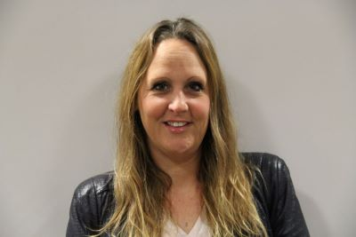

Pastoral Care
Heather Haggarty S1/2
Rebecca McFarlane/Caroline Perston/Lauren Cuthbertson S3/4
Guto Williams S5/6

Home School Link

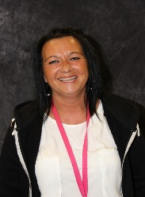
Home/School Support for Parents
Veronica McBride
Email gw12mcbrideveronica@glow.sch.uk

Pupil Attendance
Support for Parents
Parent Support Group

Teaching Staff (in Subject Department)
Art & Design
- Ms L Robertson (0.8)

Supported Classes
- Mrs C Perston (Acting Principal Teacher) (0.8)
- Ms S Cumming
- Miss L Cuthbertson (Acting Principal Teacher)
- Mrs H Haggarty (Principal Teacher)
- Mrs R McFarlane (Principal Teacher)
- Ms AM Hastie
- Mrs C Young (0.8)
- Ms R Fox (0.6)
- Mrs E McQueen
- Ms N Clements
- Mr N Swanston
- Mrs A Forrest (0.2)

Drama
- Mr B Reavey (0.8)

English
- Ms L Coyle (Literacy co-ordinator)
- Mr W McEvoy
- Mrs Robertson (0.6)

French
- Mr W McEvoy

Home Economics
- Mrs S McGowan (0.6)
- Mrs M Martin (0.2)

ICT
- Mr M Dornan

Mathematics
- Mrs Y Nandi (0.2)
- Mrs S Walker (0.6)
- Mr A Paul
- Miss L Cuthbertson (Numeracy Coordinator)

Music
- Mrs B Steel (DYW Coordinator) (0.8)

PE
- Mrs M Cresswell (DYW Coordinator)
- Mrs E Devlin (0.8)
- Mrs K Sclater (0.6)

Health & Well Being
- Mrs H Haggarty
- Mrs R McFarlane
- Mr G Williams

RME
- Ms S Cumming
- Mrs G Rosenberg

Science
- Ms L Gaughan

Social Subjects
- Mr A MacDonald (0.6)
- Mrs G Rosenberg

Spanish
- Ms AM Hastie
- Mr W McEvoy

Technical Education
- Mr A Campbell

Developing the Young Workforce
- Mrs M Cresswell (DYW Coordinator)
- Mrs S McGowan
- Mrs B Steel (DYW Coordinator)
- Mr G Smith

Outdoor Learning/Wider Achievement
- Mr Williams (Principal Teacher)

Cluster Support Services Co-ordinator
- Mrs L Seenan

Team Leaders
- Mr P Eunson
- Mrs V McBride
- Mrs M Muir
- Mrs M Naismith

Office Staff
- Ms A Cassells
- Mrs A Thorpe

Support Staff
- Mrs E Ahern
- Ms C Esler
- Ms H Matheson
- Mrs L Balfour (0.6)
- Mrs H Gemmell
- Ms S Bell (maternity)
- Mrs J Griffin (0.8)
- Mr J Paterson
- Mrs A Bennie
- Mrs M Kalsi Gray (0.6)
- Mrs F Pert
- Mrs M Brown (0.4)
- Mrs A Kirkland
- Mrs M Scott
- Mrs E Larkins (0.4)
- Mr J Templeton
- Mrs L Carroll
- Ms H Tsiolis
- Ms E J Currie (0.8)
- Mrs A Mc McLaughlin
- Mrs L Watson
- Mrs A McNulty
- Mrs K Whyte
- Mr C Mckenna
- Ms L McNeish

Instrumental Instructors
- Mr E Murray (Woodwind)
- Mrs A McKirdy (Voice)
- Mr B Payne (Percussion)

Concerns and Complaints
There are occasions when parents/carers and pupils have a concern about an aspect of the service that we provide. In the first instance parents/carers and pupils should contact the appropriate Pastoral Teacher Link to raise their concern either by telephone or email.

In most cases, the Pastoral Teacher Link will be able to investigate and respond within a few days with the majority of issues resolved in this way. For more complex or serious matters, complaints should be made in writing, again to the Pastoral Teacher Link. They will acknowledge receipt and pass it on to Depute Head/Head Teacher. Complaints will be investigated and a written response provided within 20 days, in line with South Lanarkshire Council’s, ‘Have Your Say’ policy. We would normally maintain contact within that period to provide or to seek further information.

In exceptional circumstances, where this timescale cannot be met, we would maintain contact and explain why. If we cannot resolve the complaint at School level, complaints can be escalated to the Quality Improvement Officer within the Education Resources team at South Lanarkshire Council.

Working with Parents Team
Area of Responsibility of Team
- Bullying and related issues
- Care and Welfare Issues
- Class organisation and complaints
Email parents@southlanarkshire.gov.uk

Stephanie D’ Mambro
Parent Council (Procedural and Administrative issues only)
Parental Involvement
Email theparentcouncil@glow.sch.uk

Parental enquiries and concerns relating to School transport, placing requests, property, Inclusive Education and Early Years should be directed to the appropriate Service Manager:

Aisling Boyle
Interim Head of Inclusion
Telephone 01698454455
Email aisling.boyle@southlanarkshire.gov.uk

Eleanor Brady
Inclusion Advisor (ASN Transport)
Telephone 01698 455094

Alex McLeod
Quality Improvement officer
Telephone 01698 454467
Email alex.mcleod@southlanarkshire.gov.uk

Pastoral Care is a whole school responsibility, and all staff, teaching and non-teaching have an important role to play.

We are concerned with each pupil’s personal, social and vocational welfare and are able to offer support and guidance throughout their school career. We also have close links with outside agencies: Social Work Department, Psychological Services, Allied Health Professionals and Skills Development Scotland. We are also keen to encourage close contacts between home and School and to involve parents/carers in all aspects of their child/children's school career.

Initial Contact
S1 and S2 Mrs H Haggarty
S3 and S4 Mrs R McFarlane, Mrs C Person and Miss L Cuthbertson
S5 and S6 Mr G Williams and Miss L Cuthbertson

Extended Support Team
Educational Psychologist – Mr Craig Thomson
Physiotherapist – Mrs Julie O’Donoghue, Ms Taylor Hoven, Ms Katie Clancy
Speech and Language Therapist – Mrs Phillippa Watters and Miss Amy Ritchie
Additional Needs School Nursing Team:-
- Marie Watts
- Morag Alexander
- Jacqueline Johnstone
- Seonaid Robertson
Social Worker – Ms Seonaid Robertson
Skills Development Scotland – Mrs Jennifer Latime
SDS Link – Ms Roberta MacKenzie

Inscape Therapies – Music Therapists
- Brian Smith
- Rose Galloway

Section 3 - Parental involvement
South Lanarkshire Council recognises the importance of parents/carers as partners in the education of their child and has published a strategy entitled “Making a difference – working together to support children’s learning”. This is available from the Council’s website:
https://www.southlanarkshire.gov.uk/downloads/file/13457/parents_as_partners_-_strategy_2019
Parents, carers and family members are by far the most important influences on children’s lives. Children between the ages of 5 and 16 children spend only 15% of their time in school! Research shows that when parents are involved in their child’s learning, children do better at school and throughout life. Parental involvement can take different forms, but we hope you share the same aims and agree that by working together we can be partners in supporting children’s learning. Research shows that parental involvement in learning leads to better outcomes at school and in life.
As a parents/carer we want you to be:-
- Welcomed and given an opportunity to be involved in the life of the school.
- Fully informed about your child’s learning.
- Encouraged to make an active contribution to your child’s learning.
- Able to support learning at home.
- Encouraged to express your views and involved in forums and discussions on education related issues.
To find out more on how to be a parent helper, or a member of the Parent Council, please contact the School or visit our website.
Some useful information contacts for parents to find out more on education are as follows:-
- Parentzone – www.parentzonescotland.gov.uk
- Engage Parent Forum – www.engageforeducation.org
- National Parent Forum for Scotland – www.educationscotland.gov.uk/parentzone
- South Lanarkshire Council – www.southlanarkshire.gov.uk

Parent Council
The Scottish Schools (Parental Involvement) Act 2006 aims to encourage and support more parents to become involved in supporting their children’s learning. The main aims of the Parental Involvement Act focus on the following supports for parents:-
- Learning at Home Help parents become more involved with their child’s education and learning.
- Home/School Partnership Welcome parents as active participants in the life of the School.
- Parental Representation Provide easier ways for parents to express their views and wishes.

All parents of children at School are automatically members of the Parent Forum and are entitled to have a say in what happens at the school. Parents can also decide to form a Parent Council to represent them.

Our Parent Council host monthly meetings. The School and the local authority are obliged to listen to what the Parent Council says and to respond to any issues raised.

Parent Councils decide such things as:-
- How their Parent Council will be set up.
- What it should be called (Parent Council or another name).
- What size it should be – e.g. in a very small Primary School, all parents could be involved (no limit on size).
- Who should be a member of the Parent Council (majority of members must be parents).
- How parents can join and support the School.
- How they can work together with the School and pupils to support children’s learning.
- When the most convenient time is to hold meetings.
- What will be discussed at meetings – these might be topics such as School uniform, parking near the school, the school’s anti-bullying policy.

It should be noted that the Parent Council cannot discuss issues attributed to individual pupils. More interesting is how parents can play an active part in helping the School to take forward, School development. As a School we wish to give parents/carers every opportunity to become more involved in their child’s education.

Schools and establishments should be the first point of contact for parents who wish to discuss issues about their child. Our aim is to resolve issues at a local level. Education Resources wishes to promote liaison among Schools, members of Parent Councils, parents/carers and with other services. We wish to provide advice and support to Parent Councils and parents/carers of our learners.

    - Office Bearers
Chairperson S D’Mambro
Vice Chairperson D Cathie
Treasurer L Penny
Secretary K Whyte

    - Associated Members
J Sanderson School Chaplain

Councillors
R Brown

Staff Members
R Millar
L Cuthbertson

Parent Zone Scotland
A unique website for parents and carers in Scotland, offering information from early years to beyond school.

https://education.gov.scot/parentzone

Provides up-to-date information about learning in Scotland and practical advice to support children’s learning at home and offers more detailed information on additional support needs. Also explains how parents can get involved in their child’s school and education and includes details about schools, performance data for school leavers from S4-S6 whilst link to national, local authority, and school-level data on the achievement of Curriculum for Excellence levels.

Home School Link
Rutherglen High School places a great value on the links which have been established between the School and parents. Formal consultation evenings are held twice a year (November and May).

In addition, all pupils will have a yearly review meeting:

S1 October/June
S2 April/May
S3 February
S4 March
S5/6 November/December

At all other times, parents who wish to consult a member of staff should arrange an appointment through the School office (Telephone 0141 643 3480). If the interview is concerned with a child’s general progress or welfare, a meeting with the appropriate Pastoral Care Link will be arranged. On other matters, school administrative personnel will direct parents to the most appropriate member of staff.

Parents who call at the School without an appointment may not be able to see the teacher best qualified to deal with the enquiry because of teaching commitments, but we always do our best to arrange an interview with an appropriate member of staff.

Informal school events such as School Café, Christmas Coffee Morning, Spring Coffee morning, Summer BBQ and MacMillan Coffee Morning provide an invaluable opportunity for developing links between staff and parents. It is hoped that parents will give these events their full support.

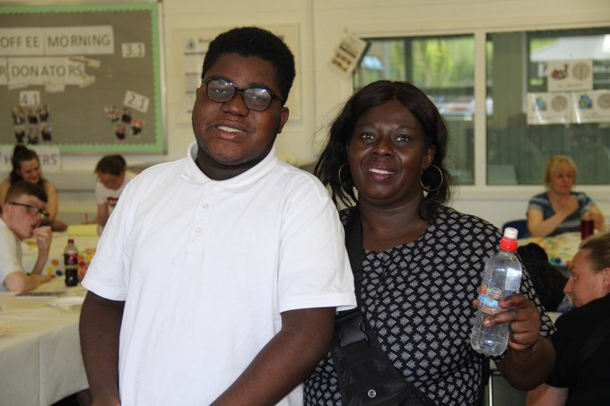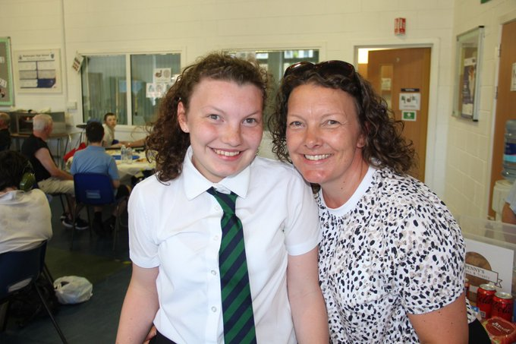

Section 4 – School Ethos

Rights Respecting Schools
Rutherglen High School pupils are encouraged to reflect on how their behaviour and actions affect those around them, which allows us to build and maintain a positive and safe learning environment for all, both in the classroom and around the school site. In the preparation for the Rights Respecting School Award and in consultation with pupils and staff at all levels, our school rules and expectations were re-written to form charters, which outline expectations in the classroom. These are displayed throughout the School.

There are four key areas of impact for children at a Rights Respecting School; wellbeing, participation, relationships and self-esteem. The difference that a Rights Respecting School makes goes beyond the school gates, making a positive impact on the whole community.
- Children are healthier and happier.
- Children feel safe.
- Children have better relationships.
- Children become active and involved in school life and the wider world.
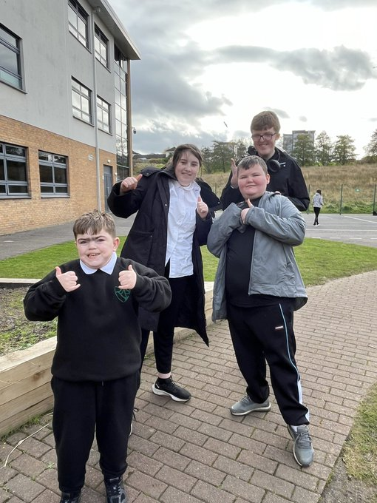

Promoting Positive Behaviour
It is the responsibility of staff within the school to ensure that Parent Council members, parents and pupils are involved in the creation of a positive school ethos that encourages good behaviour. Equally, the School whilst trying to promote positive behaviour must support young people should incidents or bullying occur. Parents have a significant role to play in working with the School so that teachers, parents and pupils know what is expected of them in trying to change the behaviour and attitudes that contribute to bullying behaviour.

Our approach is to create an environment where better behaviour will encourage improved learning. The School, along with the support of parents, can work together to create a learning environment which young people can enjoy and feel safe in.

Incidents of bullying should be reported to the School immediately so that each alleged incident can be investigated. Together we can work towards creating a safer School for pupils and staff.

In addition, our Promoting Positive Behaviour Policy provides guidance for all teaching and support staff and informs them of their roles and responsibilities in respect of dealing with the small number of pupils who may display challenging behaviour. Early identification is crucial so that intervention can be provided to support pupils to help them address their issues and concerns. Staff training is provided to help develop the skills needed to respond to and manage challenging behaviour. A wide range of appropriate staff development opportunities has been developed for this purpose.

Equal Opportunities and Social Justice
Rutherglen High School aims to provide equality of opportunity as a fundamental principle governing all School activities and within an ethos of achievement. Pupils are given equal access to the opportunities provided and we encourage the personal development of every individual within the school.

Any prejudice and injustice are treated seriously and dealt with in line with South Lanarkshire Equal Opportunities Policy.

https://www.southlanarkshire.gov.uk/info/200200/equality_in_employment/592/equal_opportunities_and_di

Rutherglen High School takes seriously any reports of racist incidents. As part of the School’s approach to promoting positive behaviour, a record of all racist incidents is maintained and each incident fully investigated. We are required to notify the Local Authority of any racist incident.

Schools and education establishments have a legislative duty to undertake an assessment of equality and diversity. This is the process of systematically assessing and consulting on the effects that a policy, process or strategy is likely to have on different groups in the community who might experience disadvantage/barriers in accessing services. The process includes monitoring the actual effects of the policy once it is put into practice. Policies do not affect everyone in the same way. By assessing in the early stages, any adverse impact can be identified and minimised.

Recognising Achievement
All pupils are entitled to have the full range of their achievements recognised and to be supported in reflecting and building on their learning and achievements.

As a School, we recognise that learning takes place not only in the classroom but also at home and in the wider community. As such, we try to recognise the achievements of our pupils in this important aspect of their School journey. Learner achievements are valued and celebrated in several ways throughout the year. By making a conscious effort to celebrate and share pupil’s accomplishments, we can improve morale and motivation, encouraging a positive educational journey for all.

We host S1-3 and S4-6 award ceremonies at the end of each year to celebrate learner success as follows:

- Excellence Across the Curriculum
- Skills Achievement
- Personal Achievement

S6 also have an individual ceremony to celebrate their achievements prior to leaving school. We also celebrate learner success widely through X (formerly known as Twitter), local media and newspaper and the South Lanarkshire Newsletter.

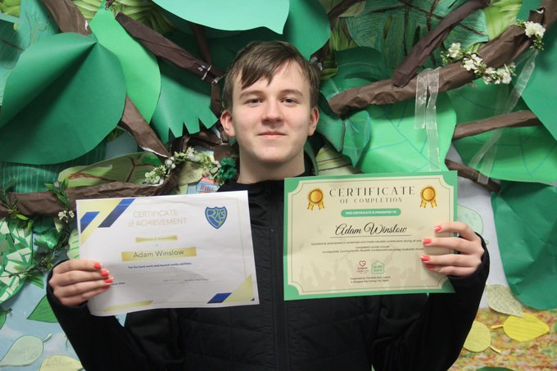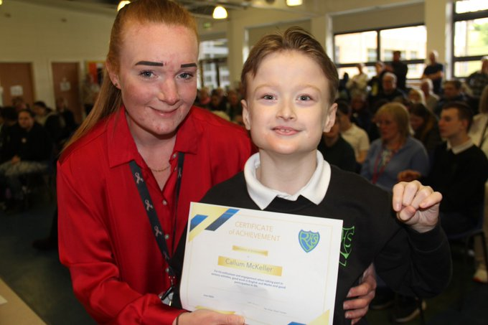
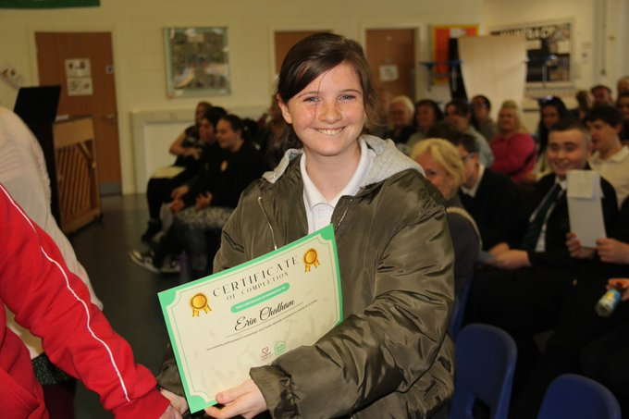

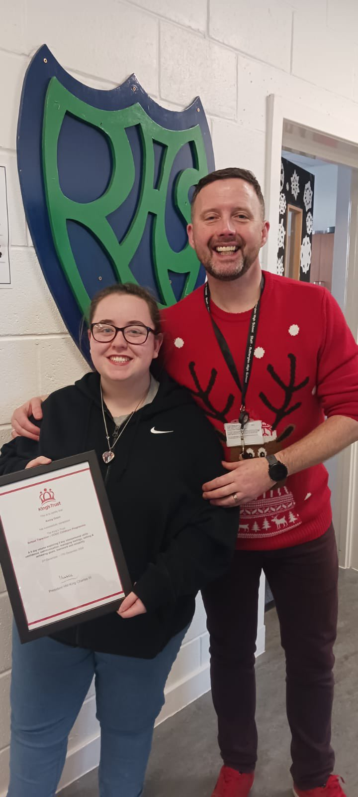

Eco Schools
Eco-Schools is the largest sustainable Schools programme in the world with 19.5 million children, young people and educators engaged worldwide in 74 different countries. It is one of the five programmes operated internationally by the Foundation for Environmental Education (FEE) and delivered by Keep Scotland Beautiful in Scotland.

Rutherglen High School is proud to have been a Green Flag holder since 2006 – A visible indication of our School's commitment to Learning for Sustainability and an internationally recognised accreditation for excellence in sustainable education.
As part of the Eco Schools Programme, pupils take part in a wide range of environmental projects and were awarded our most recent green flag in May 2024. Our key focus was on climate action, litter and waste. As a School, we have links with external agencies that have provided invaluable support to the School. In addition, we are thankful to parents and friends who have assisted at our Eco Days.
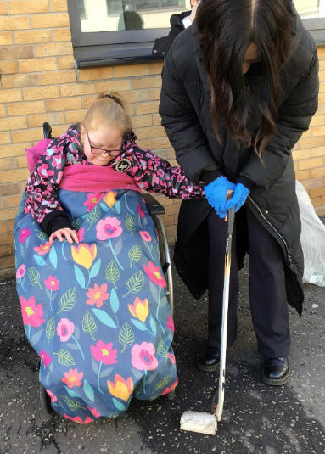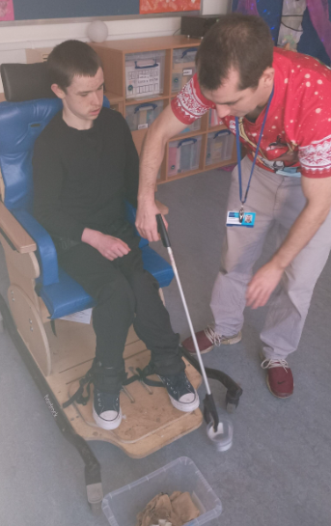
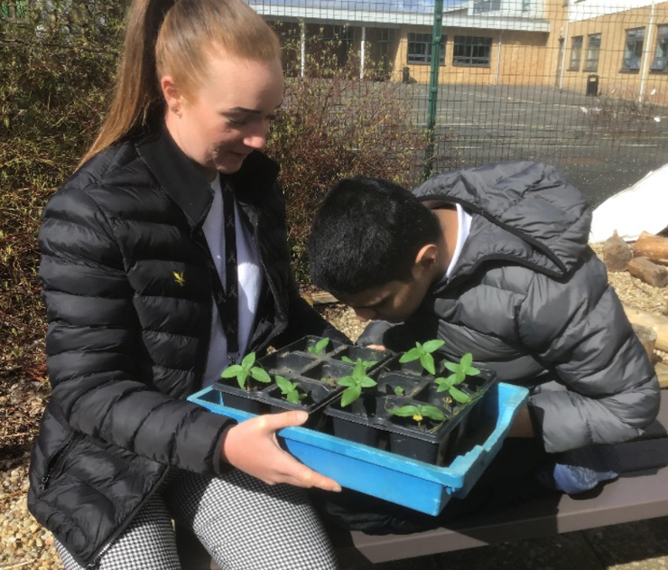

Spiritual, Social, Moral & Cultural Values
It is the policy of the School to provide in the curriculum a compulsory element of Religious and Moral Education. This is based on the policy on Religious Education and Religious Observance (1993). Although the study of Christianity is a main component of the Religious and Moral Education syllabus, it does also involve the study of beliefs and customs of a number of world religions.

We value the links with our School Chaplaincy Team, who contribute to both the formal and informal life of the School. The roll of the chaplains is diverse and includes:-

- Assisting the School to provide pupils with opportunities for reflection, both individual and collective.
- Providing pastoral care and support for staff, pupils and their families, where appropriate.
- Having a key role during times of extreme difficulty or crisis.
- Supporting School community events.
- Visiting classes to complement the curriculum.
- Leading or helping pupil groups with a particular religious, moral or citizenship interest.
- Providing a link between the School and local community.
- Addressing the school community at end of term services.

The School chaplaincy links are:-
- Rev John Sanderson – United Reformed Church
- Deacon Michael Ross – St Columbkilles Church
- Ross Murray – Outreach Trust

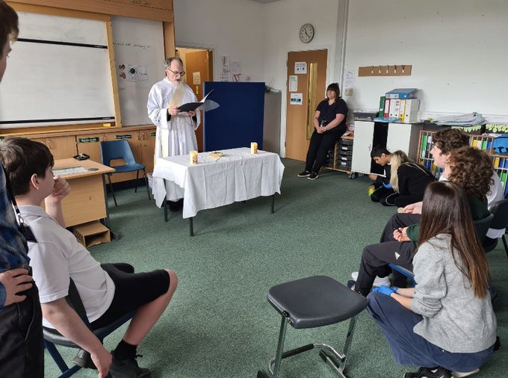

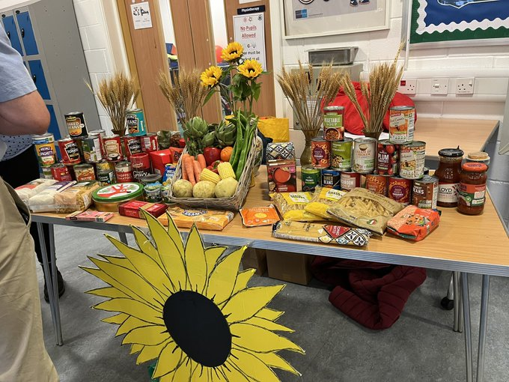
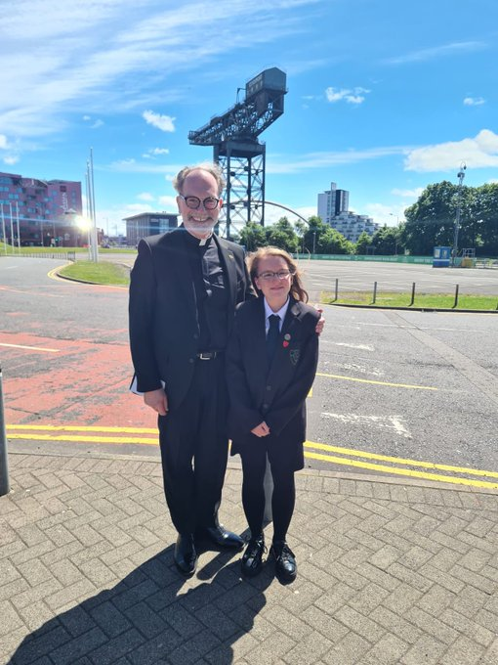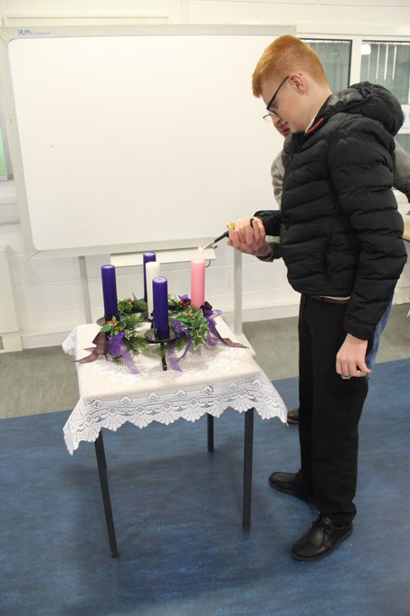

Makaton
Today over 100,000 children and adults use Makaton symbols and signs, either as their main method of communication or as a way to support speech. In addition to children and adults with communication and learning difficulties and the community around the for example, teachers, health professionals, friends, public service bodies etc., Makaton is increasingly used by the public to aid communication.

Makaton has been beneficial for multiple purposes such as for individual who may struggle with understanding concepts, those with poor literacy skills including grammatical knowledge and those with English as an Additional Language. By using Makaton, individuals can be more involved because communication and language are the key to everything we do and learn.

During 2024, the School provided Makaton Level 1 training for 23 staff. As a School, we encourage and support all pupils and staff to use Makaton as a method of communication. The School hosts a Wednesday morning Makaton Choir in our street area to encourage and develop our Makaton skills where everyone is welcome to join.
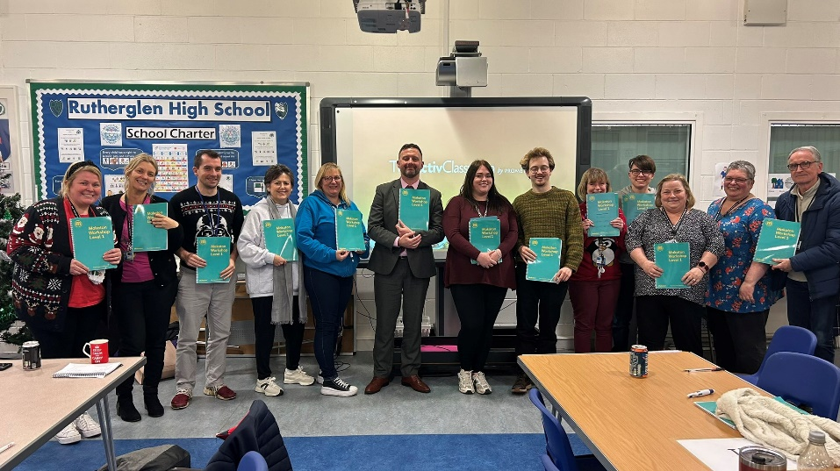
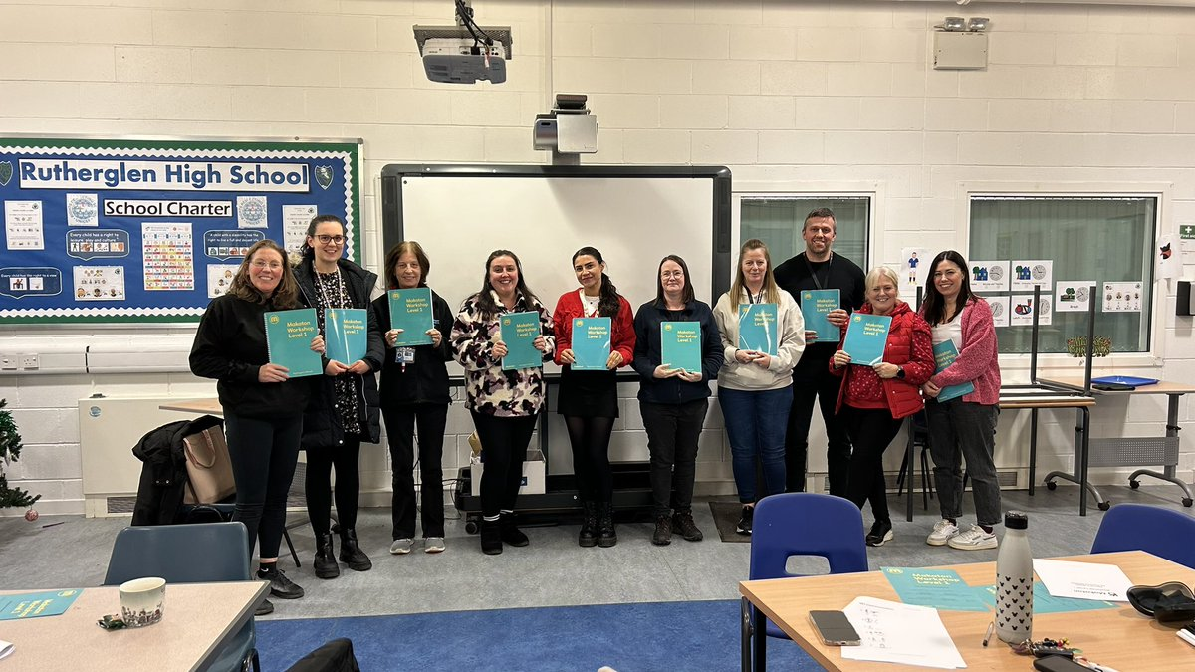

Rights of Parents/Carers
Scottish Government Ministers consider that Religious Observance complements Religious Education and is an important contribution to pupils’ development. It should also have a role in promoting the ethos of a School by bringing pupils together and creating a sense of community.

Parents have a statutory right to withdraw children from participation in Religious and Moral Education. However, national guidance also indicates that without this aspect of their education, learners will not enjoy the full benefits of Curriculum for Excellence since this area of their education contributes to pupils thinking for themselves and making their own decisions about what they believe to be true and about human living.

This right of parents’ wishes will be respected. Where a pupil is withdrawn from Religious Observance, we will make suitable arrangements for the pupil to participate in a worthwhile alternative activity.

Parents may request that their child(ren) be permitted to be absent in order to celebrate recognised religious events. Advance notice should be provided to the School when pupils will be absent. Appropriate requests will be granted and the pupil noted as an authorised absentee in the register.

School/Community Links
We aim to extend the learning experiences of our pupils beyond the confines of the classroom by means of various educational visits and excursions not only within the local area but also further afield.

The School is very conscious of its role in the wider community and every effort is made to foster links. We currently have close links with several of the local churches, representatives from St Columbkilles and the United Reformed Church participate in the school’s Chaplaincy group. Young people from the School work with these churches and churches within their own community as part of the Caritas Programme.

Some of our senior pupils' volunteer in Cathkin Community Nursery. The Nursery is often a popular choice for participants volunteering for the Duke of Edinburgh’s Award Scheme.

Groups from Rutherglen High School regularly take part in projects at Lifestyles Sports Centre, Universal Connections and Holmhills Wood Community Park. The School has links with many local employers with many of our senior pupils gaining work experience placements at a variety of local businesses.

Our pupils have regular opportunities to access the community to enhance their social and communication skills. Recent outings have included National Museum of Rural Life, Caulderglen Country Park and Zoo, local shops, Glasgow Science Centre and East Kilbride Shopping Centre.
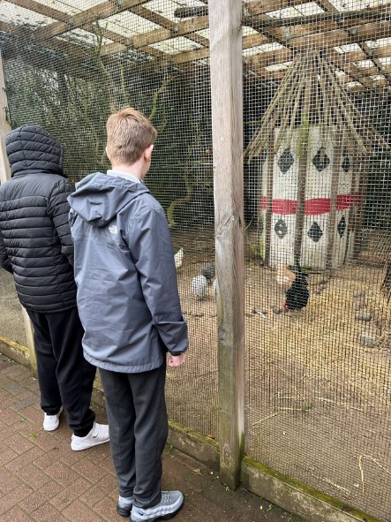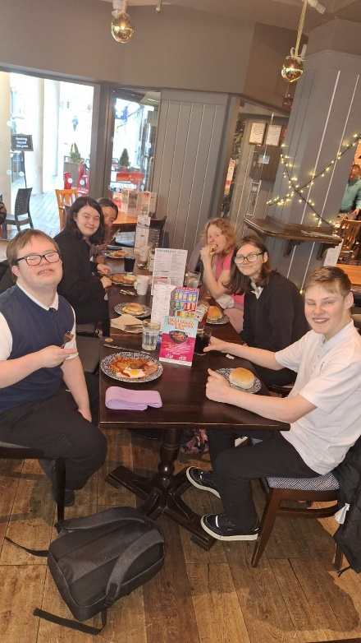
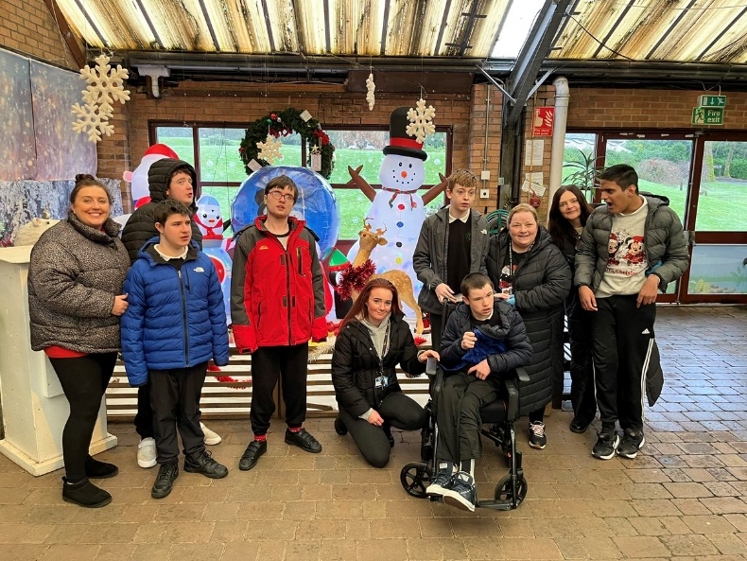

Section 5 – Attendance
Every effort should be made to ensure that your child attends School during term time. Please contact the School as soon as possible if your child is unable to attend School. It is important for the School to work with parents/carers in encouraging children to attend School.

All absences are required by law to be recorded. Absences will normally fall under two categories – authorised or unauthorised absence. In cases where your child is unable to attend School parents/carers are asked to contact the School Office. If possible, please indicate the expected duration of absence. If a child does not arrive at School, and there is no reasonable explanation provided for his/her absence, staff will investigate their whereabouts and safety. To assist the School, parents/careers are asked to ensure that home, work and emergency contact numbers are kept up to date.

If you know that your child has a hospital/dental appointment, please let us know in advance to allow us to update our records accordingly.

Requests for your child to be absent from school to make an extended visit to relatives either in the UK or overseas must be made in writing to the Head Teacher, detailing the reason, destination and duration of absence and arrangements for their continuing education. On these occasions, the pupil will be marked as an unauthorised absence.

Parents/carers may request that their child(ren) be permitted to be absent in order to celebrate recognised religious events. Advance notice should be provided to the School when pupils will be absent. Appropriate requests will be granted and the pupil noted as an authorised absentee in the register.

Emergency Information
We strive to keep the School open during term-time. However, there may be instances such as severe weather or power failures that could affect the School day. In such cases, we will inform you as soon as possible through text messages and our social media channels.

Severe Weather Protocol
In the event of severe weather like snow or heavy frost, if the School cannot open at the usual time, we will delay the start until 10 am. Notifications will be posted on social media and the South Lanarkshire Council website www.southlanarkshire.gov.uk

Communication
The South Lanarkshire Council’s website www.southlanarkshire.gov.uk, will provide updates on School closures or delays including further information about the next school day.

Parental Responsibilities
We ask that you:-
- Inform the school of any changes to your contact details.
- If unsure about the school’s status, visit the South Lanarkshire Council website www.southlanarkshire.gov.uk or email education@southlanarkshire.gov.uk

We ask that you:-
- Support and encourage your child’s learning.
- Respect and adhere to the School’s policies.
Respect School staff and support the School’s commitment to your child’s education.

Family Holidays During Term Time
Please ensure your child attends School during term time and avoid holidays during this period as it disrupts education and reduces learning time. If a holiday during term time is unavoidable, inform the School in advance by letter.

Holidays during term time will be marked as unauthorised absences, except in exceptional circumstances where parents can demonstrate the inability to obtain leave during School holidays. Unexplained absences will be recorded as unauthorised.

Encouraging School Attendance
We believe that regular School attendance is key to raising attainment and achievement. It’s a shared responsibility among parents/carers and the School to emphasise the importance of attending School.

For your convenience, School holiday dates and in-service dates can be found on the South Lanarkshire Council’s website www.southlanarkshire.gov.uk

Section 6 - The Curriculum
Curriculum for Excellence (CfE)is the name given to the curriculum in Scotland for all children and young people aged 3-18. It is a forward looking, coherent, flexible and enriched curriculum that provides young people with opportunities to engage with the knowledge, skills and attributes they will need to flourish in life, learning and work, now and in the future.

The curriculum includes all of the experiences that are planned for children and young people to support the development of their skills, wherever they are being educated, for example in the family and community, pre-school centre, nursery and school. In a secondary school setting the Broad General Education (BGE) will provide them with opportunities to become successful learners, confident individuals, responsible citizens and effective contributors to life in the 21st century. The Senior Phase that follows on from the BGE will provide learners with the opportunity to achieve a wide range of qualifications to recognise their learning.

In taking this forward our school will work closely with South Lanarkshire Education Resources and other services to enrich the curriculum, to provide the best possible education for all children and young people. We wish you to feel confident that your child is encouraged and supported to develop their literacy, numeracy and other skills whilst they attend our school. There are eight curriculum areas within CfE. Literacy, numeracy and health and wellbeing are recognised as being particularly important – these areas are seen as being the “responsibility of all” staff. The are 8 key curricular areas are:-

- Languages – includes modern languages, classical languages and Scots
- Expressive arts – including support and resources for art and design, dance, drama and music
- Health and wellbeing – includes mental, emotional, social and physical wellbeing; planning for choices and changes; physical education, physical activity and sport; food and health; substance misuse; relationships, sexual health and parenthood
- Numeracy and mathematics – includes number, money and measure; shape, position and movement; and information handling
- Religious and moral education – includes RME (non-denominational)
- Sciences – includes planet Earth; forces, electrical and waves, biological systems; materials; and topical science
- Social studies – includes people, past events and societies; people, place and environment; and people in society, economy and business
- Technologies – includes digital literacy; food and textile technology; technological developments in society and business; craft, design, engineering and graphics; and computing science.

If you want to know more about CfE, please visit website www.curriculumforexcellence.gov.uk or www.parentzonescotland.gsi.gov.uk

Our learning and teaching activities are based on the outcomes and experiences in the guidelines that all schools have for CfE.
Level | Stage
Early | The pre-school years and Primary 1 or later for some.
First | To the end of Primary 4, but earlier or later for some.
Second | To the end of Primary 7, but earlier or later for some.
Third and Fourth | Secondary 1 to Secondary 3, but earlier or later for some. The Fourth Level broadly equates to Scottish Credit and Qualification Framework level 4. The Fourth Level experiences and outcomes are intended to provide possibilities for choice and young people’s choices will not include all of the Fourth Level outcomes.
Senior Phase | Secondary 4-6 and college or other means of study.

Aims
The CfE places learners at the heart of education. At its centre are four fundamental capacities which reflect and recognise the lifelong nature of education and learning. The four capacities are aimed at helping children and young people to become:

- Successful learners
- Confident individuals
- Responsible citizens
- Effective contributors
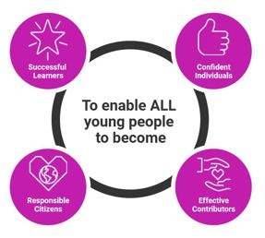

Purpose of the Curriculum 3-18
As part of their learner journey, all children and young people in Scotland are entitled to experience a coherent curriculum from 3 to 18, in order that they have opportunities to develop the knowledge, skills and attributes they need to adapt, think critically and flourish in today’s world.
The curriculum is defined as the totality of all that is planned for children and young people from early learning and childcare, through school and beyond. That totality can be planned for and experienced by learners across:-
- Curriculum areas and subjects
- Interdisciplinary learning
- Ethos and life of the school
- Opportunities for personal achievement

The curriculum provides the structure and support in learning which will develop the four capacities listed above. Our approach has been to alter the balance between a process that is heavily dependent on content, providing learning and teaching approaches that improve the pupils’ understanding of what is being taught. This is not a one-off change but the start of a continuous process of review to ensure that the curriculum remains up to date.

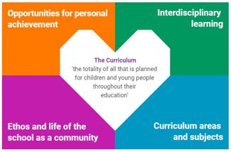

Further information about CfE can be found at:-
https://education.gov.scot/curriculum-for-excellence/about-curriculum-for-excellence/what-is-curriculum-for-excellence/

Principles for Curriculum Design
- Challenge and enjoyment
- Breadth
- Progression
- Depth
- Personalisation and choice
- Coherence
- Relevance

Curriculum Strategy – Base Classes
Our base classes follow a framework based on a multi-sensory approach with highly individualised teaching and learning opportunities to support young people with a range of individual needs. The curriculum in the base classes incorporates follows Milestones for Complex Learners, CfE and Scottish Qualifications Authority guidelines and is designed to offer young people learning experiences tailored to meet their specific needs. The curriculum is underpinned by lifelong learning skills and a focus on promoting positive outcomes for young people with individual needs. We do this by linking closely with business and academic partnerships to support our young people to become a valuable part of their community.

In S1-S3, pupils follow a broad general education working at Milestones for Complex Learners and Pre-Early, Early and First level of CfE. The base class teacher is responsible for teaching Numeracy, Literacy and Health and Wellbeing. Pupils also have daily access to a wide range of other subjects delivered by specialist subject teachers.

What do we do?
- We enjoy communication circle time. We use interactive resources and focus on pupil interests.
- We use songs, drums and Makaton.
- We familiarise ourselves with the day by using daily sensory orientation materials and also by use of board maker symbols for the timetable.
- Each pupil has a highly individualised curriculum and materials.
- We all use structured routines.
- Pupils have their sensory feedback needs met by the use of therapeutic resources.
- Staff are trained in multiple disciplines such as intensive interaction, talking mats, autistic spectrum disorders and early years pedagogue. This allows the support given to each pupil to be tailored to their needs.
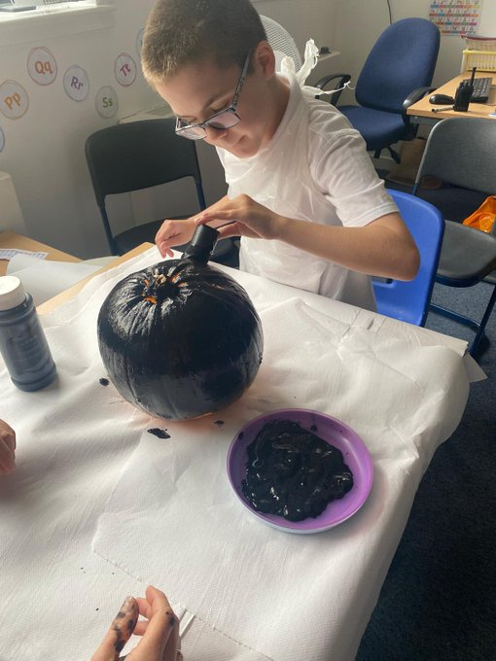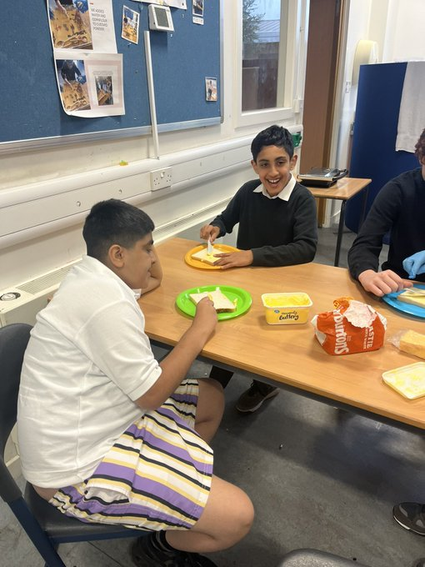
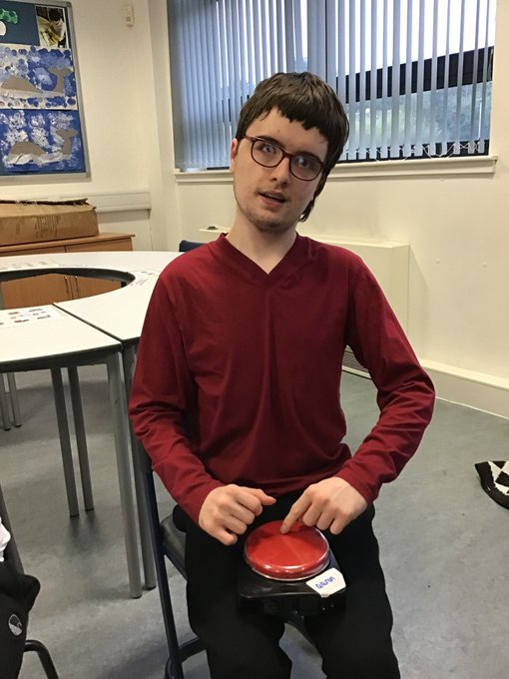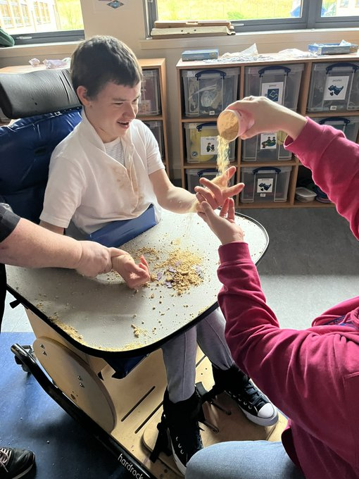

Milestones For Complex Learners
Milestones are important points in development and demonstrate progression. Young people who are not able to achieve any of the benchmarks within Early Level still require tracking and monitoring of their progression. Whilst many young people will move on to work at Early Level, some will continue to make progress at the pre-early stage. Milestones for complex learners support teachers to track the progression of young people with severe and complex needs.
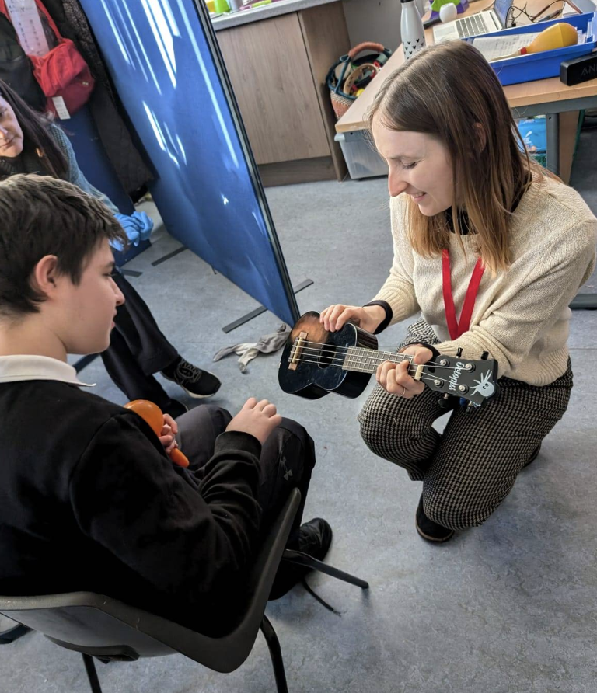

Senior Phase - National Qualifications
In S4 – S6, pupils undertake a range of SQA units specific to their needs. Scottish Qualifications Authority (SQA) is one of the four partner national organisations involved in the Curriculum for Excellence. It works with partners on all strands of the development. SQA has joined with Universities Scotland, QAA Scotland and the Scottish Government to create the Scottish Credit and Qualifications Framework or SCQF.

Every Scottish qualification is allocated a level and credit value within this framework, which all partners have agreed to recognise. There are the many qualifications often imperfectly referred to as vocational, though these are frequently stepping-stones for students at Scottish Colleges of Further Education to pursue one- or two- year programmes tailored from a wide-ranging catalogue of National Units. The actual programme may be very rigidly prescribed or be entirely freely chosen by the young people to meet individual needs.

The SQA have recently produced new qualifications which have clearer focus on skills development and a greater emphasis on deeper learning by encouragement for young people to think for themselves; to apply and interpret the knowledge and understanding they have developed and to demonstrate the skills they have learned.
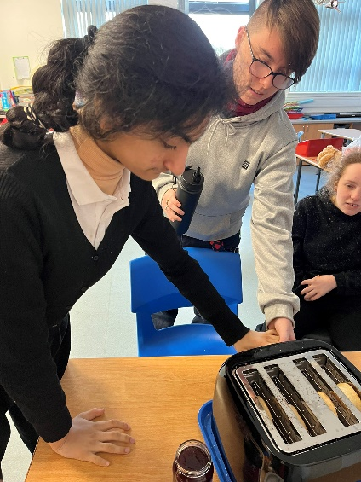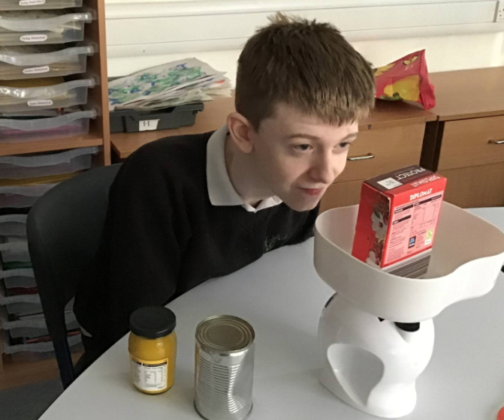
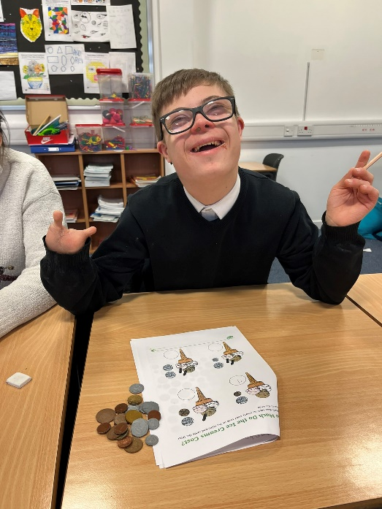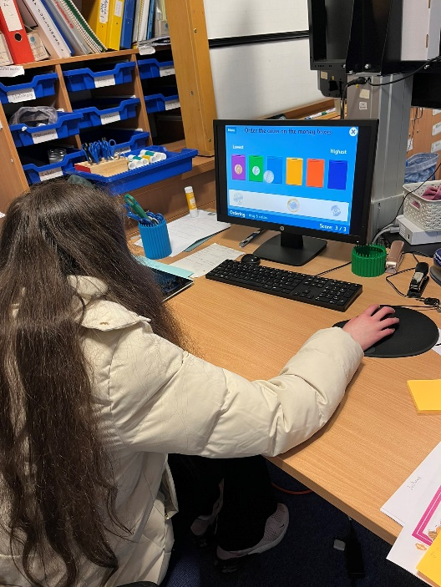

Options
Options are an integral aspect of curricular provision for all students from S4 onwards. Options allow pupils to pursue courses in which they have a personal aptitude/interest. Prior to choosing options, pupils will have the opportunity to take part in an Induction programme. This will involve input from subject specialists, Skills Development Scotland and Colleges. As part of this process an option information booklet will be issued to all pupils/parents.

Options are chosen at the end of S3 and pupils follow their chosen courses for two years.

Options: Art
Music
Drama
ICT
Technical
Science
Social Subjects
Duke of Edinburgh Award
French
Spanish
DIY
Health & Wellbeing
Home Economics (S6)

In S4, pupils choose 4 subjects from the above list and in S5 & S6 this reduces to 3 subjects. Pupils study the subject for 2 periods a week. For more information regarding the S4/5 /S6 curriculum please see the S4/S5/S6 Curriculum Handbook.

Severe and Profound Needs
Rutherglen High School’s provision for learners with Severe and Profound Needs follows the guidelines as set out in the South Lanarkshire document “Framework for Supporting Pupils with Severe and Profound Learning Needs”

Young people who would benefit from a highly support learning environment are identified at transition through consultation with Primary Headteachers, Educational Psychologists and parents. Pupils in supported classes benefit from an adapted secondary school curriculum with emphasis on supporting communication and promoting daily living skills. Provision is also made to incorporate the daily exercise programmes in response to physical and sensory needs of the individual pupils, under the direction of physiotherapists and occupational therapists, where appropriate.

While the core subjects (English, Maths, Health & Wellbeing and Independent Living Skills) are delivered in the same classroom, pupils also access a secondary school timetable in various practical classrooms around the school. Opportunity is also given in many areas of school life for all pupils to socialise and work together.
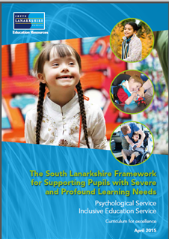

Developing the Young Workforce
Work Experience is an important part of the S4-S6 curriculum. In S4, some pupils will have the opportunity of a work experience placement. In S5 & S6 some pupils will have the opportunity to further work experience placements.

Rutherglen High has a full Developing Young Workforce (DYW) Programme which allows for individual progression at each stage for every pupil. Rutherglen high has built up excellent links with many businesses. We believe that DYW has a very important role to play in preparing pupils for post-school life.

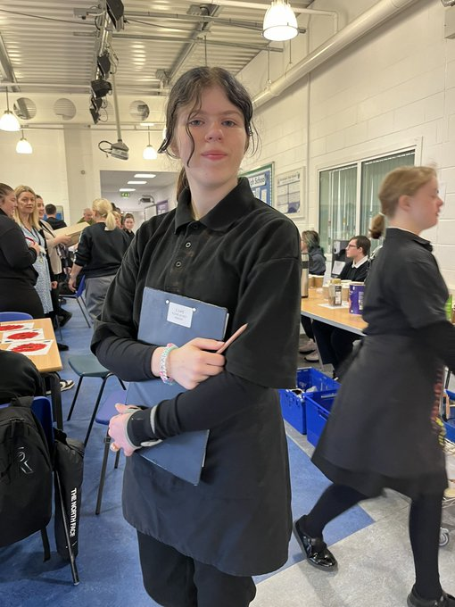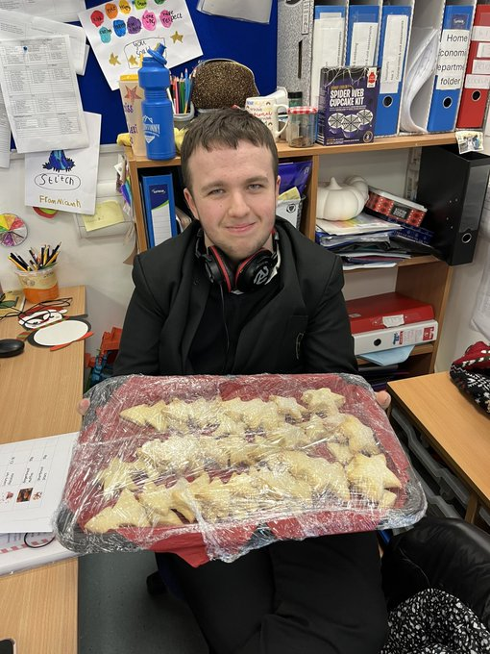
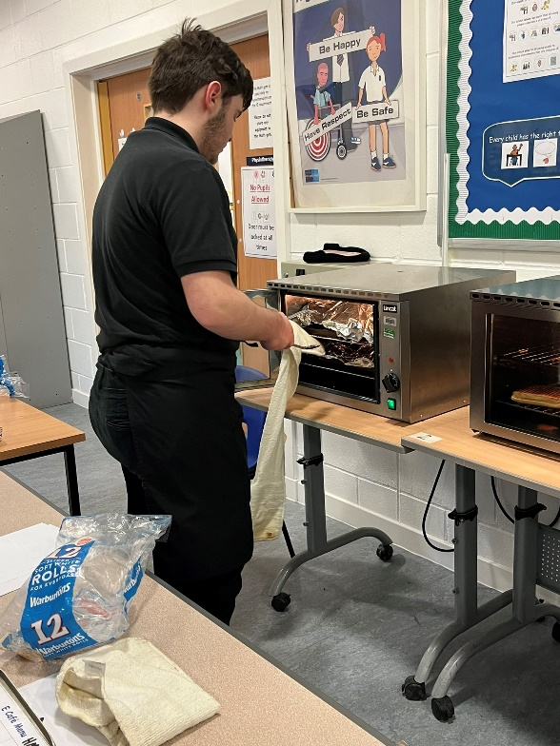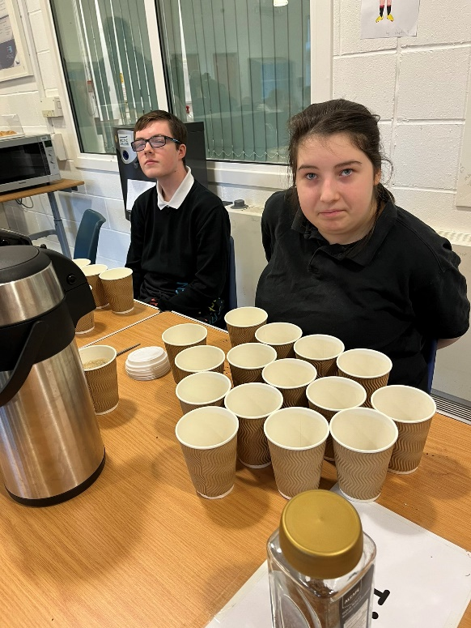

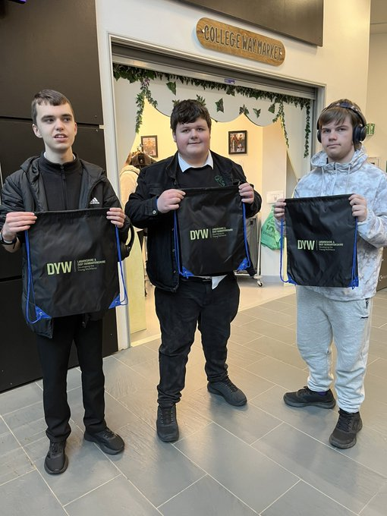

Work Experience
Some pupils from S4-S6 have the opportunity to participate in a work experience placement. All placements are agreed upon after discussion with pupils, parents and staff and are dependent on individual pupil’s needs, abilities and interests. College placements and possible career choices are also taken into consideration when choices are being made about work experience placements.

The Work Experience programme is overseen by our Developing the Young Workforce PEF Principal Teacher. This involves making new links with businesses and maintaining links with existing participating businesses, keeping pupils and parents informed of opportunities for placements, talking to pupils about career choices, arranging any Health & Safety checks wherever necessary and arranging the necessary paperwork. Preparation for work experience (Health & safety, dress code, career choices, etc) takes place at allocated times throughout the year with the school’s World of Work teacher during DYW class. During their work experience pupils keep a record of their activities through a Work Experience Diary. This provides useful feedback to school and parents about the placement and also serves as a valuable source of self-evaluation for each pupil to reflect upon both during their placement and on their return to school.
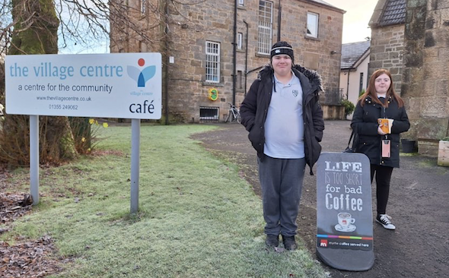
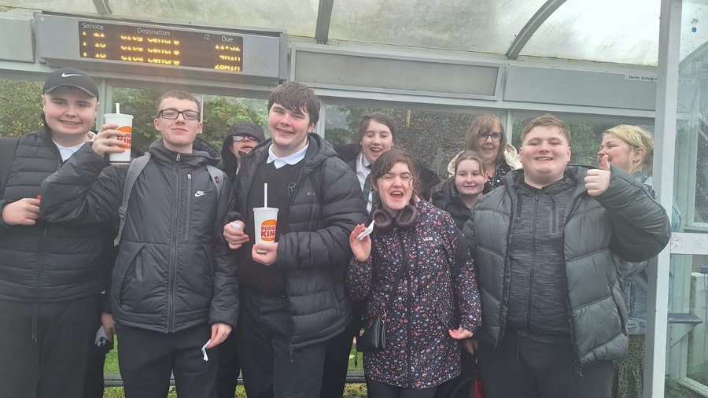
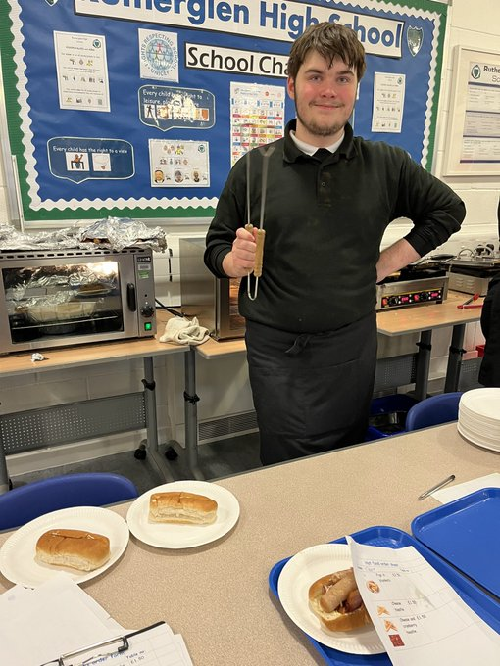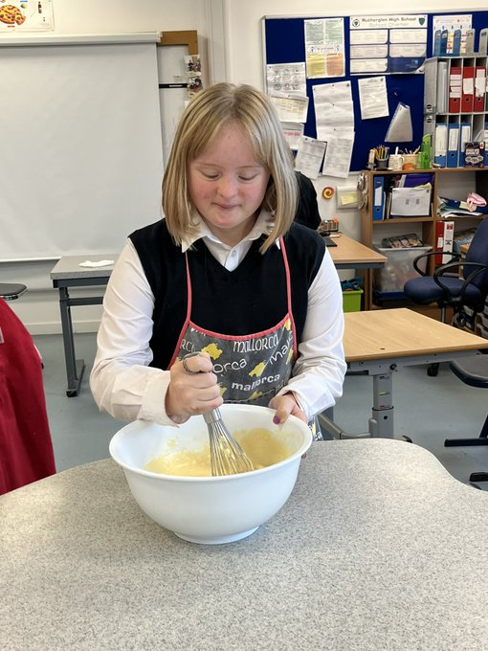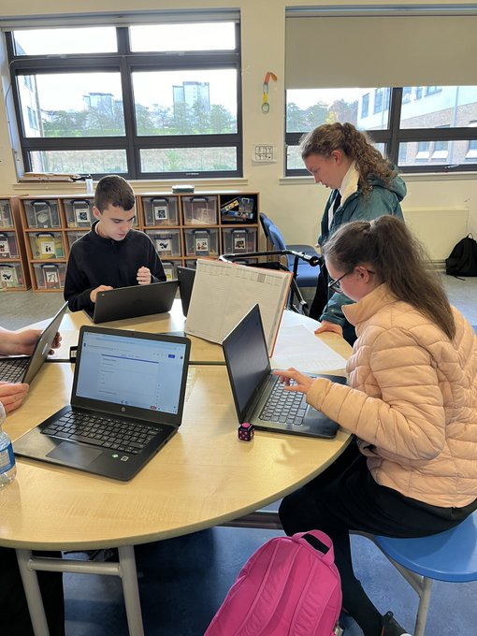

College
Rutherglen High School offers a multitude of college options for senior pupils. The school has strong links with a range of colleges: New College Lanarkshire (Motherwell Campus), South Lanarkshire College, Glasgow Kelvin College (Easterhouse and Haghill) and Glasgow Clyde College (Langside and Cardonald). Rutherglen High School believes that college is an integral part of a student’s whole education. College provides students with important skills and qualifications that will help them in post-school life. College is also a very successful destination for many of our students when they leave school.

Most pupils from S4–S6 have the opportunity to attend one of the college campuses mentioned above. Programmes are dependent on individual needs, aspirations and abilities and decisions are made after discussion with pupils, parents and staff. There is careful consideration given to progression of skills and certification prior to allocation of placements. Possible future post school placements are also given consideration when advising pupils on college choices.

Management of college provision is the responsibility of the Principal Teacher (S5 and S6). Parents are contacted to update on concerns or issues which arise throughout the year. The Principal Teacher is available to discuss reports and options at Parents evenings throughout the year.

Lunch is either purchased in the college canteen or a packed lunch is provided by the school. Pupils who have demonstrated a responsible and mature attitude are allowed to leave Langside Campus at lunchtime – after parental permission has been given and after an initial settling in period.

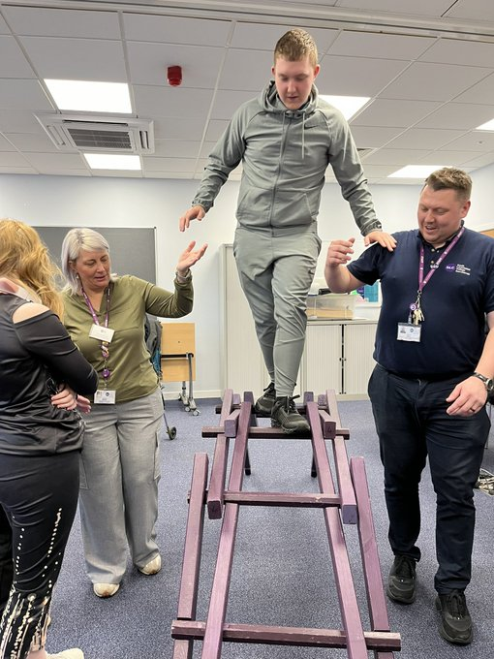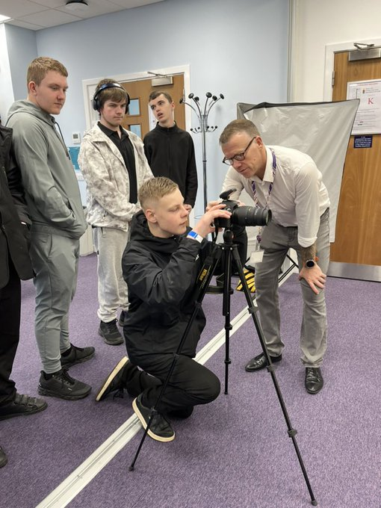

Glasgow the Caring City – Skills Barn
The majority of our S3-S6 pupils attend Glasgow the Caring City (GCC) one morning per week. The Skills Barn was set up to provide people in Glasgow with practical life skills to enable them to reach positive destinations. There are a wide range of activities available to help young people develop important community and life skills, joining in with visual and functional activities to up-skill them for their future lives. Staff also assist pupils to understand the wide range of factors that feed into positive health and wellbeing, providing them with the knowledge, understanding and skills to improve their own.
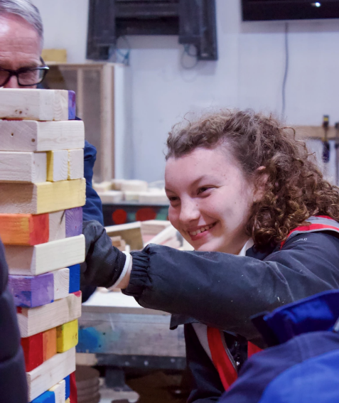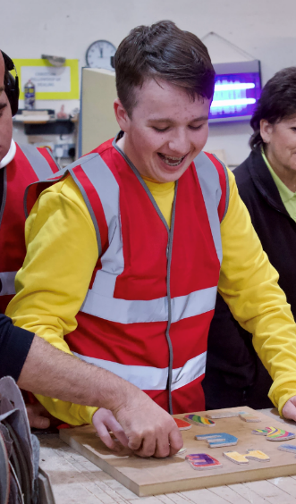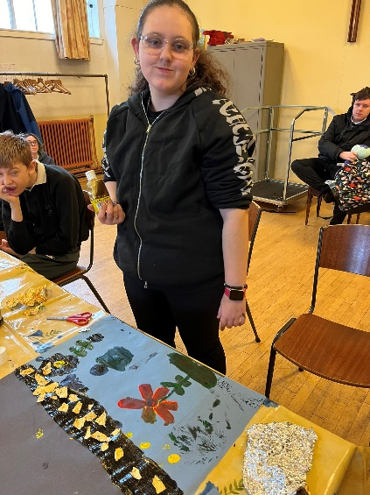
The Skills Barn is a social enterprise training accelerator aimed at increasing capacity and strength within the community skills sector, leading to more people accessing support sooner and with greater levels of success. The project empowers people and communities to obtain skills to set a pathway towards success, and work with partner organisations around the city to deliver diverse training options at an accelerated pace and with the intention to bolster opportunities for people and communities to overcome the barriers to work and success. It offers flexibility and diversity of training within the community sector, providing a range of facilities and equipment and the ability to deliver bespoke packages of support directly or on behalf of partner organisations.

Experiential Play
Play often stems from curiosity and a desire to understand the world. This curiosity-driven exploration can spark new ideas and interests, fuelling the creative process. The act of playing provides a holistic approach to developing creativity. It engages the mind, encourages exploration, fosters social skills, and creates a positive and enjoyable environment that is conducive to innovative thinking.
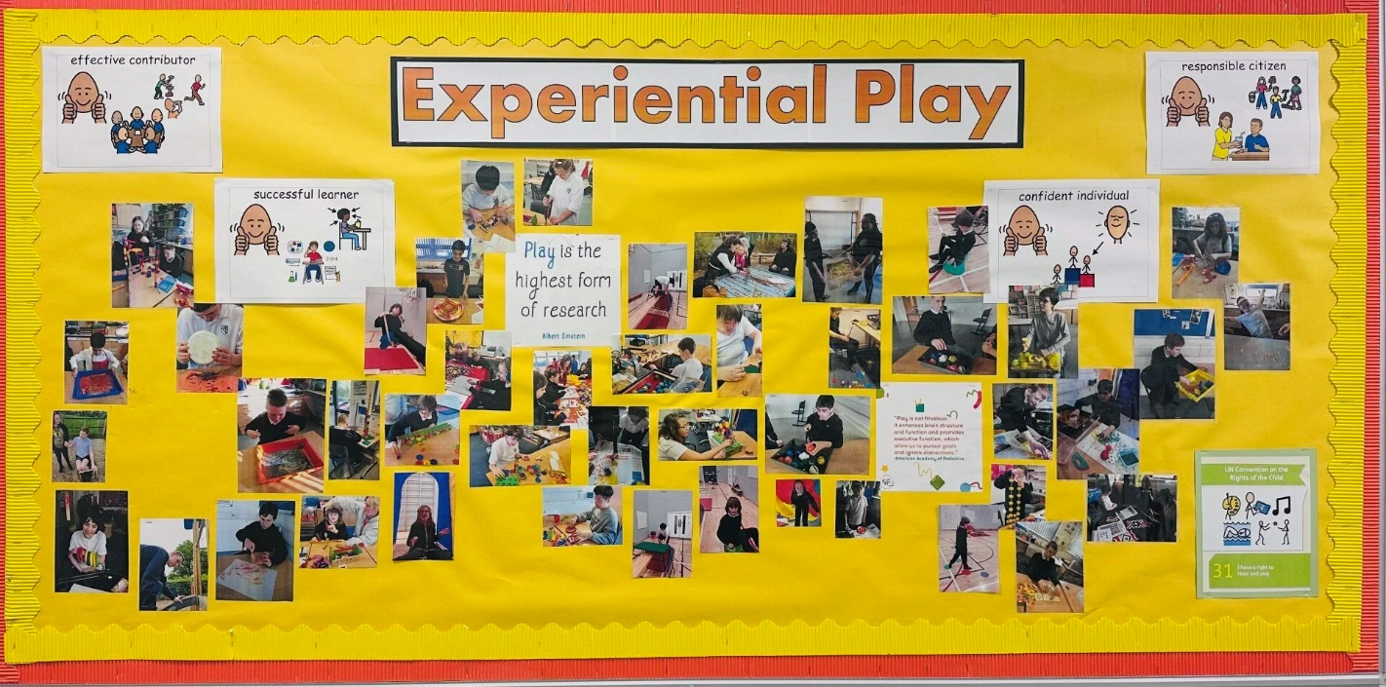Our curriculum offers authentic and real-life experiences that follow young people’s interests and encourage independence and exploration. It is designed to encourage young people to connect with nature and develop both care and respect for the environment.

At Rutherglen High School, a variety of play opportunities are available throughout all subjects. The setting provides lots of messy and open-ended play experiences using natural materials and resources, which young people can access independently throughout the day. This supports them to develop confidence and follow their own interests. Young people learn, investigate, explore, develop, grow in confidence, build relationships, improve physical and mental health and learn moral and spiritual awareness all whilst playing in a homely, safe and happy environment.

We have had strong community links and good relationships with young people and their families, which support them to engage in successful learning and become responsible citisens. Our staff team pride themselves on promoting active experiential learning. Teaching teams plan and deliver a wide range of engaging and interesting learning activities that support the development of young people’s skills while ensuring opportunities for them to follow their own fascinations and interests. Learning about different seasons and the weather is very important to young people navigating time as part of their world. This is enhanced by exploring books and stories, bug hunts, collecting leaves, and noticing changes in the environment around us.

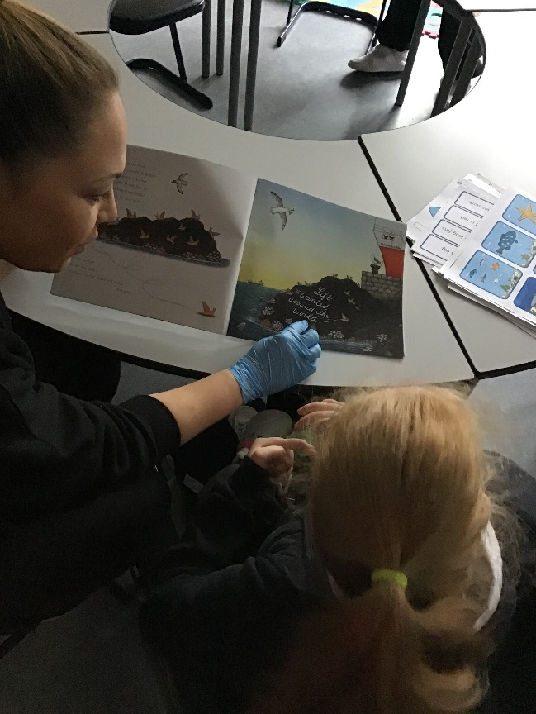
Staff believe that encouraging communication is crucial and concentrate on asking questions that encourage young people to make purposeful decisions about their play. Staff provide young people with exciting opportunities to explore and problem solve. They encourage communication skills with processing time. Play resources are equally important as they enhance investigation and imagination. Young people have opportunities to use interesting and challenging resources to develop their learning, such as magnifying glasses to look at seeds, and a pestle and mortar to grind and mix seeds and fresh herbs from the garden. Having access to natural materials such as stones, wood, bamboo, beads and real-life objects like seasonal flowers, fruits and vegetables greatly enhances their learning through tactile play.
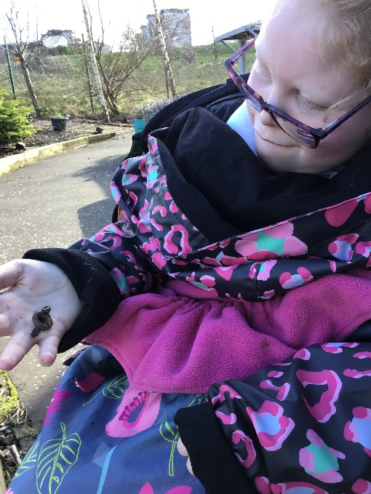

At Autumn time, the setting includes lots of conkers, pinecones, leaves, pumpkins and other root vegetables in most planned activities throughout the season. These objects provide young people with opportunities to be creative and use them in a variety of imaginative ways. Staff provide resources such as magnifying glasses, cameras, clip boards and mark making tools to encourage young people to think in new ways and problem solve, exploring cause and effect. Through trial and error, they gain confidence in expressing themselves and process the world around them.
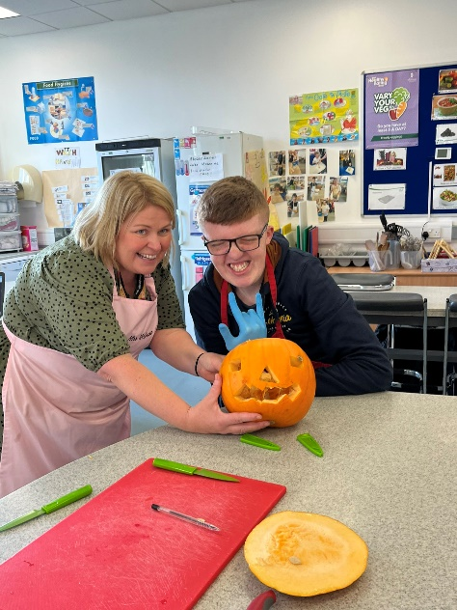
We provide a rich learning environment where young people have autonomy to make decisions, communicate and problem solve. Observations of each young person’s interests and fascinations are included in planned activities with lots of responsive planning that is young person led. Observations around experiential play interactions ensure that staff respond to young people’s individual needs. Young people have the opportunity to enjoy cooking skills and are supported to prepare their own snack, where appropriate, to developing their fine motor skills and independence.
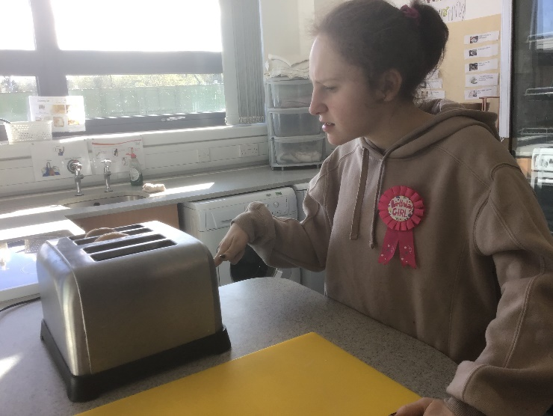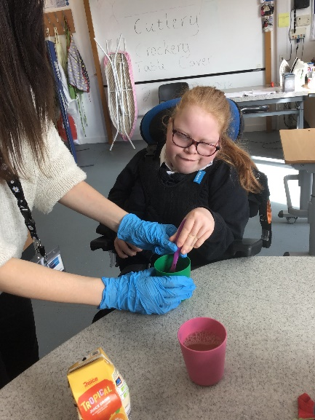

Young people have access to the outdoor resources and areas throughout the day and are encouraged to develop their physical skills through a range of natural outdoor learning activities. They play on a bikes or scooters and have a go at growing their own plants. For young people to become confident explorers, staff plan opportunities to allow them to make choices and decisions about their learning to enhance confidence and independence, in addition to supporting individual well-being. Promoting and encouraging independence and confidence within young people creates a sense of belonging. Modelling good practices and behaviour by adults encourages young people to act in a similar way. Staff support young people to interact with each other, sharing attention, turn taking and showing kindness and trust with peers, friends and family.
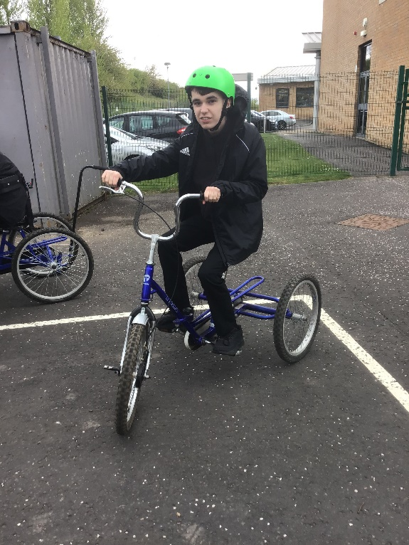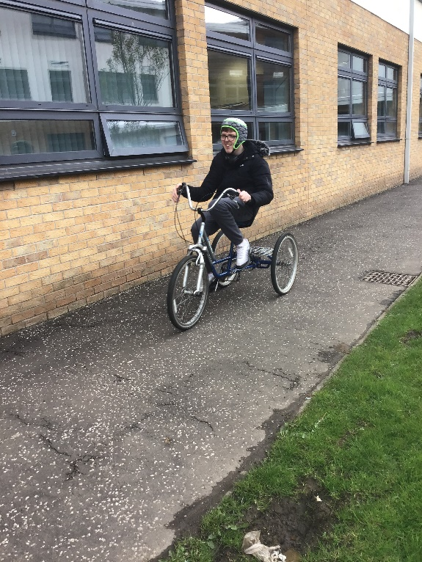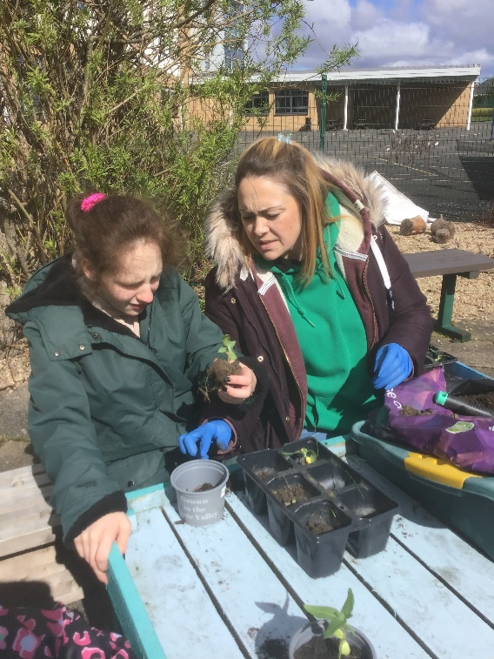

Edible Curriculum
Rutherglen High School pupils are offered a sensory based edible curriculum which allows all learners to engage in learning whilst taking into account their sensory needs. Many of our learners are oral sensory seekers and require safe and appropriate resources. Our curriculum offers authentic and real-life experiences that follow young people’s interests and encourage independence and exploration.

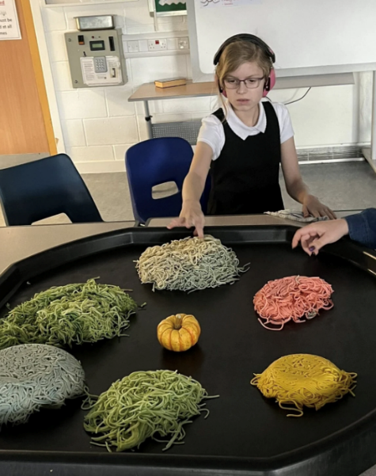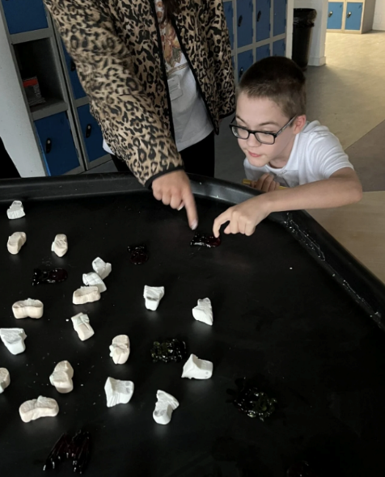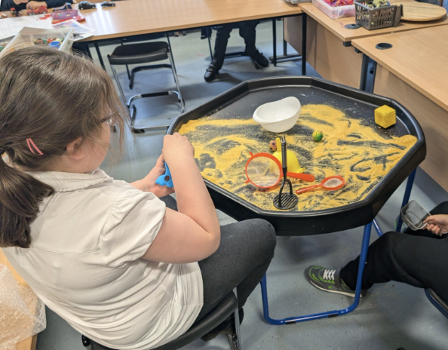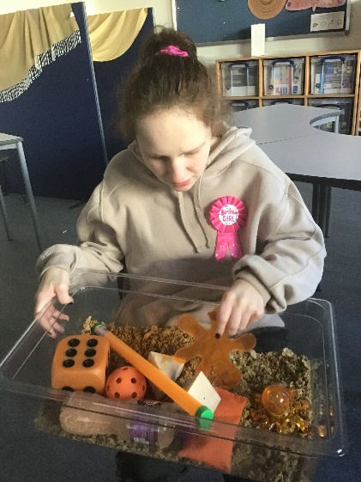
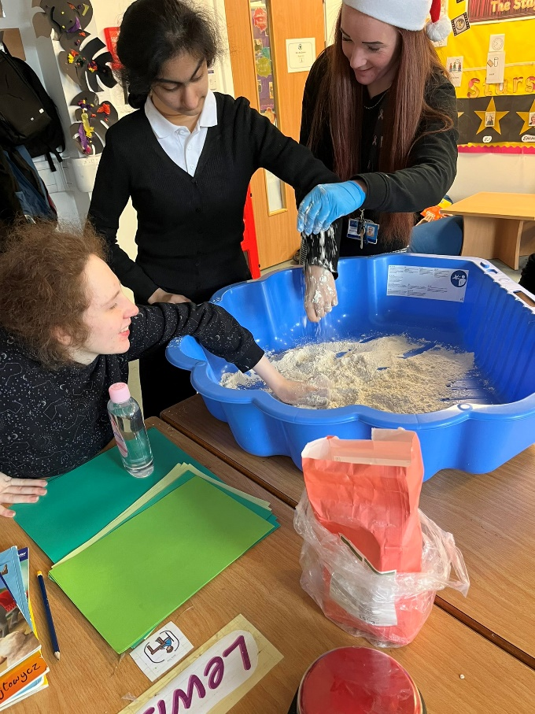

Animal Assisted Therapy – Gus
We have recently introduced animal assisted therapy on a Friday afternoon with Gus who is a gorgeous Border Terrier. He is a full pedigree Border Terrier and is registered with the Kennel Club. His legal owner is Mrs Lynn Blair, Depute Head at Cathkin High School. Mrs Blair has full responsibility for the welfare of Gus ensuring that he is vaccinated, wormed and flea treated. The day-to-day care and welfare of Gus is overtaken by a team of staff who ensure that Gus is fed, watered, taken for toilet breaks, given play time, appropriately trained and is well rested throughout the day. Cathkin High’s liability insurance covers the school for risk related to a working dog on site. Training for Gus to be a Reading and Therapy dog will be ongoing. Team Gus staff will receive dog handling training by a trainer fully qualified and approved by The Institute of Modern Dog Trainers (IMDT), The Dog Training College, Licenced Canine Body Language and Pet First Aid. Only named staff trained to handle Gus in pupil sessions will have permission to do so.

The benefits of a school dog have been proven to help develop learners’ reading skills, improve behaviour, attendance and academic confidence, as well as increasing learner understanding of responsibility and develop empathy and nurturing skills. Gus will support our staff team in bringing all of these benefits to our learners. Gus will be trained as a therapy dog and a reading dog. The plan is to register Gus as an Emotional Support Animal and once he has passed through adolescence and completed accredited behavioural trainings. Our pupils access Gus within Cathkin High School. Animal assisted therapy can:-
- Teach empathy and appropriate interpersonal skills
- Help individuals develop social skills
- Support emotional regulation through the positive impact on the autonomic nervous system
- Increase motivation for learning, resulting in improved outcomes
- Support children with social and emotional learning needs, which in turn can assist with literacy development.

Research into the effects of therapy dogs in schools is showing a range of benefits including:-
- Increase in school attendance
- Gains in confidence
- Decreases in learner anxiety behaviours resulting in improved learning outcomes, such as increases in reading and writing levels
- Positive changes towards learning and improved motivation
- Enhanced relationships with peers and teachers due to experiencing trust and unconditional positive regard from a therapy dog. This in turn helps students learn how to express their feelings and enter into more trusting relationships.
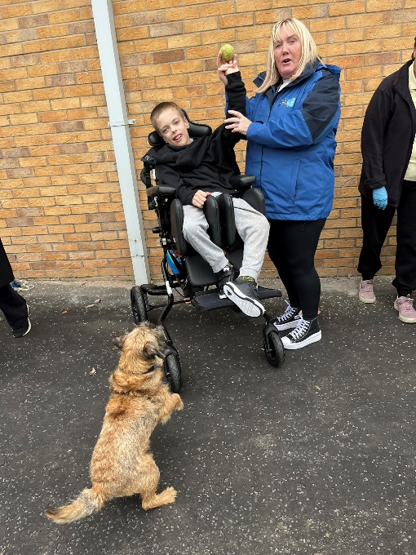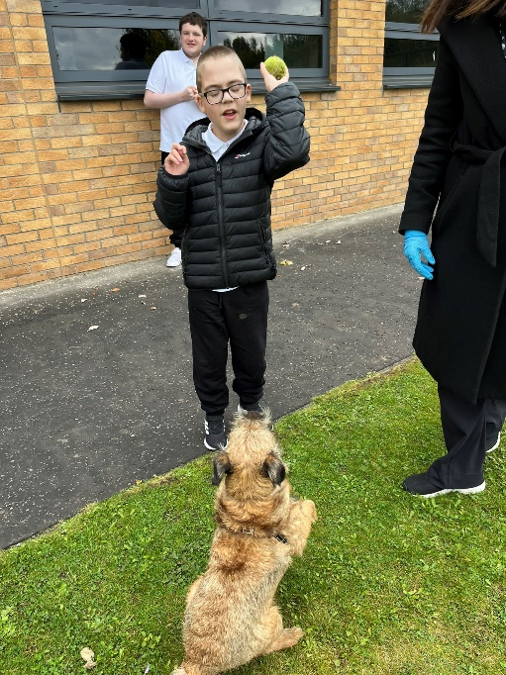
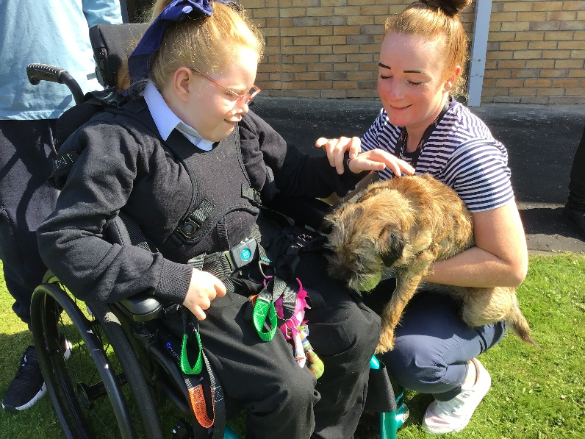
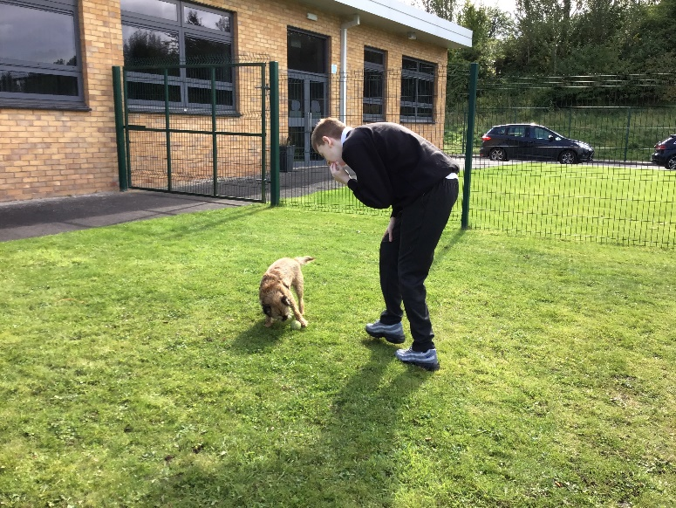
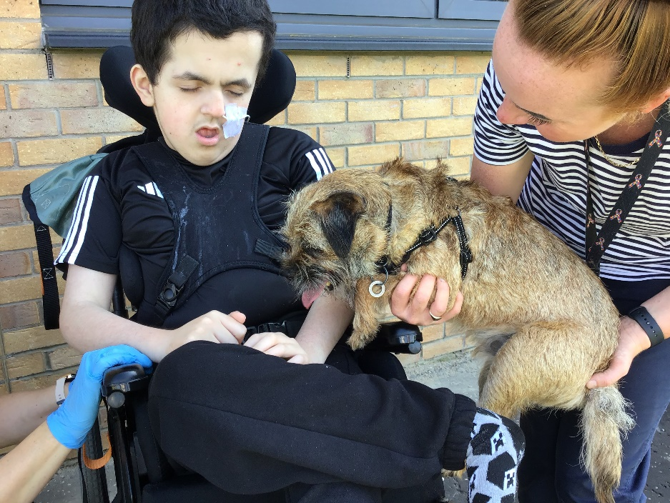

Section 7 - Assessment
In Rutherglen High School we believe firmly in continuous assessment. Class work, homework, project work etc. are all considered when deciding how pupils are progressing. It is more important for pupils to know if they are working to their own capacity than to compare them with others. Self-Assessment is also important. We try to give pupils some responsibility for their own learning, and we hope that the work done in primary is carried on into S1 as part of the Curriculum for Excellence programme. In our school, assessment will focus on:-
- Strengths
- Development Needs
- Next Steps
Assessment is important in giving pupils feedback on how well they are doing, and it helps teachers to judge how effective their teaching is or how appropriate the lessons/resources are. We try to train pupils to look positively at their work, sometimes with others in the class - always looking for ways to improve.

Most S3 pupils participate in Scottish National Standardised Assesment (SNSA). Pupils complete online standardised assessments in literacy and numeracy as part of everyday learning and teaching. The assessments help to identify individual’s progress, providing diagnostic information to support teachers' professional judgement. Children and young people do not have to revise or prepare for these assessments and there is no pass or fail. The assessments are as inclusive as possible to accommodate the needs of pupils who require additional support with their learning.
The SNSA was introduced as part of the National Improvement Framework for Scottish Education to provide teachers with objective, comparable information about progress, to help improve outcomes for all pupils. Assessment is a central part of everyday learning and teaching for every pupil and the SNSA assessments have been specifically designed to reflect the way we deliver education in Scotland. It is aligned with Curriculum for Excellence.
Ongoing and periodic assessments are, and will continue to be, the main basis upon which teachers make their professional judgements about learners’ progress. Teachers continue to draw on all of the assessment information available to them when considering children and young people’s progress and planning next steps in learning.
For our senior pupils we engage in both internal and external moderation and have formed strong links with both Cathkin High School and Sanderson High. The moderation process ensures that the way the “standard” is applied in one school is similar to the way it is applied in other schools. This can be particularly useful in single form entry schools where there is no-one else teaching a particular age group. We also have a successful SQA external verification every year and there is planned moderation throughout the year.

Over the last few years we have been working hard to improve our recording of assessment and have introduced the use of “B-Squared” to assess, engage and graph individual pupil progress. The assessment software focuses on continuous assessment to help pupils achieve their full potential. B-Squared allows staff to record smaller steps of progress and show pupils progressing towards a number of benchmarks from the Curriculum for Excellence. As a result, staff can show progress, plan next steps and give the whole school picture around assessment and progress. The software also encapsulates Milestones for Complex Learners and SQA National Qualifications.

Section 8 – Reporting
Reporting will be ongoing and comprise of a range of activities which can include children presenting their learning, newsletters, and ongoing oral discussions.

We will provide parents with reports so that you can see what your child is doing and how they are progressing. In addition, there will be parents’ meetings which offer you the opportunity to discuss how your child’s progressing and how you can contact the school if you wish further information. The school will offer you an appointment time so that you can have a discussion about your child’s education.

Our pupil reports will help you to get to know more about the curriculum which each child follows and will describe their strengths, achievements and areas for development so you know what encouragement and support you can give.

S1-S6 Interim Reports November
S1-S6 Final Reports May

We welcome any comments or additional information from parents to help us provide the best possible education for your child. In addition, all pupils will have an annual review to update their Additional Support Plan/Coordinated Support Plan.
We are currently revieing our reporting procedures and are piloting a new and exciting way to update parents through photographs via the EviSense app. Communication is a fundamental skill that transcends the classroom, influencing and empowering every aspect of a young person's life. Rutherglen High School is committed to regular communication with parent/carers which is personalised, linked to learning, framed positively and promotes parent efficacy and partnership with the school. The app has been successfully implemented in one of our senior phase base classes and feedback was very positive. In the coming term we will be moving into the second phase of our pilot to include all base classes which will provide families with continuous visibility into their child’s learning experience to support and celebrate their learning.

Section 9 - Transitions
We endeavour to ensure a smooth transition for pupils. All pupils who attend Rutherglen High are involved in a comprehensive induction programme where regular liaison takes place with the sending primary school and units. The Principal Teacher with responsibility for S1, works closely with the sending schools.

Throughout the school year, subject teachers visit schools to get to know the pupils.
In addition to the Induction programme, P7 pupils are encouraged to visit the school café, which provides them with the opportunity to become familiar with their new surroundings and to meet staff and pupils.

An information session is held for new S1 parents in January. School staff visit all associated schools to talk and get to know the pupils prior to transfer to Rutherglen High. Our S4 & S5 pupils receive “buddying” training. On arrival at Rutherglen High, each new first year is teamed with senior pupils who will support the pupil in transition. All Primary 7 pupils attend a two-day induction in June. An extended transition programme also takes place from March through to June with parents and teachers. Throughout the year pupils are invited to various events held within Rutherglen High, including:-

February / March Café Visits
March Health & Wellbeing
April Literacy & Expressive Arts
May Numeracy & Technologies
June Two day Induction

We will also provide you with information at this time and on events designed to support P7 children before they move onto secondary school.

Normally children attend the school in their catchment area. However, there are times when parents may wish their children to go to other schools. If you wish your child to go to another school then you may make what is known as a “placing request”. If you live in South Lanarkshire and decide to submit a placing request, we are unable to reserve a place in your local school until the Council have made a decision on the placing request. Please note if your placing request application is unsuccessful and all places at your catchment school are filled you will be offered a place at the next nearest appropriate South Lanarkshire School. Furthermore, if an application for a placing request is successful then school transport is not provided.

If you move out with your catchment primary school a “request to remain form” must be completed. If you move out with your catchment primary, this may affect your right to transfer to the associated Secondary School. Please note the secondary school is determined by the pupil’s permanent home address and chosen denomination. If you require further information, please contact Education Support Services on edauppserv.helpline@southlanarkshire.gov.uk or 0303 123 1023.

Section 10 - Support for Pupils

Getting it Right for Every Child
Getting it right for every child (GIRFEC) supports families by making sure children and young people can receive the right help, at the right time, from the right people. The aim is to help them to grow up feeling loved, safe and respected so that they can realise their full potential.

Most children and young people get all the help and support they need from their parent(s), wider family and community but sometimes, perhaps unexpectedly, they may need a bit of extra help. GIRFEC is a way for families to work in partnership with people who can support them, such as teachers. If you have any concerns about your child’s wellbeing you can speak to the named person who will work with you to provide support and decide how to move forward.
In Rutherglen High School the named people are:-
S1 & S2 Mrs H Haggarty
S3 & S4 Mrs R McFarlane/Mrs C Pertson/Miss L Cuthbertson
S5 & S6 Mr G Williams

More information can be found on: www.scotland.gov.uk/gettingitright

Nurture
Nurture groups are an initiative within Rutherglen High School which provides a nurturing and supportive environment where our pupils can thrive. The Reach Forward groups support a significant number of our young people who have had early adverse experiences, specifically trauma. These young people can show signs of secondary traumatic stress and insecure attachment patterns have led to a difficulty regulating emotion and therefore struggle to manage traditional classroom settings successfully.

At the core of the Reach Forward programme is the health and wellbeing of the pupils through a varied and structured programme, through which we believe that their physical and mental health can be enriched. The programme is based on the evidence now widely accepted, of Bruce Perry and the development of the brain and its optimal functioning. Bruce Perry’s particular focus in his research is children and young people who have experienced trauma and neglect.

The specific outline of the programme is an 8 week blocks in which we have:-
- Circle time – a chance for the young people to discuss particular issues that they wish to raise or a topic is picked for them to discuss.
- A craft orientated task is undertaken - we have found that the craft materials not only allow the young people to relax, but the physical action of painting, constructing a model, making sculptures, etc. allow the young people to focus and articulate their experiences.
- A paperwork exercise – the pupils undertake a solution focused approach where they are asked a question or given a scenario where they rate their answer on a scale of 1 to 10.

Lunchtime Activities
As a school, we strongly believe in the importance of lunchtime activities and we offer a range of activities out with normal classroom work which help to widen the experience of all pupils. Lunchtime activities can relieve some of the pressures of academic work and assist pupils to develop their talents and use leisure time effectively. Activities which have recently been available to pupils include:-

Reading Music club
Good News School Band
Warhammer Maths club
Weaving club Chat and chill club

There is also a well-developed house system which encourages healthy competition between the houses, and which helps to foster good relationships between pupils and staff. Many pupils participate in the Duke of Edinburgh Award Scheme, John Muir Award, Caritas and Youth Achievement Awards,

Support for All (Additional Support Needs)
GIRFEC is a partnership commitment to ensure that your child has the best possible start in life, based on a shared understanding of their wellbeing. Most of the time, most children get all the support they need from their families, with help from universal education and health services. When needed, the named person in education can offer help and support to children and families to make sure that the child’s wellbeing is developing and that any issues are being addressed.

If you have any concerns about your child’s wellbeing, you can speak to the named person who will work with you to ensure that your child gets the right help from the right person at the right time. In the first instance, this would be your child’s princpal teacher. More information can be found on: www.girfecinlanarkshire.co.uk and www.scotland.gov.uk/gettingitright

Additional Support for Learning and Additional Support Needs
South Lanarkshire Education Resources have published a series of leaflets available which cover information for parents and carers about the Additional Support for Learning Acts. These are available through the school or on the South Lanarkshire Council website www.southlanarkshire.gov.uk . The leaflets available are:-
- The Additional Support for Learning Act
- Requesting an Assessment
- Planning for Learning – ASP
- Planning for Learning – CSP
- Transitions
- Future Planning
- Information for Parents and Carers about moving on from school
- Inclusive Education
- ICT Assessment
- Visual Impairment Support
- Early Years Specialist Support
- Independent Adjudication

Enquire is funded by the Scottish Government to provide information on the framework for supporting children who require additional support for learning and to encourage positive partnerships between families, schools and local authorities to ensure children get the right support. Enquire – the Scottish advice service for additional support for learning Enquire offers independent, confidential advice and information on additional support for learning through:- Phone Helpline: 0845 123 2303
Address: Enquire Children in Scotland Rosebery House, 9 Haymarket Terrace, Edinburgh EH12 5EZ
Email Enquiry service: info@enquire.org.uk
Advice and information are also available at www.enquire.org.uk
Enquire provides a range of clear and easy-to-read guides and fact sheets including the parents’ guide to additional support for learning.

In Rutherglen High School we support the above policies and try to ensure that the individual needs of each pupil are met through an appropriate and rewarding curriculum.

We believe that every pupil will require support at some time. Consequently, we offer co-operative teaching with Additional Support Needs staff working alongside the subject teacher in class. Some pupils are given additional support through small group tuition. If pupils feel that they are having difficulty with their work, they should consult with their class teachers. It is important that if pupils are off ill that they catch up with any work missed. Extended absence should be discussed with their principal teacher who will ensure that appropriate work is sent home.

Additional information can be found at the following web addresses:-

For links to relevant legislation and guidance including the arrangements that should be in place to support pupils with additional support needs:- http://www.scotland.gov.uk/Topics/Education/Schools/welfare/ASL

For information about the universal entitlement to support that underpins Curriculum for Excellence:- http://www.educationscotland.gov.uk/supportinglearners/whatissupport/universalsupport/roleofkeyadult.asp

For statutory guidance relating to the Education (Additional Support for Learning) (Scotland) Act 2004:-
http://www.scotland.gov.uk/Publications/2011/04/04090720/21

Attachment – what we do to support children and young people
South Lanarkshire Council Education Resources is committed to improving outcomes for children and young people by creating emotionally supportive learning experiences in our nurseries and schools.

The Education Resources Attachment Strategy was launched in March 2019 and supports the action in the GIRFEC in South Lanarkshire’s Children Services Plan 2017-20 – “Develop an attachment strategy and to inform training for staff working with early years to secondary aged children and young people on attachment-informed practice”. The aim of the strategy is to promote better experiences of attachment for South Lanarkshire’s children and young people and to ensure that all education practitioners understand the importance of attachment theory and its application and how positive relationships can make a difference to outcomes. South Lanarkshire Council Education Resources have published a series of leaflets and posters for establishments and for parents/carers which aim to share information on attachment theory and on how this can inform the ways in which we support children and young people. These are available from the school office.

South Lanarkshire Education Resources have published a series of leaflets which cover information for parents and carers about Additional Support for Learning Acts.

In keeping with duties set out in the Education (Additional Support for Learning) (Scotland) Act 2004 (as amended) the guidance states that handbooks should specifically mention Enquire, the Scottish advice for additional support for learning.

Section 11 - School Improvement

The School
A team of inspectors form Education Scotland visited Rutherglen High School in June 2024. This process highlighted specific strengths and development areas in relation to:-
- Learning, Teaching and Assessment
- Pupil attainment, achievement and identification of individualised learner journeys
- Approaches to wellbeing, equality, and inclusion
- Curriculum structure and progression pathways.
Key strengths from the inspection visit were as follows:-
Strength 1 - Learning, Teaching and Assessment | - The majority of young people engage well in their learning. They are enthusiastic and enjoy attending a range of subjects across the school day.  - When provided with challenging learning activities, young people demonstrate high levels of interest and motivation.  - Almost all young people access learning from subject specialist teachers such as art, music and science.  - The majority of young people in the supported classes transition well to subject specialist classes throughout the school day. In most of these classes, lessons are well planned and young people engage appropriately.  - Across the school, staff have an appropriate understanding of the needs of young people.  - In the majority of classes, lessons are appropriately planned and delivered.  - The majority of young people have opportunities to access digital technology through discrete learning. As a result, they are developing skills in areas such as word processing and online research.  - In a few classes, teachers help young people to identify what they are learning and what they need to do to improve.  - Teachers assess young people’s progress in literacy, numeracy and health and wellbeing using their professional judgements. Assessment information is added to an electronic tracking system to support teachers to understand young people’s progress.  - Assessment information should provide more detail about the individual outcomes for young people, how well they have achieved and their next steps. Assessment information should be used to inform future planning more effectively. Teachers need to develop further their understanding of national Benchmarks and standards.  - Teachers plan learning in a range of ways, such as curriculum planners and additional support plans. These plans provide relevant information that detail the tasks and activities that young people will undertake.  - Teachers plan learning in a range of ways, such as curriculum planners and additional support plans. These plans provide relevant information that detail the tasks and activities that young people will undertake.
Strength 2 – Pupil Attainment, Achievement and Identification of Individualised Learner Journeys | - Most young people are making satisfactory progress in literacy and English.  - The majority of young people are making satisfactory progress innumeracy and mathematics.  - Most young people are making satisfactory progress in literacy and English.  - Most young people are making satisfactory progress in developing their communication and listening and talking skills. Young people working at Milestones use a range of gestures, vocalisation, words and phrases to respond to familiar spoken routines and communication exchanges. Young people at early level use symbols, words and phrases to respond to simple questions. Young people at first and second levels respond to a range of questions showing understanding and can contribute ideas and views to discussions.  - Most young people are making satisfactory progress in developing their pre-reading and reading skills. At Milestones, young people express an interest in sensory stories and show preferences for sensory objects in a familiar story. At early level, young people recognise familiar words in texts and answer simple questions about a text they have read. Most young people at first and second levels can decode unknown words and use context clues to understand texts and answer a range of comprehension questions.  - A few young people enjoy using class libraries and accessing the lending library to select books for personal reading. This supports them to develop their reading in an enjoyable, motivating way.  - Most young people are making satisfactory progress in developing their writing skills. Young people at Milestones and early level explore and develop their fine motor, pre-writing, and writing skills and can use a range of tools to make patterns and form letters. Young people at early level form letters and write simple sentences. Young people at first level produce more extended pieces of writing, using punctuation and grammar accurately.  - Overall, the majority of young people are making satisfactory progress in numeracy and mathematics.  - Young people working at Milestones use songs and nursery rhymes to recognise and sequence number. At early level, young people participate in daily activities which reinforce previous concepts they have learned. They complete calculations successfully using addition, subtraction, multiplication and division. Almost all young people understand the sequence of events through the use of visual timetables.  - Young people working at Milestones take part in activities and games to build their awareness of shape, position and movement. At early level, young people learn about position and use positional language correctly in the playground. At first level, young people name two-dimensional shapes and measure the perimeter of squares and rectangles.  - At early and first levels, young people sort items using simple charts. They use tally charts and bar charts to organise information.  - Senior leaders introduced a new tracking and monitoring system for literacy and numeracy in September 2023.  - Since 2021, most young people in the senior phase have gained a number of National Qualification units, predominantly from National 1 to National 4. A few young people have gained course awards. Most young people achieve awards across a range of curriculum areas including social subjects, physical education and information technology.  - Attendance within the school is a key priority for the school, however it has been below the national average. The school recognised there was an emerging issue with pupil attendance. A home school worker has been appointed, who is working with identified young people and families. The home school link worker has successfully supported a few learners to attend school more regularly. Young people and parents speak very highly of the home school worker’s input.  - Almost all young people are successfully achieving a positive post-school destination. Staff from Skills Development Scotland support individual young people well to identify a personal learning pathway. This is helping almost all young people secure a positive transition after leaving school.  - Almost all young people in the senior phase are gaining life skills and achieving awards.  - A few young people achieved the Duke of Edinburgh Awards at bronze level and at silver. In addition, some young people completed sectional awards when they have been unable to complete the full award. A few young people are achieving Sports Leader awards, enabling them to progress volunteering in local primary schools.  - In partnership with neighbouring Cathkin High School, a few young people are completing Caritas awards. This is helping them to engage with their faith, learn new skills and give back to their community. They are learning life skills through working with the Community Cupboard in Cathkin High School. A few young people are developing customer service skills, for example by volunteering in charity shops.
Strength 3 – Approaches to Wellbeing, Equality and Improvement | - Teachers use strategies and approaches, such as signs and pictures, to help young people understand their day. In the base classes, a few young people are improving their communication skills through the use of Alternative and Augmentative Communication (AAC).  - Staff have an awareness of young people who face additional challenges as a result of poverty, such as those entitled to free school meals. Senior leaders recognise that these learners require greater support and interventions to close the poverty-related attainment gap. Senior leaders use Pupil Equity Funding (PEF) for additional staffing to help raise attainment in literacy and numeracy and improve pupil attendance. The school’s targeted interventions, such as music therapy, are impacting positively on a few young people’s attendance, attainment and wellbeing.  - Most young people display positive behaviours towards each other. Most young people act responsibly as they move around the school and transition calmly to classes throughout the day. They are respectful to staff and interact appropriately.  - Most support staff provide well considered assistance to young people. They know young people well and are sensitive to their learning and care needs. Senior leaders need to work with education authority colleagues to deploy support assistants more effectively.
Strength 4 – Curriculum Structure and Progression Pathways | - Most young people, particularly in the senior phase, are improving their life chances through attending valuable weekly sessions at a nearby skills project. They participate well in a range of learning experiences such as car valeting, serving in the café and bike-ability. Almost all young people are gaining in confidence and developing resilience. A few are securing qualifications. A few young people also progress to work placements and volunteering.  - Staff work with a range of curriculum partners to enhance learning experiences for young people. As a result, a majority of young people have appropriate opportunities to learn outwith school, through participation in activities such as sailing, camping and learning in local colleges. A nearby skills project run by a community partner provides young people with opportunities to participate in a range of work placement activities to help them develop skills for life beyond school. Staff should continue to extend their work with partners in the local and wider community in order to provide further learning opportunities for young people.
Following on from our recent inspection visit, Rutherglen High School has 3 strategic priorities and 1 collaborative priority for improvement, as detailed below.
Strategic Priority 1 | Improve the quality of learning, teaching, and assessment across the school.
Strategic Priority 2 | Improve pupil attainment, achievement and identification of individualised learner journeys.
Strategic Priority 3 | To improve our approaches to wellbeing, equality, and inclusion to meet the needs of all learners at Rutherglen High School.
Collaborative Priority 1 | To improve our curriculum structure and to develops a clear and ambitious progression pathway for all of our learners.

Pupil Equity Fund (PEF)
Pupil Equity Funding is additional funding allocated directly to schools and targeted at closing the poverty-related attainment gap. The Scottish Government has committed to this funding as part of the Scottish Attainment Challenge programme from 2017/18. The Pupil Equity Funding forms part of the Attainment Scotland Fund. National guidance is available at:-
https://www.gov.scot/publications/pupil-equity-funding-national-operational-guidance-2021/
This national guidance is intended to help schools plan how they will most effectively invest their Pupil Equity Funding allocation to improve the educational outcomes of children affected by poverty.
This year we have allocated some of our PEF funding to improve our breakfast club and train staff in rebound therapy.
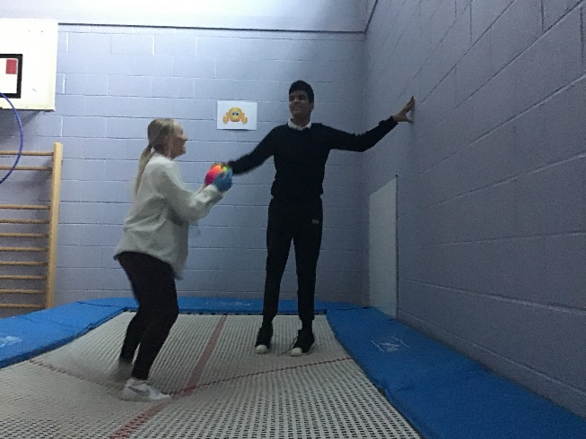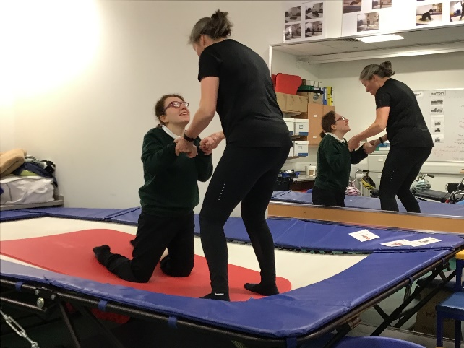
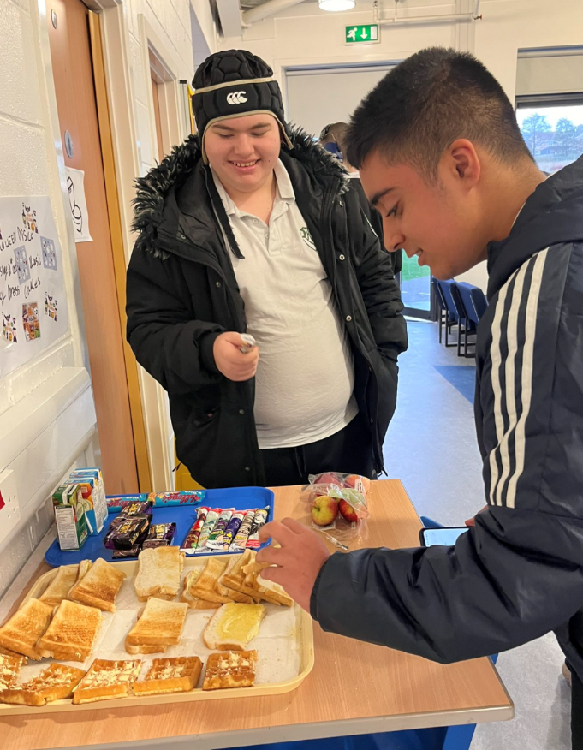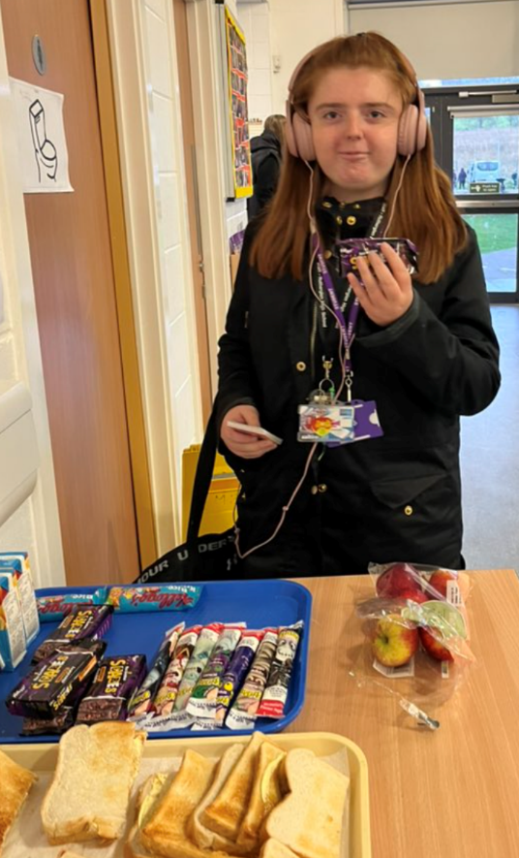

Section 12 - School Policies and Practical Information

School Meals
Healthy eating is something that the school supports, and a range of meals are available at lunchtime that meet the Nutritional Requirements for Food and Drink in Schools (Scotland) Regulations 2020. The regulations can be accessed via:-

https://www.legislation.gov.uk/ssi/2020/153/made

The secondary school menu includes a range of options available from breakfast, mid-morning and lunchtime.
- A meal deal for £2.40 consisting of a choice of main meals served with two portions of vegetables/salad and seasonal fresh fruit selection
- A selection of Grab ‘n’ Go snacks that are individually priced including panini, pizzini and freshly prepared baguettes and sandwiches with a selection of fillings
- “Beat the Queue” use our new Pre-order Fusion Mobile App where mid-morning snacks and lunches can be ordered via mobile phone and pick it up during mid-morning and lunch break avoiding the queues

Fresh drinking water is also available with all meals.

Special diets
If your child within Nursery, Primary or Secondary requires a special diet for medical reasons please speak to the school/nursery office who will provide the request form for you to complete

Free School Meals
Children of parents who receive the following benefits are entitled to a free lunchtime meal for their child:-
- Income Support, Universal Credit (where your take home pay is less than £796 per month), Job Seeker’s Allowance (income based), Employment and Support Allowance (income related), Working Tax Credit and Child Tax Credit (where your gross annual income does not exceed £9,552 as assessed by the HM Revenues and Customs), Child Tax Credit Only (where your gross annual income does not exceed £19,995 as assessed by the HM Revenues and Customs) or receive support under Part VI of the Immigration and Asylum Act 1999.

If you are in receipt of Housing Benefit and/or Council Tax Reduction from us there is no need for you to apply online, we will use the information we hold to automatically award free school meals (P4 to S6) and/or school clothing grants (P1 to S6) to eligible families.

We would encourage parents of pupils who are in receipt of any of the above benefits to take up the opportunity of having a meal provided for their child when they are at school. All secondary schools operate a cashless school meals system which protects the anonymity of pupils entitled to a free school meal.

We encourage all pupils to remain in school at lunch times. Currently all pupils at Rutherglen High School receive a free school meal irrespective of income.

Education Maintenance Allowance
Education Maintenance Allowance is available to young people between 16 and 19 years of age and is awarded depending on your household’s gross taxable income and the number of other dependent children living with you.

The online application form and information is available from South Lanarkshire Council website:-https://www.southlanarkshire.gov.uk/info/200188/secondary_s/chool_information/158/education_maintenance_allowance_-_financial_help_for_senior_pupils

Clothing grant
In certain circumstances the Council provides support to parents/carers for the purchase of school wear. Applications can be made online at:-
https://www.southlanarkshire.gov.uk/info/200186/primary_school_information/159/school_clothing_grants_and_free_school_meals
If you are required to submit evidence of your Tax Credit income it is important that a copy of this evidence is attached to your online application. Should you require further information, or you are unable to submit an application online then please contact the helpline number 0303 123 1011 (option 5).

School Uniform
We ask all parents/carers to support the school by encouraging your child (ren) to adhere to the agreed dress code and the wearing of our school uniform. The wearing of a school uniform helps promote the identity of the school in the local community and helps create an ethos of sharing and pride in the school.

In addition, the wearing of a uniform helps towards increasing the protection of all pupils. The wearing of a uniform helps staff and the pupils to distinguish between who belongs to the school and those who may be visitors. This enables staff to approach and identify visitors more readily and helps in trying to offer a safer environment for pupils and teachers alike.

Equality of opportunity is an important aspect of the life of the school. Any proposals on the dress code and on what constitutes the school uniform will be the subject of discussion with the Parent Council and where appropriate consultation with parents, pupils and staff.

There are forms of dress which are unacceptable in all schools such as:-
- the wearing of football colours
- clothing with slogans that may cause offence (anti-religious, symbolism or political slogans)
- clothing which advertises alcohol, tobacco or drugs
- clothing which can be deemed unsuitable in terms of health and safety grounds such as shell suits, combat style clothing, dangling earrings, loose fitting clothes particularly in practical classes
- articles of clothing that could be deemed to inflict damage on other pupils or be used by others to do so
- footwear that may be deemed to damage flooring.

The uniform for all Rutherglen High pupils is:-

- White shirt with school tie
- White school polo shirt
- School sweatshirt
- Black jumper/cardigan
- Black trousers/skirt

Allergies
Many children in our schools have allergies, and it is crucial for parents to keep the school informed about these conditions.
Allergies can manifest at any time with symptoms ranging from mild to severe. Children with moderate to severe allergies often have a Health Care Plan from the NHS, detailing symptoms and interventions. Parents must share this plan with the school and provide updates as necessary.

Even without a Health Care Plan, parents should regularly update the school on any new triggers, medications, or actions required. School staff need to know your child’s symptoms, treatments, and actions required to prevent exposure and minimise the risk of reactions. Staff receive training on allergies and will consult with parents and the NHS for any additional specialist training needed. In supporting children and young people with allergies, school staff will follow South Lanarkshire Council’s Safe Systems of Work, risk assessment process, and national guidance on the administration of medicines.

Mobile Phone Policy
We are committed to providing a caring, friendly and safe environment for all our students and believe that modern technology in the form of mobile phones, when used appropriately offers young people /carer’s peace of mind, particularly when travelling to and from school. We are also clear that when phones are used inappropriately, they distract from our core business of learning, and at the worst can be used as a tool for bullying.

- Pupils are allowed to bring mobile phones into school.
- If mobile phones are brought to school it is entirely at the owner’s risk. The school accepts no responsibility for replacing lost, stolen or damaged mobile phones/electronic devices.
- Parents are advised that in cases of emergency the school office is the point of contact to ensure that information is communicated quickly and in an appropriate way.

School Hours

Day/  Time | 8.50-  9.00 | 9.00-9.50 | 9.00 – 10.40 | 10.40-10.55 | 10.55-  11.45 | 11.45-  12.35 | 12.35-  1.15 | 1.15-  2.05 | 2.05-  2.55 | 2.55-  3.45
Monday | Reg | Period 1 | Period 2 | Interval | Period 3 | Period 4 | Lunch | Period 5 | Period 6 | Period 7
Tuesday | Reg | Period 1 | Period 2 | Interval | Period 3 | Period 4 | Lunch | Period 5 | Period 6 | Period 7
Wednesday | Reg | Period 1 | Period2 | Interval | Period 3 | Period 4 | Lunch | Period 5 | Period 6
Thursday | Reg | Period 1 | Period 2 | Interval | Period 3 | Period 4 | Lunch | Period 5 | Period 6
Friday | Reg | Period 1 | Period 2 | Interval | Period 3 | Period 4 | Lunch | Period 5 | Period 6

School holiday Dates Session 2024/25
Types of holiday listed by month | Holiday dates
In-service days - all schools | Monday 12 and Tuesday 13 August 2024
Teachers return on Monday 14 August 2023 | All pupils return on Wednesday 14 August 2024
September weekend | Friday 27 and Monday 30 September 2024
October break | Monday 14 to Friday 18 October 2024  Pupils return on Monday 21 October 2024
In-service day - all schools | Monday 11 November 2024
Christmas/New Year | Schools close at 2.30pm on Friday 20 December 2024  Schools re-open on Monday 6 January 2025
February break | Monday 17 and Tuesday 18 February 2025
In-service day - all schools | Wednesday 19 February 2025
Spring break/Easter | Schools close at 2.30pm on Friday 4 April 2025*  Schools re-open on Tuesday 22 April 2025
In-service day - all schools | Thursday 1 May 2025
May Day | Monday 5 May 2025
Local holiday | Friday 23 and Monday 26 May 2025
Summer break | Schools close at 1pm on Wednesday 25 June 2025

Transport
South Lanarkshire Council’s mainstream school transport policy provides transport for primary school pupils who live one mile or more from their catchment primary school by the shortest safe walking route. The calculation on the measurement of distance from home to school is measured using a Geographical Information System (GIS), which is used for all measurements to ensure that Council Policy is consistently applied across the Authority. More details on school transport can be found at the following link including the online application form:-
https://www.southlanarkshire.gov.uk/info/200186/primary_school_information/545/school_transport

If you consider your child to be eligible you should complete the online application form. Forms should be submitted before the end of March for those pupils starting school in August to enable the appropriate arrangements to be made.

A privilege transport scheme is operated on mainstream school contracts where a pupil is not entitled to free school transport. Privilege Transport will only be provided where there is a space on an existing school contract and will be from and to designated pick-up and drop-off points. It will not be provided where a service bus is used on the school run. Any spare capacity will be allocated using agreed priorities. A new application must be made each year. More details on Privilege school transport may be found here: https://www.southlanarkshire.gov.uk/info/200186/primary_school_information/784/privilege_transport_to_school

Currently all Rutherglen High School pupils are offered transport to and from school. The transport department will contact families directly prior to a young person's educational placement beginning to advise arrangements.

Pick-up points
Where school transport is provided it may be necessary for pupils to walk a certain distance to the vehicle pick-up point. Walking distance in total, including the distance from home to the pick-up point and from the drop-off point to the school in any one direction, will not exceed the authority’s distance limit for school transport.

It should be noted that it is the parent’s responsibility to ensure their child behaves in a safe and acceptable manner while travelling in and alighting from the vehicle. Misbehaviour can result in your child losing the right to school transport. Parents are asked to note that South Lanarkshire Council does not provide transport for those pupils who attend school via a placing request.

Insurance for Pupils’ Personal Effects
South Lanarkshire Council has noted an increase in claims for loss or damage to pupils’ clothing and personal effects. Please be aware of the Council’s insurance policy regarding pupils’ personal items:

Theft/Loss of Personal Effects:-
- The Council is not responsible for the loss or theft of pupils’ personal items, such as mobile phones or tablets. These items are brought to school at the pupil’s and parents’ own risk.
- To prevent loss, please avoid bringing valuable or unnecessarily expensive items to school.
- Staff members are instructed not to take custody of any personal items.
- This policy also applies to musical instruments and other equipment used for school activities. If such items are left at school, it is at the pupil’s and parents’ own risk.
- For valuable items like musical instruments, parents should ensure they are covered by their own household insurance.

Damage to Clothing:-
- The Council is only liable for damage to pupils’ clothing if it is caused by the negligence of the Council or its employees. Claims for other reasons will not be accepted by the Council’s insurers.

Child Protection
All staff in educational establishments in South Lanarkshire Council receive an annual Child Protection update and are required to follow the advice and guidance contained within relevant Education Operating Procedures. They must also complete a mandatory Learn online Course “Child Protection in Education”.

South Lanarkshire’s children’s services partnership works together to support children, young people and their families so that children grow up in communities where they are safe, healthy, active, achieving, respected, responsible and included, and have the opportunity to achieve their full potential. They are committed to continuously improve our services to ensure children, young people and their families get the right support at the right time.

Sometimes children and young people need additional help to make sure that they are “cared for and protected from abuse and harm in a safe environment in which their rights are respected” (CPC South Lanarkshire Child Protection shared vision). The Child Protection Committee has the overarching responsibility to ensure that agencies individually and collectively work to protect children and young people as effectively as possible.

All staff have a responsibility to report any suspicions that a child has been abused or is at risk of harm, abuse, or neglect. Robust procedures and guidance are in place to support education staff to: -
- be alert to signs that a child may be experiencing risks to their wellbeing,
- report concerns to the head of establishment or the child protection coordinator without delay.
- be actively engaged in support and protection and development of wellbeing.

If you would like more information, or if you have a concern of a child protection nature, please contact the head of the educational establishment which your child attends. The Child Protection Committee’s website has a range of useful information for parents/carers on how to help them keep their children safe. www.childprotectionsouthlanarkshire.org.uk

Information on Emergencies
We make every effort to ensure the school remains open during term-time for pupils. However, on occasions circumstances may arise which can affect the school. Schools may be affected by, for example, severe weather, power failures or through any other circumstances that may impact on the school day. In such cases we shall do all we can to let you know if this happens. We shall keep you in touch by telephone, text, where appropriate, letters, web news and through local radio stations particularly if there are prolonged periods of severe weather. The Council’s website www.southlanarkshire.gov.uk will be used to let you know if the school is closed and when it will re-open.

It is important for parents/carers to let the school know of any change to your mobile/home telephone number and change of address.

If for any reason, you are unsure if the school is open visit the website www.southlanarkshire.gov.uk or email us at:- education@southlanarkshire.gov.uk

Your commitments
We ask that you:
- support and encourage your child’s learning
- respect and adhere to the schools policies and guidance
- let the school know if you change your mobile/telephone number and/or address
- enjoy and take part in school activities
- accept your responsibility to respect staff who work in the school and for the school to be proactive in taking forward its commitment to care for and educate your child.

General Data Protection Regulation as supplemented by the Data Protection Act 2018 (GDPR)

Information on pupils, parents and guardians is held by the school to enable the teaching, registration and assessment of pupils as well as associated administrative duties. The information is stored and used as per the requirements of the GDPR, with South Lanarkshire Council defined as the data controller. The Council have established a data protection policy that applies to all of its school.

Education Resources has also prepared a privacy notice (below) which sets out how we will deal with personal information as part of our statutory function as an education authority. For more information please contact the school.

Privacy Notice

In line with the General Data Protection Regulation (GDPR) we have produced this privacy notice to inform you how we deal with personal information as part of our statutory function as an education authority. The Council has a legal obligation to deliver effective education services to children, young people and adult learners in South Lanarkshire. In order to do this we need to collect personal information about children, young people and their families so that we can help them to learn and keep them safe.

Using your personal information
The Council is a “controller” of the personal information you provide when enrolling for a nursery or school, applying for an education service or participating in groups or activities provided by Education Resources.

Information we collect from you about you and your child at enrolment
When you enrol for a nursery or school, we ask for the following information:-
- parent/carer contact details (name, address, phone, email);
- the child’s name, date of birth, gender and address;
- information about medical conditions, additional support needs, religion and ethnicity;
- any information you may wish to provide about family circumstances.

Information we collect at other times
We will also collect information at other times such as when you apply for a benefit, request a services or other support. We will provide an additional privacy notice at these times.
- If you apply for an education service or benefit, such as school transport, free school meals, clothing grant, placing request or EMA, we will also ask for personal information as set out above. We will also ask for information about your income for education benefits applications.
- If you make a request for additional support such as an educational psychologist or other support for learning we will ask for more detailed information to allow us to provide the most appropriate support for your family. This may include information about family circumstances or medical conditions.
- If there are concerns about your child’s wellbeing and/or your child has needs that may require additional support, we will wish to work with you to collect and consider information to enable us to help you get the right support at the right time in line with the Getting it right for every child approach.

We require this information to ensure that children and young people are educated appropriately, supported, and that we take account of their health and wellbeing. We will also ask you to update this information annually and to tell us when there are changes to your details.

Information that we collect from other sources
As an education authority and as part of our statutory function in accordance with our legal obligations, we receive information from other sources such as the SQA, the NHS or Social Work about you or your child, this includes:
- exam results and assessment information;
- information about health, wellbeing or child protection.

Why do we need this information?
We need this information so the Council can ensure it is delivering education services appropriately to all learners:
- for the education of children, young people and adult learners
- for teaching, enrolment and assessment purposes and to monitor the educational progress of children, young people and adult learners.
- to keep children and young people safe and provide guidance services in school;
- to identify where additional support is needed to help children, young people and adult learners with their learning;
- to maintain records of attendance, absence and behaviour of children and young people (including exclusions);
- to support children and young people moving on each year from nursery to primary, primary to secondary and when they move or leave school;
- to help us develop and improve education services provided for young people, adult learners or families
- In accordance with our legitimate interests as an education authority we will also use your information to create statistical reports.

We will share your information with
As an education authority and as part of our statutory function in accordance with our legal obligations we will share information with other bodies or parts of the Council, including:
- The Scottish Government and bodies such as Education Scotland, Scottish Qualifications Authority, Skills Development Scotland and other organisations that support children and young people’s learning.
- Other parts of the Council when required for services such as school meals, school transport, education benefits and with Social Work in connection with any child protection concerns we become aware of.
- The NHS, to support health initiatives in accordance with the legal obligation on the Council in terms of section 39(3) of the National Health Service (Scotland Act 1978)
- South Lanarkshire Leisure and Culture Limited, where children and young people are participating in sports and leisure activities.
- Other schools/local authorities – if a child moves or transfers to another school the Council has an obligation to pass on information with regards to pupil records to the new school/local authority.

You have the right to access your personal information as well as the rights of rectification, erasure, restriction and the right to object. For information on these rights and how to exercise them or for information about how we manage your personal information, you can get a copy of our full privacy notice from our website:
(https://www.southlanarkshire.gov.uk/info/200235/meta/1730/general_privacy).

Our full privacy notice will also provide information on how to make a complaint or to request a paper copy of the privacy notice from the Data Protection Officer.

The Freedom of Information (Scotland) Act 2002
The Freedom of Information (Scotland) Act 2002 came into force on 1 January 2005 and gives a person the right to request information held by Scottish public authorities. The act refers to information held in a “recordable” format and relates to information held within documents, not the documents themselves. Parents wishing to make a request for information under the terms of the Freedom of Information (Scotland) Act 2002 should submit their request in writing to:-

Freedom of Information Officer
Education Resources
South Lanarkshire Council
Council Offices, Almada Street,
Hamilton, ML3 0AA

Or email: foi.request@southlanarkshire.gov.uk

Requests for information can also be submitted using the online form available from the South Lanarkshire Council website (Request it section) (www.southlanarkshire.gov.uk)

Appendix A
For a comprehensive list of useful information, please visit the Council’s website:- http://www.southlanarkshire.gov.uk/info/200186/primary_school_information/1264/curriculum_for_excellence/3
Additional Information
Education Scotland’s Communication Toolkit: A resource for engaging with parents.
- The Scottish Government Guide Principles of Inclusive Communications: Offers information on communications and a self-assessment tool for public authorities.
- Choosing a School: A Guide for Parents: Provides information on choosing a school and the placing request system.
- A Guide for Parents About School Attendance: Explains parental responsibilities regarding children’s attendance at school

Parental Involvement
Guidance on the Scottish Schools (Parental Involvement) Act 2006 provides guidance on the act for education authorities, Parent Councils and others

Parentzone provide information and resource for parents and Parent Councils
National Parent Forum for Scotland; www.npfs.org.uk

School Ethos
Supporting Learners - guidance on the identification, planning and provision of support

Journey to Excellence - provides guidance and advice about culture and ethos

Health and wellbeing guidance on healthy living for local authorities and schools

Building Curriculum for Excellence Through Positive Behaviour and Relationships outlines the Scottish Government’s priority actions around positive behaviour in schools and is also a source of support

Scottish Catholic Education Service’s resource ‘This is Our Faith’ which supports the teaching and learning of Catholic religious education

Curriculum
Information about how the curriculum is structured and curriculum planning

Information about the outcomes a learner can expect to experience and achieve across literacy, numeracy and health and wellbeing, as well as the 8 curricular areas

Advice, practice and resources to support the experiences and outcomes on literary, numeracy and health and wellbeing

Broad General Education in the Secondary School – A Guide for Parents and Carers

Information on the Senior Phase

Information on Skills for learning, life and work

Information around the Scottish Government’s ‘Opportunities for All’ programme

Information for organisations responsible for the planning, management and delivery of career information, advice and guidance services

The Skills Development Scotland website “My World of Work” offers a number of tools to support career planning

Assessment and Reporting
Building the Curriculum 5: a framework for assessment provides guidance around the assessment framework

Information about Curriculum for Excellence levels and how progress is assessed

Curriculum for Excellence fact file - Assessment and qualifications

Information on recognising achievement, reporting and profiling

The Scottish National Standardised Assessment- in Scotland, pupils in P1, P4, P7 and S3 complete online standardised assessments in literacy and numeracy as part of their everyday learning and teaching.

Transitions
Curriculum for Excellence fact file - 3-18 Transitions - provides information on the transitions children and young people will face throughout their education and beyond

Career Information, Advice and Guidance in Scotland - A Framework for Service Redesign and Improvement provides guidance on career information, advice and guidance strategy

Choices and changes provide information about choices made at various stages of learning

The Additional support for learning page provides links to relevant legislation and guidance, including the arrangements that should be in place to support pupils with additional support needs

Supporting Children's Learning Code of Practice includes specific requirements on education authorities and others under the new legislation in relation to transition

Enquire is the Scottish advice service for additional support for learning

Parenting Across Scotland offers support to children and families in Scotland

Support for Pupils
The Additional support for learning page provides links to relevant legislation and guidance, including the arrangements that should be in place to support pupils with additional support needs

Information about the universal entitlement to support that underpins Curriculum for Excellence

Supporting Children's Learning Code of Practice (Revised edition) - provides Statutory guidance relating to the Education (Additional Support for Learning) (Scotland) Act 2004 as amended

Getting It Right For Every Child and Young Person, is essential reading for anyone involved or working with children and young people, including practitioners working in adult services with parents and carers

School Improvement
Scottish Schools Online - provides a range of school information, including contact details, school roll, facilities, website, inspection reports

Education Scotland’s Inspection and review page provides information on the inspection process

Scottish Credit and Qualifications Framework (SCQF)

Scottish Qualifications Authority provides information for teachers, parents, employers and young people on qualifications

Amazing Things - information about youth awards in Scotland

Information on how to access statistics relating to School Education

School Policies and Practical Information
Schools and local authorities should consider the most relevant school, local and national policies and include details or links for parents to sources of further information.

National policies, information and guidance can be accessed from the Scottish Government website on www.gov.scot

